ORDINANCE NO. 881

AN ORDINANCE AMENDING CHAPTER 9 OF THE CITY OF UMATILLA COMPREHENSIVE PLAN TO INCLUDE LANGUAGE OUTLINED IN THE 2025 ECONOMIC OPPORTUNITIES ANALYSIS

WHEREAS, the City of Umatilla Planning Commission duly considered the goals and policies of the Comprehensive Plan as applied to the application during a public hearing held on September 23, 2025, and subsequently recommended approval of the request to the City Council; and

WHEREAS, the Umatilla City Council conducted a public hearing on October 7, 2025, to consider the Planning Commission’s recommendation for amendments to Chapter 9 of the Umatilla Comprehensive Plan and adopted the Planning Commission’s findings and conclusions as its own in approving the application, as contained in the Umatilla City Council Report and Decision for Comprehensive Plan Change CP-1-25.

NOW, THEREFORE, THE CITY OF UMATILLA DOES ORDAIN AS FOLLOWS:

Section 1. The Umatilla City Council does hereby adopt the findings and conclusions recommended by the City Planning Commission as its own in support of this amendment to the Umatilla Comprehensive Plan, as contained in the Umatilla City Council Report and Decision for Comprehensive Plan Change cp-1-25.

Section 2. Chapter 9 – Economic Development of the Comprehensive Plan of the City of Umatilla is hereby amended to read as follows:

Underlined language proposed to be added; Strikethrough language proposed for deletion by Comprehensive Plan Change application CP-1-25

CHAPTER 9 – ECONOMIC DEVELOPMENT
Chapter 9

Section 9.0 – Economic Development Goal

The City of Umatilla aspires to remain a strong and vibrant economy and place to live by supporting the health, retention, and expansion of existing businesses while welcoming new opportunities to the region.

Section 9.1 – Background

The City of Umatilla updated its Economic Opportunities Analysis (EOA) in 2025, evaluating the economic context and growth potential for the next 20-year period. The analysis incorporates employment and workforce trends, development potential for the anticipated labor market growth, the Land Demand Analysis, and an Employment Buildable Lands Inventory.

Umatilla is positioned as a regional economic hub. Situated at the conjunction of the I-84 and I-82 freeways, the City is a key access point and throughway for commuters and freight. These routes provide direct access from Boise, Idaho to the Tri-Cities in Washington. Its location also provides easy access to surrounding jurisdictions, including Hermiston, Boardman, and Pendleton.

Umatilla’s location along the Columbia River has offered opportunities for agriculture, food processing and manufacturing, government and educational services (Two-Rivers Correctional Facility, Umatilla School District as the largest public sector employers), construction, and retail. Natural resource industries look to the river as an ample and affordable power and water resource necessary to power data center campuses that serve some of the largest companies in the world, including Amazon, Google, Facebook, Apple, and Microsoft.

Commuting trends in the city also have an impact on employment. Roughly three percent of Umatilla’s population both live and work in the City, which is low compared to other jurisdictions in Umatilla County. The most common commute desitinations for City residents are the surrounding cities of Boardman, Pendleton, and Portland. 85% of employees in Umatilla commute from elsewhere.
The City of Umatilla is estimated to have over 150 busineses and approximately 2,900 workers. The economic landscape and recent employment trends include:

- Amongst the top employment sectors in the City are agriculture, forestry, fishing and hunting (34%), government and educational services (29%), and construction (8%). Transportation, food manufacturing, and finance or insurance industries were the most under-represented of the major industries evaluated.
- The majority of workers (59%) earn more than $3,333 per month.
- The City has a greater proportion of workers with at least a high school education than the State as a whole (43% versus 23%, respectively). 41.5% of the adult population has some education beyond high school, compared to 51% countywide, and 69% statewide. 22% of local adults have completed a post-secondary degree, compared to 28% of the county population, and 45% of the state population.
- The local workforce has good capacity to fill many information technology (IT) jobs, a field which has seen growing demand due to the region becoming an emerging data center hub. Contrary to popular belief, many IT jobs do not require a college degree. For example, data from Indeed.com shows that as of 2023, 36% of “Data Center Technician” job openings only require a high school diploma or GED, while 31% require a bachelor’s degree, 27% require an associate’s degree, and 6% require a master’s degree. (https://www.indeed.com/career/data-center-technician/career-advice )
- Umatilla County has been very resilient in the face of the COVID-19 pandemic and the job loss it caused, recovering all of the jobs that were lost during that time while the state has only recovered an estimated 80% of the jobs lost during the same period.
- Between 2012 and 2022, Umatilla saw a positive regional shift in employment (compared to the rest of the country) in the agriculture, forestry, fishing and hunting, educational services, and health care & social assistance industries. These sectors grew faster than the national pace. Since 2012, the agriculture, forestry, fishing and hunting employment base has grown by over 300% and stands out as a growth cluster, providing positive growth for the City over the past decade.
- A rapidly growing industry is the information sector, both in the city and county, though experiencing more significant growth in the county (increasing by 250% in the last decade and 15% per year). Drivers for this sector include local and state financial incentives and the county’s strategic positioning in the region; with close proximity to freeways, water resources, and the fiber optic network.
Employment Forecast and Economic Growth

Oregon Statewide Planning Goal 9 requires jurisdictions to “plan for a 20-year supply of commercial and industrial capacity.” The EOA uses the employment trends and target industry data to determine whether or not the city can meet these needs by looking at:
- What the total forecasted employment and land use demand looks like through 2045, and
- What the land capacity is within the City’s UGB to meet development needs for the projected employment growth and demands.
Using an adjusted growth forecast, the City of Umatilla needs to accommodate an additional 2,994 jobs by the year 2045 (Figure 1).

Figure 1. Growth Forecast, 5-year Increments, City of Umatilla (2025-2045)
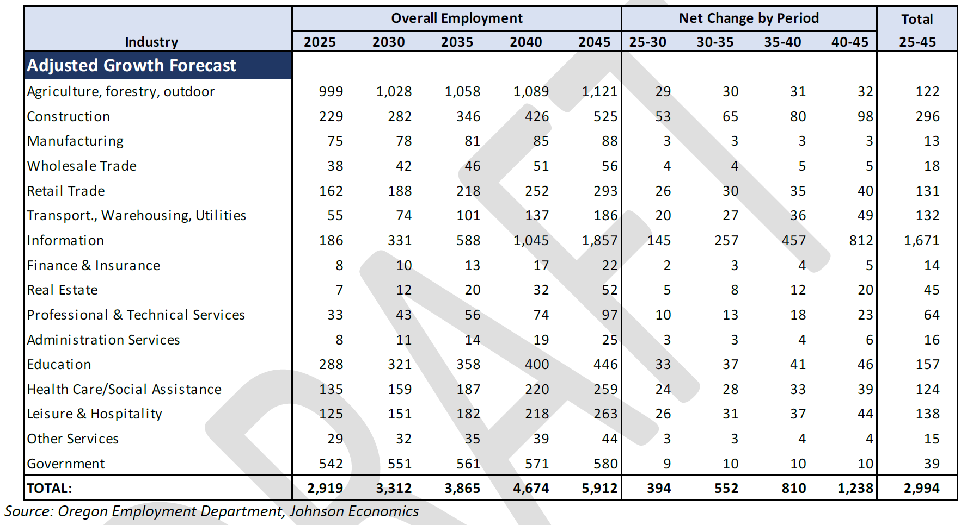
Source: Oregon Employment Department, Johnson Economics

The land demand analysis revealed a need for approximately 1,180 gross acres across building types to meet employment demand. Data centers account for 1,060 gross acres of this need. Other industrial uses account for 77 gross acres of need, and commercial uses 45 gross acres.

The EOA found that there is sufficient gross acreage of commercial land to meet forecasted needs, however the City lacks commercial and industrial sites in the specific identified size categories (Figure 3).
Figure 2. Land Supply and Land Demand, 20-year Period
Source: Johnson Economics, City of Umatilla, MIG

Figure 3. Forecasted 20-year Site Need Versus Site Supply but Land Use and Site Size (acres)

Source: Oregon Employment Department, Johnson Economics, MIG, City of Umatilla
Figure 4. Summary of Forecasted New Site Needs, with Estimated Acreage
Source: Oregon Employment Department, Johnson Economics, City of Umatilla

This information informs the City’s economic development policies, listed in Section 9.2.

Section 9.2 – Economic Development Goals and Policies

Goal 1. Support traditional and emerging industries and businesses in the City of Umatilla.

Policy 1A. Designate adequate available employment space and land opportunities, as identified in the Economic Opportunities Analysis (EOA).

Policy 1B. Identify large-lot sites and ensure adequate land supply for hyperscale data centers or larger consolidate campuses and that would provide opportunity for other catalyst projects.

Policy 1C. Encourage infill, redevelopment, or adaptive reuse of underutilized properties to revitalize employment zones.

Policy 1D. Prioritize and preserve key employment areas through phased infrastructure investments that provide the needed capacity for transportation and utilities.

Policy 1E. Develop and implement a marketing plan to attract businesses within the identified target industry business sectors.

Policy 1F. Remove barriers to development by installing infrastructure or reimbursing infrastructure costs using Urban Renewal funding or other sources.

Policy 1G. Manage the City’s Urban Growth Boundary (UGB) to ensure that an adequate supply of employment land exists within the UGB to accommodate the commercial and industrial land needs identified in the EOA.

Policy 1H. Protect sites brought into the UGB for specific employment uses (such as data centers) for those intended uses through policy, annexation agreements, the development code, and/or other means as appropriate.

Goal 2. Maintain and enhance business partnerships and coordination.

Policy 2A. Support and engage regional and statewide partners such as the Chamber of Commerce, Port of Umatilla, Umatilla County, City of Hermiston, NEOEDD, and Business Oregon on economic development projects.

Policy 2B. Expand and conduct outreach and communication efforts for targeted industries.

Policy 2C. Coordinate business cluster and employment district networking opportunities.

Goal 3. Promote small business development.

Policy 3A. Develop and support a new incubator space for start-ups and production businesses.

Policy 3B. Expand opportunities for emerging and under-funded firms through market programs and technical assistance.

Goal 4. Develop and attract a skilled workforce.

Policy 4A. Utilize and support local training programs, such as those at the Blue Mountain Community College, to build workforce skills that meet the needs of local employers, including the growing data center and information industry.

Policy 4B. Support housing, childcare, and amenities that encourage workforce retention and industry hubs.

Goal 5. Strengthen Downtown as a commercial corridor.

Policy 5A. Coordinate public activities that support Downtown as a community gathering place.

Policy 5B. Promote a mix of civic, retail, service, and office uses, designed to be pedestrian-friendly and oriented towards fronting streets and sidewalks.

Policy 5C. Identify incentive programs, such as an Urban Renewal (TIF) District, to bridge the feasibility gap for business development and extend the commercial corridor to accommodate more job growth.

Goal 6. Prepare for and ensure economic resilience.

Policy 6A. Consider natural hazards in the siting of facilities and businesses, limiting floodplain development to open space, recreation, or other appropriate uses that minimize loss to life or property.

Policy 6B. Plan for long-term adaptability through the monitoring and reporting of economic metrics.

CHAPTER 9
GOAL 9: ECONOMIC DEVELOPMENT

Section 9.0 Economic Development Goal
To provide for the economic diversification and stability of the area.

Section 9.1. Economic Development Background and Discussion
While area economics have experienced fluctuations with the advent and departure of defense- related industry and hydro-power construction, agriculture has been a sustaining economic force. Future expansions in irrigated agriculture, agri-business, and industrial facilities will add economic strength to the area.

9.1.100 Growth Opportunities
At the present time, a number of known projects are anticipated for Umatilla and the surrounding area. These projects are summarized in Table 9.1-1.
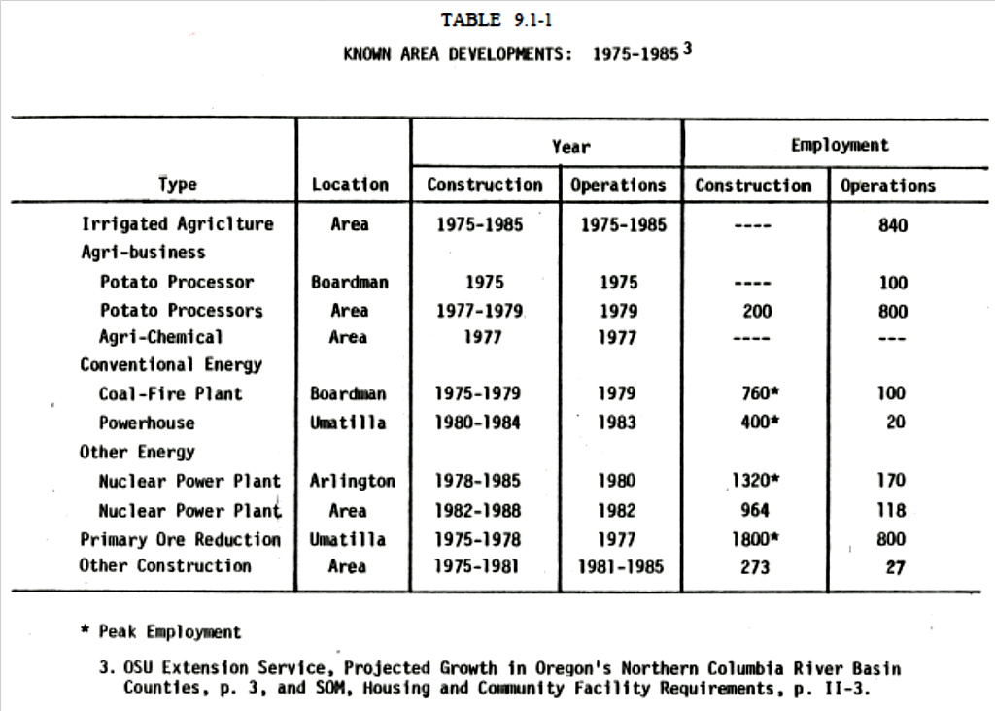

The employment forecast resulting from all projects is for 5,717 construction jobs, and 2,975
full-time jobs would be available at Umatilla.³⁴ This activity will produce a rather abrupt
upward trend in basic employment opportunities which in turn will influence secondary business activity. As construction activities are completed, secondary business may dip slightly until area population stabilizes and resumes a more normal rate of increase.

At the county level, based on an employment forecast prepared by BPA, the most significant increases in business activity will occur in wholesale and retail trade, services, and in government. Increases in manufacturing were also among the leaders. These projections are summarized in Table 9.1-2.
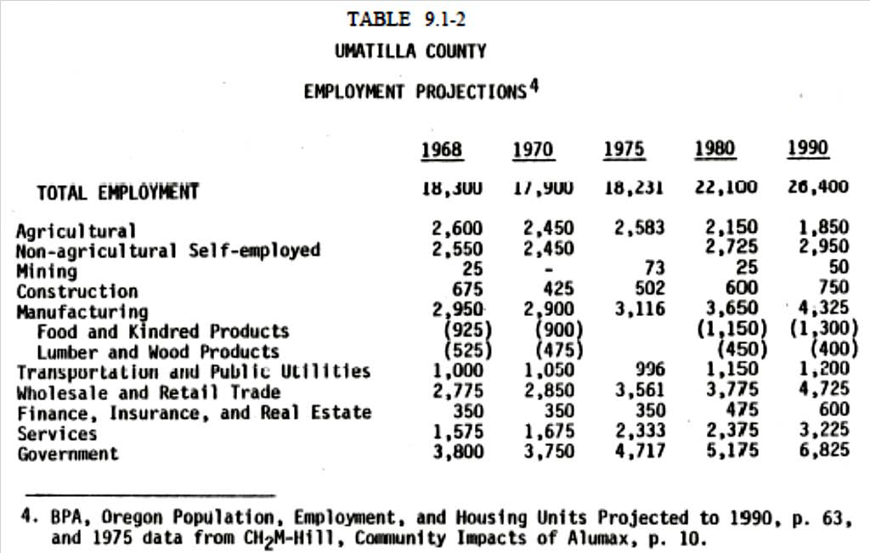

9.1.200 Local Employment
The short-range forecast for local employment presented here is largely a function of two projects, Alumax and McNary Second Powerhouse. The anticipated construction force for these two projects is estimated to total 2,200 people during peak periods.³⁵

For the Alumax project, a fairly detailed breakdown of direct and indirect employment has been achieved. This is summarized in Table 9.1-3. The figures for secondary employment are derived directly from a multiplier and thus do not show the time lag that will probably occur before the jobs actually begin. Using a similar method to determine employment attributable to McNary Second Powerhouse construction would produce 400 construction jobs with 160 secondary positions.

Operation of the powerhouse would require 20 people with 25 secondary positions resulting.
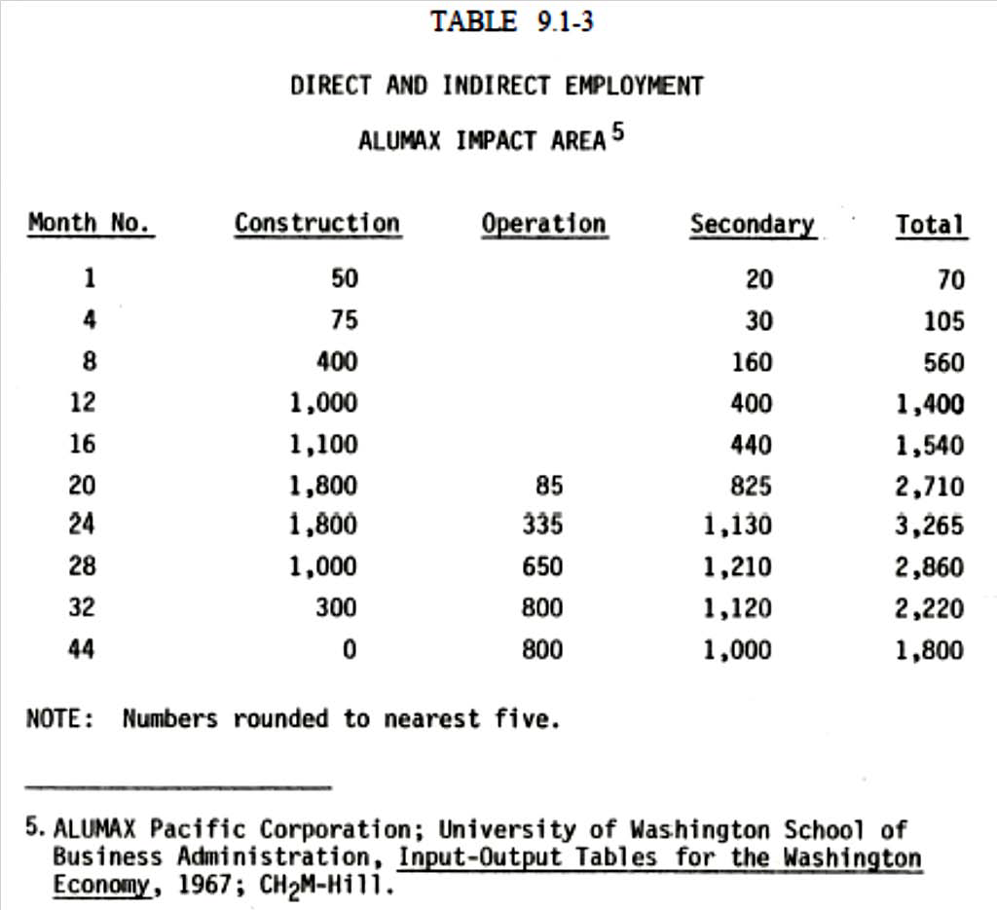

The implications of this employment availability to local residents may not be as significant as it may first appear. Estimates of local hiring for construction range between 2.8% and 10% of required construction personnel.³⁶ Applying these percentages to the construction labor force for the two projects produces 73 to 260 people hired from the Umatilla area. Some additional local hiring can be attributed to power generating projects in the area which could raise these figures from 116 to 414.

Employment figures during the operation of the Alumax plant indicate that between 50 and 165 people may be hired locally. Another 100 people may be hired outside of the Umatilla- Hermiston area. Secondary employment associated with plant operation is estimated to provide 100 positions for people in the Umatilla-Hermiston area, and another 200 positions for people in the surrounding area. The remaining secondary jobs are predicted to be filled by 700 people from outside the area.³⁷

Agricultural business in Umatilla and the surrounding area has generated additional employment opportunities. New business in food processing, agricultural chemicals and fertilizers have added to the area’s economy. This is a trend that is estimated to continue through the planning period. Additional economic inventory can be found in an ECOAC Overall Economic Development Program Revision.
Section 9.2 Downtown Revitalization and Circulation Plan
9.2.010 Introduction
The Downtown Revitalization and Circulation Plan will help the City of Umatilla redevelop the downtown as a vital, pedestrian-oriented center and create an efficient transportation system. The plan identifies a series of projects and strategies that will enhance the pedestrian environment in the community and improve the transportation system.

The plan identifies opportunities for downtown redevelopment, transportation improvements and defines a project implementation strategy, which if properly implemented, should result in significant revitalization of the downtown area. The plan is intended to function as a specific plan with key policies, projects, and programs that guide public and private investment in the community.

9.2.020 Project Study Area
The downtown revitalization plan has a general study area defined by the Columbia River to the north, Umatilla River to the south, Powerline Road to the west, and Umatilla River Road to the east. The interchange improvement component of the project will be documented in a separate report and encompasses a study area east of Umatilla River Road to the I-82 interchange with Highway 730. More specific elements of the downtown revitalization plan focused on Highway 730 (6th Street) and one block north to 5th Street and one block south to 7th Street. Figure 9.2-1 shows the study area.

While plan recommendations are focused on the downtown area of the City, the project study area includes the downtown area and its immediate surroundings. Activities of influence and connections surrounding the downtown were considered to be important factors during the development of the plan.

9.2.030 Planning Process
The planning process used to produce the City of Umatilla’s Downtown Revitalization Plan is unique in several respects. First, a market analysis was integrated into the study to provide a strategic basis for implementing elements of the Plan. Concepts and design ideas were expressed graphically, to make them more understandable and help the community envision elements of the Plan. The public involvement process was designed to reach a broad segment of the local community and to include people of all age groups in the development of the Plan. During the early stages of the planning process, a broad spectrum of revitalization ideas was considered, but only practical and achievable ideas where included listed as project goals and objectives. Finally, the Plan has been coordinated with the Circulation Plan aimed at alleviating traffic issues associated with the Downtown Revitalization Plan.

More detailed information that resulted from the charrette and public workshops is provided later. Listed below are the major steps included in the planning process and the project meetings that were held.
Project Steps
- Project initiation, data collection, meeting preparation
- Project reconnaissance and meetings
- Base map and sections
- Opportunities and Constraints Report
- Community Involvement
- Options for downtown development
- Downtown Development Workshop (consensus)
- Strategic Plan
- Strategic Plan Presentation
- Code amendments – review and adoption

Meetings
October 2000 – Distribute Public Questionnaire
2 November 2000 – Walking Tour and Community Visioning Exercise 2 November 2000 – Management Team Meeting
8 November 2000 - McNary Heights Elementary School Charrette 8 November 2000 – Clara Brownell Middle School Charrette
8 November 2000 – Advisory Committee Meeting
8 November 2000 – Umatilla High School – Adult Charrette
9 November 2000 – Downtown Workshop
22 January 2001 – Dinner Meeting with City Council and Planning Commission 25 January 2001 – Management Team Meeting
25 January 2001 – Interchange Refinement Planning Meeting #1
25 January 2001 – Joint Planning Commission/City Council Work Session
26 April 2001 – Management Team Meeting
26 April 2001 – Interchange Refinement Planning Meeting #2
26 April 2001 – Strategic Plan Presentation to Planning Commission 31 May 2001 – Planning Commission Hearing
4 June 2001 – City Council Hearing

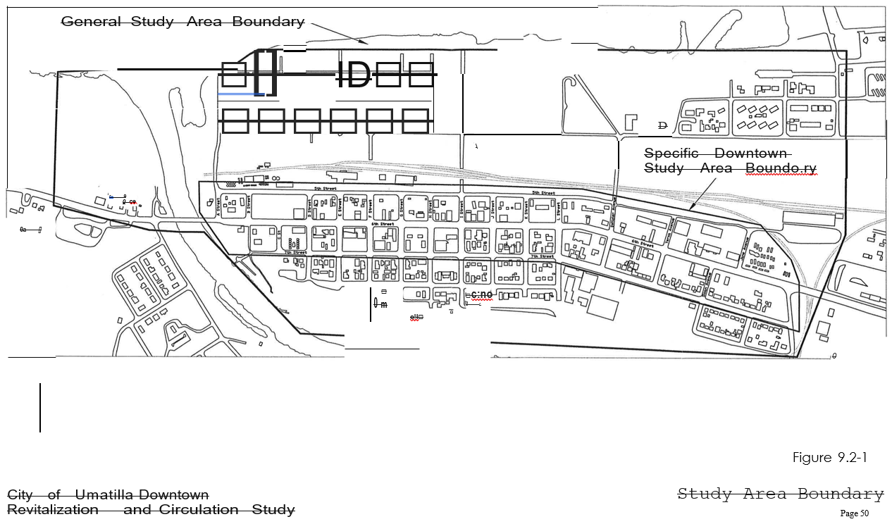

9.2.100 Opportunities and Constraints
The planning team determined opportunities and constraints for the downtown revitalization study through site analysis, research, and public involvement techniques. Team findings are documented in detail in the Opportunities and Constraints Report dated June, 2001. Included in this chapter is a summary of the most significant findings of that report.

When developing opportunities and constraints for downtown Umatilla, a wide range of topics was considered. These topics included:

- Questionnaire results and results from the walking tour
- Historic sites
- Inventory and evaluation of pedestrian facilities
- Identification of significant sources of pedestrian traffic
- Location of public buildings and uses
- Analysis of buildings fronting 6th Street
- Inventory of DEQ cleanup sites, sites that store hazardous material and potentially contaminated sites
- Survey of vacant or underutilized land and facilities
- Evaluation of existing neighborhood boundaries and land use
- Street layout and traffic control facilities
- On-street and off-street parking
- Public utilities
- Waterways
- Streetscape
- Pedestrian linkages, and
- Planned public facility improvement projects

After analyzing opportunities and constraints, the team concluded that there does not exist a distinct node or center in downtown around which focus future redevelopments efforts. Alternatively, the downtown is effectively a ‘blank slate,” allowing great flexibility for future redevelopment.

Table 9.2-1 summarizes the most significant findings of the Opportunities and Constraints report.

The opportunities and constraints were considered in developing the framework for the concept plan. They are also important in determining factors when devising a strategic approach to downtown revitalization.

Because no clearly defined town center exists, members of the planning team, together with community participants, selected a focus area for downtown redevelopment. While about half of the twelve public buildings are scattered in the downtown area, there is a cluster of public uses along Sixth Street between “I” Street and “J” Street. The corner of Sixth and “I” Streets was selected as the focus area for redevelopment and is envisioned as the central place of Umatilla’s downtown. A long-term opportunity for Umatilla is to cluster public uses near the downtown center.

The opportunities and constraints for downtown Umatilla indicate that immediate results will be difficult to achieve, and that the best results might be realized by implementing a long-term revitalization strategy.

Table 9.2-1. Opportunities and Constraints Summary

Opportunities Constraints

  - Schools and the grocery store are pedestrian generators.
  - Downtown has two nodes of buildings with frontage on Sixth Street.
  - There is a concentration of buildings around the museum and library.
  - Downtown vacant and underdeveloped lands offer redevelopment potential.
  - Downtown has potential linkages to surrounding neighborhoods.
  - The street grid in downtown provides good access.
  - Plenty of parking capacity exists in the downtown.
  - Generally, Sixth Street is well served by improvements such as sidewalks and curbs.
  - Extension and expansion of the
  - There are numerous missing ramps and sidewalks along Sixth Street.
  - Downtown blocks are underdeveloped and public and private buildings are scattered.
  - Abandoned gas stations are potentially contaminated sites.
  - There is no concentration of opportunities in downtown.

  - Few distinct neighborhoods exist in downtown.
  - There is no identifiable center in the downtown.
  - Perceived street crossing problems for pedestrians in downtown.
  - Side streets lack sidewalks, curbs and other improvements.
  - The downtown lacks cohesion.

Heritage Trail

9.2.200 Market Analysis
This section provides an overview of the current commercial and residential markets in the City of Umatilla and a brief assessment of the economic opportunities and constraints for revitalizing the downtown. This work recognizes the notable social and economic changes in Western Umatilla County in the last five years. Much of the recent economic activity is related directly or indirectly to the addition of four major employers to the region. Many of the impacts of these employers were anticipated and discussed in the HUES³⁸ Growth Impact Study, February 1998.

9.2.210 Housing Market
Housing construction in the City of Umatilla has experienced a significant upswing in recent years. The housing needs analysis completed for the City in 1999 identified over 1,200 existing housing units and indicated permitting for new units had been relatively sparse from 1987 through 1998 (approximately 78 permits over 11 years). However, in the last two and half years, 144 new housing units have been permitted (nearly twice that of the previous 11 year period). This trend can be seen from the data summarized in Table 9.2-2.

Recent developments have included Phase 1 of Riverview Estates and Telleron. Phase 1 of Riverview included 49 lots, of which three remain (two with new homes on them).

Table 9.2-2.Housing Permits (1987-2001)

Unit Type | Prior to 1987 | 1987-1998 | 1999-March 2001
Single Family | 767 | 68 | 63
Multi-Family | 75 | 8 | 44
Manufactured | 359 | 2 | 37
Total | 1,201 | 78 | 144
Note: Adjustment made to 1987-1998 multi-family units permit number to account for reporting variations.
Source: City of Umatilla Housing Needs Analysis, Benkendorf Associates Corp., Oregon Building Permit Reports, CPRC Portland State University, and City of Umatilla.

Properties were sold both with Hayden Homes and as vacant lots. Twenty-six Hayden homes sold in the last 18 months. The majority of these single-family homes had three bedrooms and two baths. Sales prices ranged from $78,715 – for a two bedroom two bath home – to $116,240 – for a four bedroom two bath home. Phase 3 is expected to begin soon.

Eight Tellaron properties (which feature Penbrook homes) sold over the same period. Again the majority of the homes included three bedrooms and two baths. Sales prices ranged from
$102,000 to $164,000.
Other residential development projects include construction of twelve 4-plexes for rental housing, a 265 unit manufactured home park, and conversion of an existing single-family rental community to owner occupied units.
A review of existing and new single-family home sales in the City over the last 18 months indicates a strong market for starter homes priced $125,000 or less. This data is shown in Table 9.2-3. Of the 96 sales identified, only 6 came in at prices above $125,000. The least expensive homes were previously owned manufactured units – the majority of which were priced at $50,000 or less.

Table 9.2-3 City of Umatilla Home Sales for Single Family Units Under $300,000 (November 1999 to March 2001)
Unit Type
Sales Price | Standard | Manufactured
Less than $50,000 | 3 | 10
$50,000 to $75,000 | 18 | 3
$75,001 to $100,000 | 31 | 2
$100,001 to $125,000 | 23 | 0
$125,001 to $215,000 | 6 | 0
Total | 81 | 15
Note: Sales include existing and new standard housing units and existing manufactured housing resales that include land in price.
Source: Local real estate agent contact.

Table 9.2-4 summarizes the multi-family rent range in the City of Umatilla. Most apartment units in the City were constructed in the 1970s. Multi-family rents range from $355 to $700 per month depending on the unit size, furnishings, and/or subsidization. Landlords report that there are many short-term renters associated with temporary employment such as construction projects and agricultural or factory employment. This results in fluctuations in vacancy rates.
With the exception of subsidized housing (which tends to have fewer vacancies), vacancy rates range between 4% and 15%. Landlords comment that there seems to be noticeable excess supply of apartment rentals at the moment.

Table 9.2-4 City of Umatilla Multi-Family Rents
Unit Size Rent Range
Studio & 1 Bedroom $355 to $450
- Bedroom $410 to $700
- Bedroom $470 to $675
Note: Low-end of rent range generally associated with subsidized housing units, some of higher-end units are furnished.
Source: Local property managers.

9.2.220 Commercial Space Market
Currently there is little apparent demand for commercial space in the City of Umatilla. Reportedly no new commercial construction has occurred recently and about half of the recent existing commercial building sales in the City were to the School District.

Commercial rents for the region are summarized in Table 9.2-5. Vacant commercial space is available in both the 6th Street commercial area and in McNary. As a result of the lack of demand, rental rates for commercial space in Umatilla range from $2.40 to $6.00 per square foot per year, less than half the cost of space in nearby Hermiston. These rental rates are typically not adequate to support new construction or significant improvements to existing buildings.

Table 9.2-5 Commercial Rents (2001)

City/Area Annual Rent per Square Feet

Hermiston
- Downtown $12.00 to $16.80
- Hermiston Plaza $10.00 to $13.00
- Other $10.20 to $12.00
Umatilla $2.40 to $6.00

Note: Detail on condition of commercial spaces not readily available. Source: Local real estate tenants, appraisers, agents.

Commercial rents in Hermiston reportedly are highest in the downtown ($12.00 to $16.80 per SF per year) and drop by as much as 25% (to a range of $10.00 to $13.00 per SF per year) for areas outside the downtown. The market for commercial space also appears to be quite price sensitive. An increase in rents at Hermiston Plaza apparently has been accompanied by a loss of tenants including anchor tenant Rite Aid Drugs. Some remaining businesses report a significant drop in sales as a result of this loss and that the quality of incoming businesses and merchandise has lowered.

On the other hand, demand for warehouse or flex space for storage and/or light manufacturing businesses has been noted in both the Umatilla and Hermiston markets.

9.2.230 Economic Assessment
The City of Umatilla has a number of strengths but also faces numerous challenges in its attempt to develop a stronger commercial core and city center. The strengths include:

- Successful marketing of port industrial property is bringing in new light industrial and transportation businesses such as trucking, farm tool & implement, and rustic furniture companies.
- Residential development occurring in just the last two plus years has already outpaced development over the previous decade.
- On the demographic side, strong population growth and increasing incomes for households in their prime employment years are being experienced.
- The existing commercial business mix includes some key anchor businesses (such as the grocery, drugstore and bank) and provides a good base from which to build future commercial expansion and investment.
However, despite these strengths, tenant based locally driven commercial development isn’t occurring in Umatilla. The following challenges are likely reasons for the apparent lack of commercial interest/development:

- The downtown commercial area is a mile-long rectilinear district and is most likely still too large for the number of commercial businesses supportable by the City population and incomes.
- The downtown commercial district is west of both the I-82 freeway and the port of entry.
- Area businesses face direct competition from national and local stores in nearby Hermiston. For at least some forms of retail, the Umatilla trade area is too small to support competing businesses that can generate industry standard sales volumes.
- The downtown commercial area is currently characterized by a significant number of vacant and underutilized commercial properties (including several prominent former gas station sites).
- Based on a series of conversations with local business proprietors, property owners, city and development corporation staff, it appears these groups have a variety of agendas and at times are working against each other – whether intentionally or inadvertently.
- In some instances it has been suggested Umatilla has a poor business climate making entry and start-ups difficult by discouraging potential tenants.
- Commercial rents in Umatilla are not sufficient to support new construction or significant improvement to existing structures.

In summary, there is nothing on the immediate horizon to suggest vacant or underutilized commercial properties in Umatilla will fill absent a program of proactive public/private investment strategies.

9.2.300 Public Involvement
The public involvement program for the Downtown Redevelopment Plan involved several components. First, in October 2000, 2900 project newsletters with a community questionnaire were distributed. The second step in the public involvement program was to conduct a walking tour of the study area with local stakeholders. Also included in this tour was an educational presentation of downtown planning concepts and a community visioning exercise. The third step was a series of charettes to generate ideas to revitalize the downtown Umatilla. Three charettes were conducted. Two of the charettes involved elementary and middle school children. The third and final charette was for the general public and held at the Umatilla High School. Following the charettes the next day was a downtown workshop. The downtown workshop summarized the public input and developed alternative concepts to revitalize the downtown area.

9.2.310 Community Questionnaire
In October 2000, 2,900 questionnaires were mailed to area residents. The questionnaire was part of a project newsletter and listed a series of open-ended questions. In the six weeks following the mailing, approximately 28 questionnaires were returned. A copy of questionnaire responses is included in Appendix 9A-1. Key observations include the following:

Downtown Identity - Respondents provided a wide variety of answers to a question that asked people to list the landmarks and buildings that best identify downtown. Responses ranged from businesses and buildings in the core area (Carlson’s Drug Store, City Hall, and the Red Apple Cowboy) to outlying uses, such as the Port of Entry and the Umatilla Marina RV Park. Clearly, there was no consensus about what defines downtown Umatilla.

Positive Characteristics - In response to a question regarding the positive characteristics that should be maintained, there were few responses that focused on positive attributes. Some of the positive features included: parks, new high school, craft shops, murals, Umatilla Museum, library, and the MOR Theater.

Negative Characteristics - A longer list of negative characteristics was generated when people were asked to list the features that needed to be improved. Examples included: retail along main street, ugly buildings and signs, trees, green areas, old gas stations, and storm drains.

Commercial Development - In response to a question asking what type of commercial development is desired, people listed the following uses often found in a downtown area: bakery, hardware store, restaurants, a deli, real estate office, professional offices, a bowling alley, clothing store, and shoe store. People also listed uses that are not typically found in downtowns, including a lumber yard, Fred Meyer, Wal-Mart, Bi-Mart, and drive-through restaurants. Again, there was no clear consensus about what should occur in the downtown and what type of businesses should locate there.

Traffic Issues - Public response ranged from general to very specific improvements when asked if there were traffic problems related to pedestrian safety, speeding, parking, and congestion. A number of respondents mentioned the high levels of truck traffic in the downtown and problems for pedestrians attempting to cross Sixth Street.

General Comments - A variety of general comments was provided. Comments addressed issues such as signage, tourism, retail opportunities, and public involvement.

The results of the community questionnaire are included in Appendix 9A-1 with a copy of the questionnaire questions.

9.2.320 Walking Tour
On November 2, 2000, the consultant team conducted a walking tour of downtown with a number of downtown stakeholders. As part of that process, a work session was held with participants. Notes from the work session are included in Appendix 9A-2. Key observations included:

Constraints:
- Downtown businesses are too spread out.
- The downtown is a highway with sidewalks.
- There is no reason for visitors to stop in the downtown.
- Hazardous materials at abandoned gas stations limit development.
- There are numerous absentee owners in the downtown.

Opportunities:
- The museum should have a strong presence on Sixth Street.
- Recruit the post office back to the downtown.

- Parking is available on the street.
- Gaps between existing buildings are an opportunity for development.
- “E” Street provides an opportunity to link to the park.
- The tour boats bring many visitors to Umatilla.
- Lots of small improvements will provide a realistic strategy for successful revitalization.

    - Charette and Downtown Workshop
On November 8 and 9, 2000, the H. Lee and Associates team held a two-day charrette that culminated in a downtown workshop attended by stakeholders, city officials, and citizens. The charrette activities on November 8 included two workshops with school children, a meeting with the project advisory committee, and an evening community workshop. On November 9, the consultant team synthesized information collected on the previous day and conducted a downtown workshop in the evening. Two separate reports document the workshop activities. The Charrette Report documents activities on November 8. The Downtown Workshop Report addresses activities on November 9.

    - Charrette Report
Charrette activities conducted on November 8, 2000, are summarized below. Each event is described separately.

Children’s Charrette – McNary Heights Elementary School.
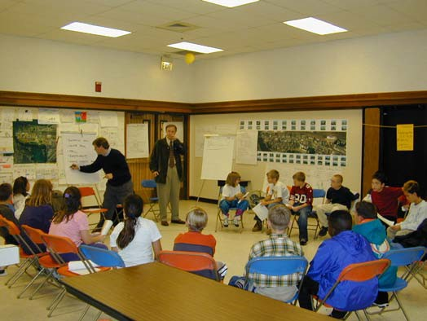
The consultant team met with 16 elementary school children on the morning of November 8, 2000. Before the meeting, teachers had students draw pictures of uses and activities that children envisioned for downtown Umatilla. At the workshop, students took turns describing their drawings. A sampling of student drawings is included in Figure 9.2-2. As children talked about their desires, Bob Foster sketched images depicting the type of activities described. Following the discussion, the ideas that were most commonly stated were listed. The
students were then given five adhesive dots and were asked to vote for their favorite ideas. The results are provided in Table 9.2-6 below. Elementary school students had a strong desire to see better parks and playing fields. They also wanted a local swimming pool and the MOR movie theatre reopened. There was interest in creating a science museum. This idea received further discussion later in the day as citizens discussed local natural and archeological features. A sample of the elementary school children design charrette drawings is shown in Figure 9.2-2.

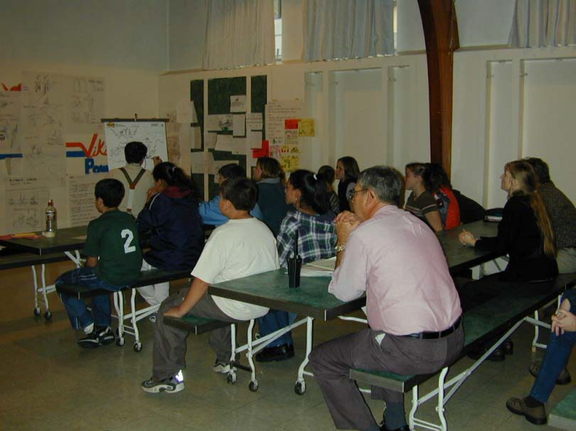
Children’s Charrette – Clara Brownell Middle School.
During the afternoon of November 8, 2000, the consultant team met with approximately 10 middle school children. As was done with the elementary school children, students prepared drawings before the workshop. Each child took a turn describing their vision of downtown Umatilla. Again, as students presented ideas, Bob Foster sketched concepts. Common ideas were listed and students voted to identify their preferences.
The results are included in Table 9.2-6 below. Samples of student drawings are shown in Figure 9.2-3. The most popular idea among middle school students was establishment of a skating rink - the Skate O’ Rama. Other popular ideas included a swimming pool, movie theater, and skate park.

Table 9.2-6 Summary of Results of Elementary School Children Design Charrette

Idea of Improvements to Umatilla | Number of Votes for Idea
Additional Parks and Sports Fields | 17
Swimming Pool | 13
Rehabilitate the Movie Theatre and Open | 13
Mall | 11
Science Museum | 9
Teen Center | 8
Restaurants | 8
Arcade | 5
Skate Park | 4

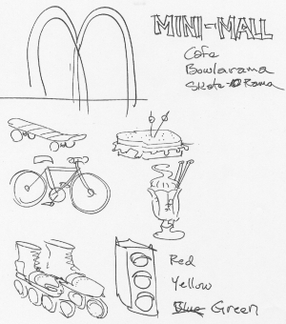
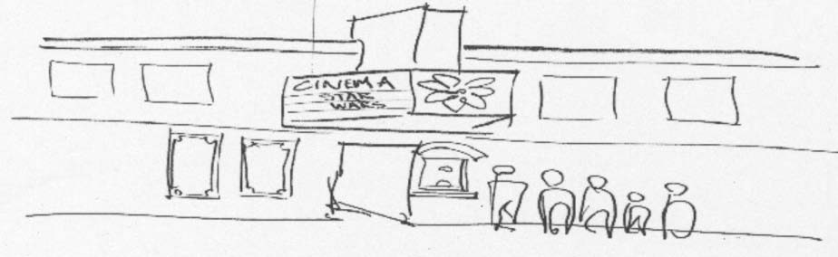
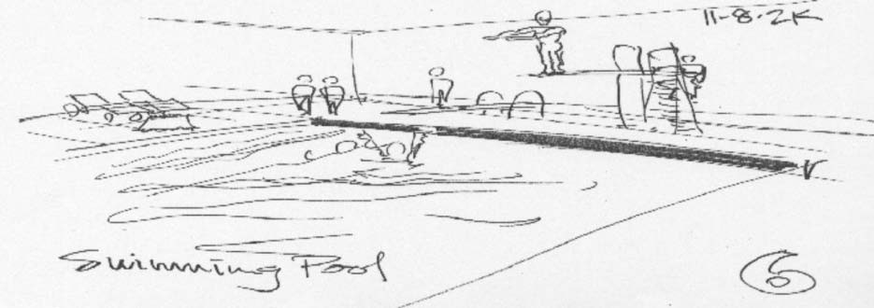
Figure 9.2-2 Sample of Ideas from Elementary School Children Design Charrette

Table 9.2-7 Summary of Results of Middle School Children Design Charrette

Idea of Improvements to Umatilla | Number of Votes for Idea
Skate o’ Rama | 22
Movie Theatre | 9
Swimming Pool | 9
Skate Park | 6
Bike Trails | 3
Bowling Alley | 3
New Middle School | 3
Window Decorations | 2
Fitness Center | 1
Take Down Cowboy and Put Up Viking | 1
More Shops | 1

    - Project Advisory Committee Meeting
On November 8, 2000, a project advisory committee meeting was held after the children’s workshops and before the evening adult charrette event. The focus of the meeting was to review activities of the day and identify key concerns of the committee. The following list represents the key concerns of the committee:
      - There is a major concern of how traffic will affect the downtown core. Three basic options exist. They are 1) move truck traffic away from downtown via an alternative route, 2) move the downtown center away from 6th Street, and 3) slow traffic down on 6th Street.
      - The downtown needs to be separate from the major traffic corridor.
      - More commercial development is needed to support the Columbia River tour boats. These developments need to be such as to keep patrons of the tour boats occupied for stops of one to two hours. Ideas for these developments include museums and small shops.
      - The tribe should consider developing an interpretive center in town.
      - No commercial kitchen exists in town. One should be sought to be developed in conjunction with other retail uses.
      - There is a safety concern on 6th Street regarding truck traffic. The preference is to move truck traffic away from the downtown core.
      - A traffic light should be considered to be installed along 6th Street to slow truck and general traffic down.
      - Timing is critical in any redevelopment of downtown. The major issues are when, where, and how.
      - The bridge on the west end of town is in need of replacement. It is tentatively scheduled to be replaced in 2005.

Figure 9.2-3 Sample of Ideas from Middle School Children Design Charrette
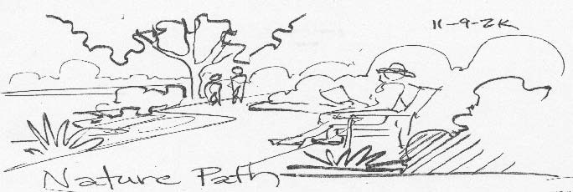
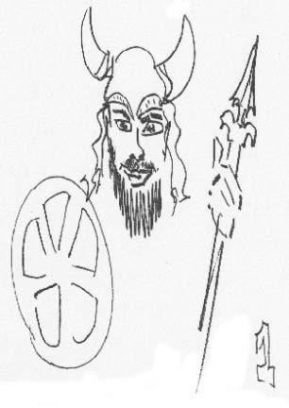
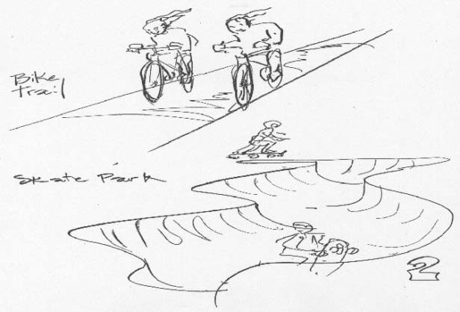
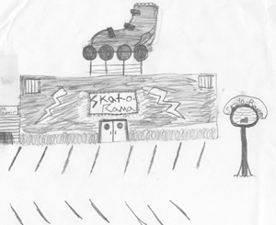
    - Adult Charrette
As part of the charrette process, a workshop was held with the general public on the evening of November 8, 2000. The session was held in the Umatilla High School and was attended by approximately 30 people. At the session, the consultant team presented background information on downtown planning principles. The student workshops were described, and the drawings were displayed. Charrette activities included prioritizing goals and providing comments at four workstations. One of the work stations is shown in Figure 9.2-4.

Draft downtown goals were prioritized by voting with adhesive dots. Participants were given four dots. Results are presented in Table 9.2-8. Goals that received the most votes were to cluster public and civic uses in downtown and to encourage improvement of downtown buildings. The goals that received the fewest votes were to provide more housing and mixed-use development in the downtown.

Figure 9.2-4 One of Four Workstations at Community Workshop
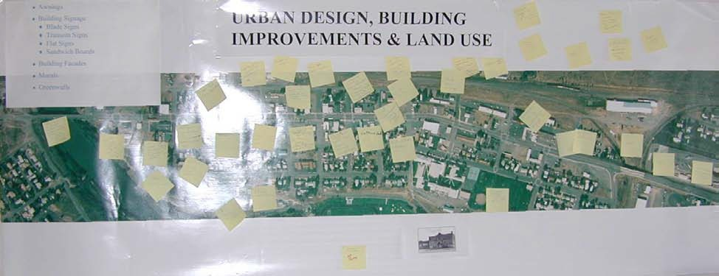

Four workshop stations were provided. Participants made comments and noted ideas on post-it notes and applied the notes to large aerial photographs. The stations included the following topic areas:

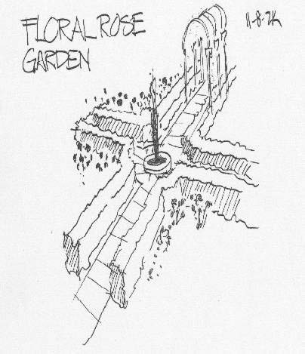
      - Urban design, building improvements, and land use.
      - Pedestrian improvements.
      - Circulation and parking.
      - Streetscape improvements.
A transcript of comments from each station is included in Appendix 9A-3. Select comments from the workstations include the following:
Urban Design, Building Improvements, and Land Use.
      - Murals/green walls
      - Awnings
      - Signage/sign controls
      - Fix up movie theate
      - Skate park
      - Move post office downtown
      - Town garden
      - Accent the “cowboy” – light him at night

Table 9.2-8 Downtown Goals

Downtown Goals
1. Cluster public and civic uses (Post Office/City Hall) in downtown.
2. Encourage improvement of downtown buildings.
3. Enhance the pedestrian environment by providing a community gathering place and minimizing conflicts between pedestrians and highway traffic.
4. Improve city park (e.g. add a skate park and playing field) near downtown.
5. Define the downtown by creating landmarks, focal points, or other features. Use landscaping, lighting, and street furniture to improve downtown streetscapes.
6. Create a focused core area in the downtown by concentrating new pedestrian oriented development in key locations.
7. Improve pedestrian connections between the downtown and surrounding residential areas.
8. Improve parking in the downtown.
9. Discourage auto-oriented business in the core area of downtown.
10. Provide more housing and mixed-use development in and near the downtown.

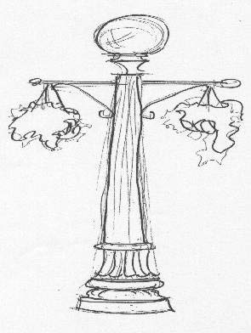
Streetscape Improvements.
      - Gateways
      - Public art
      - Bulb-outs at crosswalks
      - Drinking fountains
      - Historic pedestrian lighting
      - City center gathering spot
      - Street trees

Circulation and Parking.
      - Public parking lots
      - Parking available on side streets

      - Screen parking
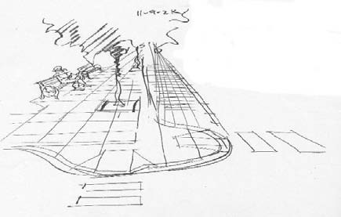
      - Parking signage
      - One-way couplet
      - Traffic lights

Pedestrian Improvements.
      - Bulb-outs at crosswalks
      - Accent paving/raised pavements
      - Medians/islands
      - Improved sidewalks
      - Handicap ramps
      - Stop light

    - Downtown Workshop
On November 9, 2000, a downtown workshop was held at city hall. Approximately 25 people
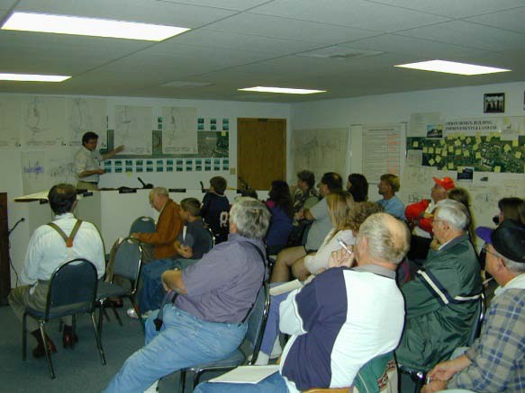
attended the workshop. Participants included stakeholders, city officials, and the general public. The purpose of the workshop was to test a series of downtown alternatives and develop a conceptual framework for development of the downtown plan. The team summarized the work of the previous day and presented four basic concepts for how the downtown could develop including: a nodal commercial center, a truck bypass on Fifth Street, a Seventh Street commercial center, and a new town center. The team presented three variations of the nodal commercial
center, which resulted in a total of six alternatives. Each of the six alternatives is discussed below.

9.2.334(1) Alternative 1. Commercial Center - Lateral Node Concept
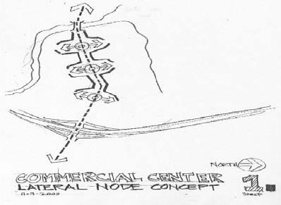
This alternative is intended to focus new pedestrian- oriented commercial development at three nodes along Sixth Street in the downtown area. The nodes are likely to include Switzler Street, I Street, and E Street. The basic nodal concept emphasizes development and pedestrian improvements perpendicular to the highway along the side streets. These streets offer a better, quieter, more pedestrian- friendly environment for people walking or sitting downtown. They also provide linkages to the surrounding residential areas.
9.2.334(2) Alternative 1A. Commercial Center - Lateral/Civic Center Node Concept
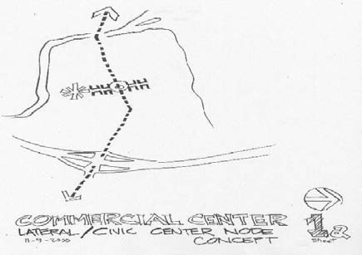
Alternative 1a is a variation of Alternative 1, but all development is focused on a single node at I Street. This alternative includes the idea of building a new civic center as part of the node. The civic center would include a new city hall and library and would anchor the southern end of the node to the south of Seventh Street. This concentration of activity would help encourage new storefront development along I Street to create a high-quality pedestrian environment perpendicular to the highway. Under this
alternative, I Street would become an active gathering place that could be closed at certain times to accommodate events such as a city art fair. This illustration is shown below in Figure 9.2-5.

Figure 9.2-5 City Art Fair Concept with Alternative 1A
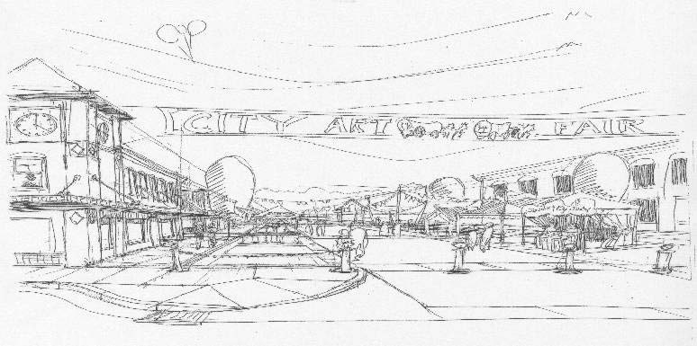

9.2.334(3) Alternative 1B. Commercial Center
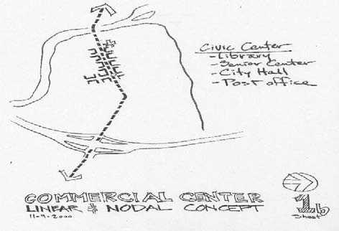
- Linear and Nodal Concept
Alternative 1b builds on the ideas included in Alternatives 1 and 1a. It emphasizes creation of a pedestrian-friendly shopping area along I Street perpendicular to the highway, but it also emphasizes pedestrian-oriented development between I Street and E Street to take advantage of existing commercial buildings along Sixth Street. The two most distinctive commercial buildings on Sixth Street are the MOR Theater at E Street and the
Wards building at I Street. This alternative links the two buildings by encouraging additional development on underdeveloped lots along Sixth Street. The concept is intended to concentrate pedestrian-oriented retail development along a corridor no greater than 1,000 feet in length. The length is critical, because typically shoppers will not walk more than 1,000 feet. Creating a concentration of activity is important if the area is to be a successful pedestrian district. Another feature of this alternative is the location of a new civic center along Sixth Street at the E Street
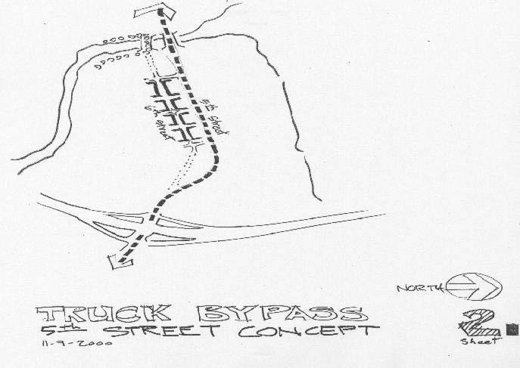
intersection. Figure 9.2-6 illustrates a new civic center concept with Alternative 1b.

9.2.334(4) Alternative 2. Truck Bypass – Fifth Street Concept
Under Alternative 2, highway traffic would be rerouted along Fifth Street crossing the Umatilla River at a new bridge. The old bridge would continue to provide a pedestrian connection. Downtown development could be enhanced and concentrated by removing the noisy truck traffic from Sixth Street.
Pedestrian-oriented commercial activity would be concentrated to an approximately 1,000-foot- long area along Sixth Street between I Street and E Street.

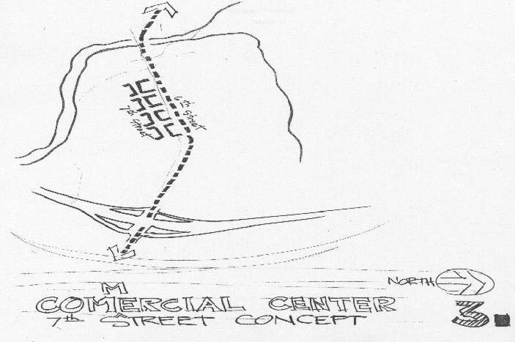
9.2.334(5) Alternative 3. Commercial Center Concept - Seventh Street Concept
Alternative 3 would maintain Sixth Street as an auto-oriented corridor and concentrate pedestrian-focused commercial uses along Seventh Street. This concept was mentioned at previous meetings.

Figure 9.2-6 City Square Concept with Alternative 1B
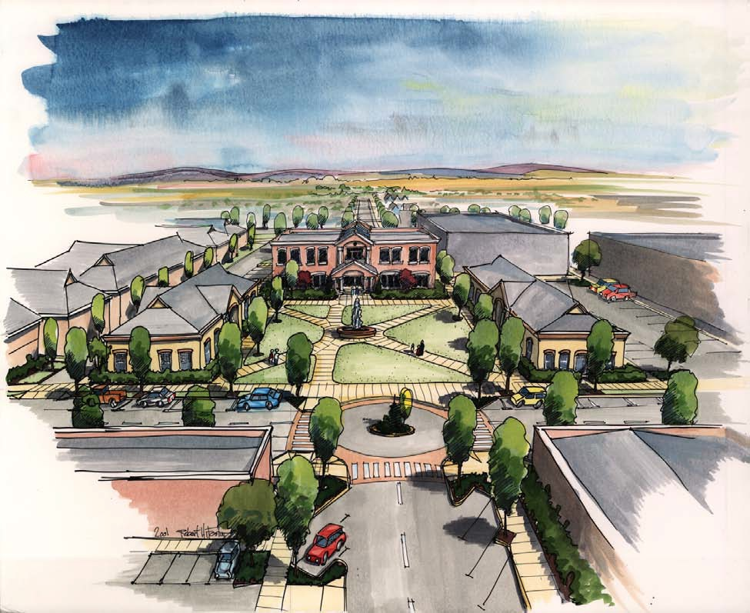

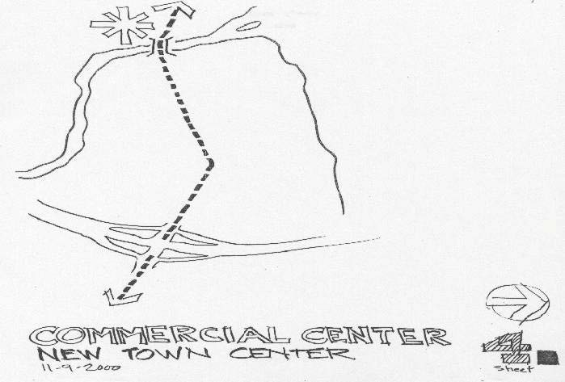
9.2.334(6) Alternative 4. Commercial Center - New Town Center
Like Alternative 3, Alternative 4 would maintain Sixth Street as an auto-oriented corridor. This concept proposes a new pedestrian-oriented town center at a new site west of the Umatilla River.

    - Workshop Activity - Prioritize Alternatives
Following the presentation of the alternatives, workshop participants were given one adhesive dot to vote for their preferred alternative. A second adhesive dot was provided so participants could vote to locate a new civic center. A limited number of participants voted, but of those that did, Alternative 1b was the preferred alternative and I Street was the preferred location for a new civic center.

    - Pedestrian and Streetscape Improvements
In addition to alternatives, workshop activities focused on pedestrian and streetscape improvements that could be implemented along Sixth Street. Diagrams were used with aerial photographs to identify potential locations for new bulb-out pedestrian crossings, textured crosswalks, medians, and street trees. Figure 9.2-7 illustrates these diagrams. Participants were generally supportive of all concepts.

    - Land Use Districts
New land use districts were identified for the downtown. A key element of the district concept is the downtown core area that extends from D Street to I Street. In the downtown core, pedestrian-oriented retail and service development would be encouraged, and auto-oriented uses would be discouraged. To the east and west of the downtown core along the highway, a “downtown transition district” would be formed that would allow some auto-oriented commercial uses. Flanking the downtown would be districts that would allow higher density housing. New housing in the downtown can help enliven the area and bring more customers to retail businesses. Figure 9.2-8 shows the land use district map described above.

    - Conclusion
The two-day charrette and workshop process produced a wealth of ideas for the downtown. These ranged from large-scale projects, such as a science museum, to simple projects, such as improved flower boxes. The key to success for Umatilla will be to identify projects and programs that are realistic and can truly be implemented, given the financial capability of the community. A concept plan was developed after the downtown workshop. This concept plan is shown in Figure 9.2-9.
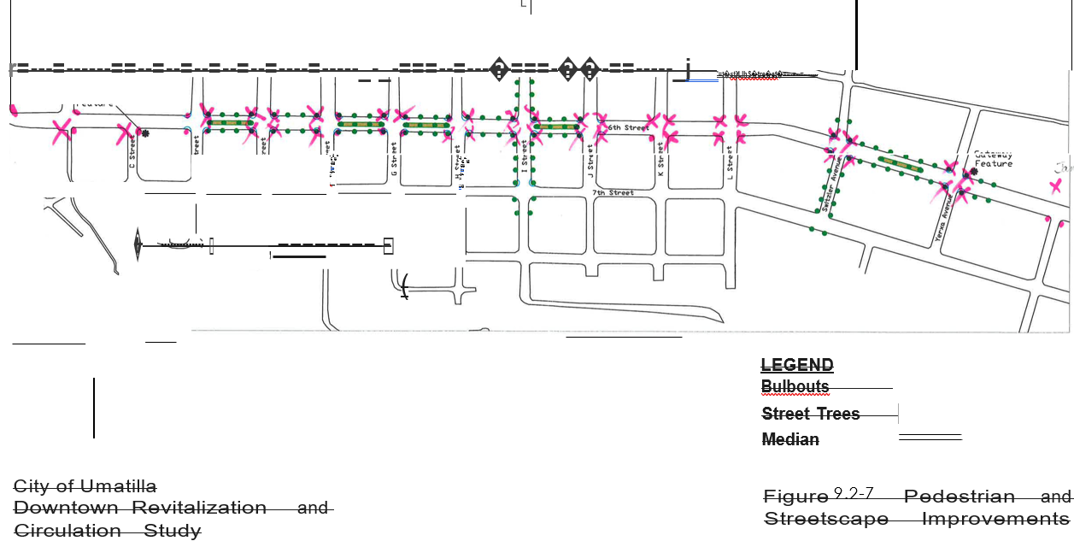
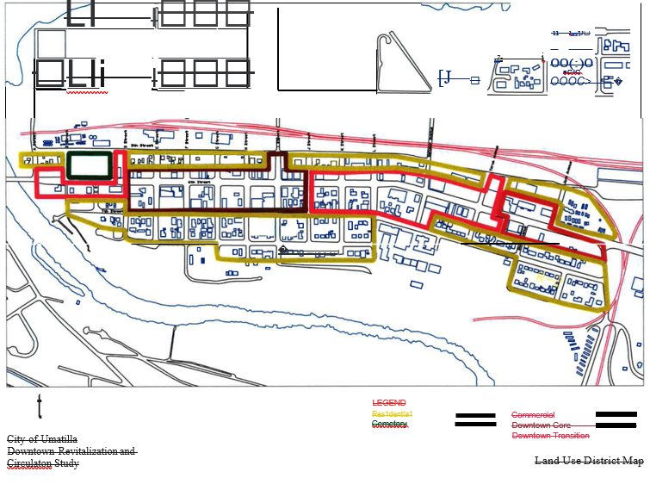
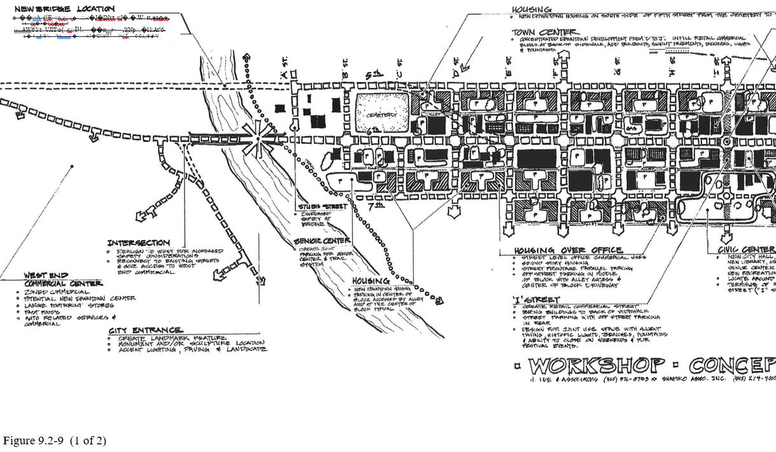
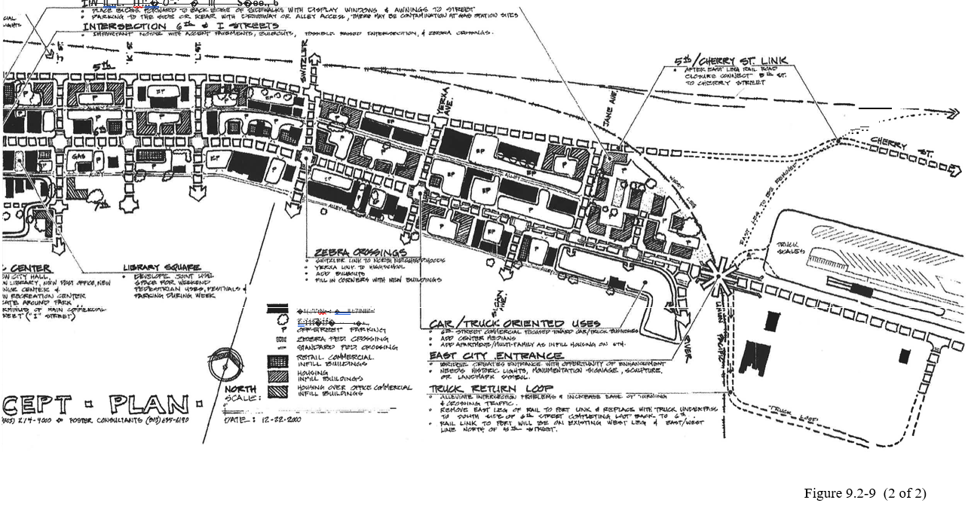
9.2.400 Downtown Revitalization Plan
The purpose of the project is to create a strategic plan for the revitalization of the downtown core area of the City. The plan is intended to enable the community to benefit from an improved and efficient transportation system and redevelopment of the downtown core area as a vital, pedestrian-oriented center.

Objectives of the Downtown Revitalization Plan are to:
Create incentives for businesses to locate in the core area of the City;
Create a pleasant pedestrian experience in the core area;
Identify streetscape improvements that will enhance the character of the City, including sidewalk treatments and lighting.
Mitigate the effects of truck traffic along U.S. Route 730; and
Identify redevelopment opportunities.

The greatest challenge for the City is to find a way to attract significant private investment in the downtown over a long period of time. The revitalization plan is a blueprint to achieve this goal.

One of the guiding principles of the Downtown Revitalization Plan is to concentrate redevelopment efforts. A key problem with the existing pattern of development is that it is scattered over a large area. By first focusing the community’s efforts on a small area, the City can later expand the area of focus to other locations throughout downtown. The intent of concentrating redevelopment efforts is to achieve a critical mass of business activity and investment that will trigger a cycle of economic growth.

Commercial opportunities are often present at intersections that have high rates of flow of either vehicles or pedestrians. The intersection of U.S. Route 730 and Interstate 82 is the primary vehicular intersection in the City. During the planning workshop, members of the community identified the primary pedestrian intersection in downtown as the junction of 6th Street (U.S. Route 730) and I Street. The Downtown Revitalization Plan recommends that the City focus on the potential of the 6th Street/I Street intersection. The US Route 730 and Interstate 82 intersection improvements are a part of the Interchange Refinement report that is a separate report.

Public improvements and redevelopment can help attract new businesses. Because downtown Umatilla lacks sufficient investment to attract other commercial activities, the City should commit public resources to improvements and redevelopment that make the downtown a viable and attractive location for businesses. In addition to investing in civic improvements, the City should also attempt to concentrate jobs, commercial activities, and housing in the downtown.

9.2.410 Redevelopment Opportunities
This section presents a summary of redevelopment opportunities envisioned to help revitalize downtown Umatilla. Together, these opportunities establish a conceptual framework for redevelopment that is consistent with the vision and goals of the community identified during the planning process.

9.2.410(1) Town Center
Town Center is envisioned as a pedestrian friendly district. To help concentrate future development and make the area pedestrian friendly, a 1,000-foot distance was used create alternative development concepts for downtown Umatilla. This is a comfortable walking distance for most pedestrians.

The Downtown Revitalization Plan proposes that future development be concentrated along 6th Street between E and J streets. Town Center also would extend along I Street one block to the north of 6th Street and along I Street to the south; a site for a proposed Civic Center. Retail and commercial infill projects would be the most desirable type of development for Town Center. New structures would typically include commercial storefronts that abut the sidewalk.

Pedestrian and streetscape improvement projects, including street furnishings such as benches, lights and fountains, would be focused in the Town Center. To improve the pedestrian environment, sidewalk bulb-outs would be added at critical intersections along 6th Street, as well as crosswalks and accent pavements.

9.2.410(2) Intersection of 6th and I Streets
The Downtown Revitalization Plan identifies the intersection of 6th and I streets as potentially the strongest pedestrian node within the community. The intersection is the commercial center for the downtown area because 6th Street is the primary vehicular route through town and I Street is considered to have the greatest potential as a pedestrian-oriented cross street. Improvements to this intersection would include accent pavement, benches, and possibly a raised intersection with pedestrian crossings designated with wide crossing strips.

Two infill sites are adjacent to this intersection, one on the northwest corner, the other on the southwest corner. An underutilized property also is identified at the southeast corner of the intersection. As the revitalization plan is implemented, redevelopment of these properties is likely. New structures at these locations should follow the commercial storefront model by building to the edge of the sidewalks and having facades orienting toward both 6th and I streets, including display windows and awnings.

Figure 9.2-10 illustrates a vision of what 6th Street east of I Street could look like with the improvements described above.

Figure 9.2-10 6th Street Future Concept with Streetscape and Building Improvements

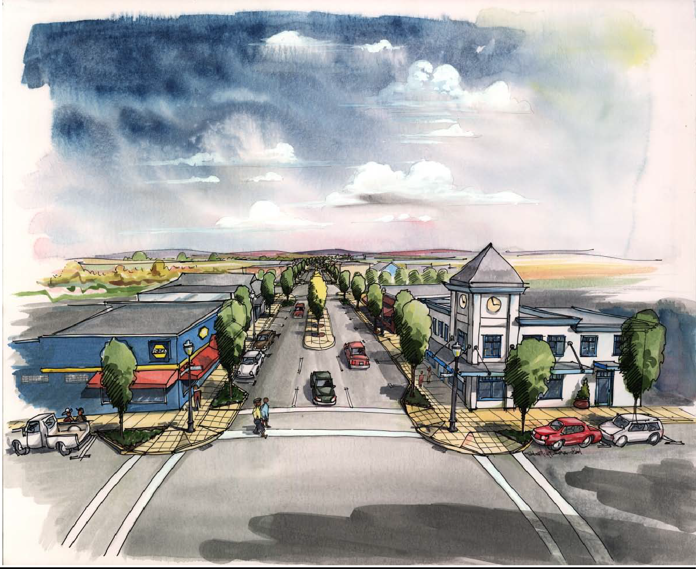

9.2.410(3) I Street
Participants at the community workshops identified I Street as a likely place for a pedestrian center. I Street should be redeveloped as a commercial street strongly oriented to pedestrians. Commercial storefronts would abut the sidewalk. Street parking can be supplemented by off- street parking located behind buildings that face I Street. The street would be designed for both vehicle and pedestrian use by using accent paving, historic lights, benches and fountains. As a pedestrian street, I Street could be closed to vehicular traffic for special events or festivals.

9.2.410(4) MOR Theatre
One of the most significant buildings located in downtown is the MOR Theatre. While some community participants commented on the building’s poor appearance, others suggested that the theatre was worth keeping. Renovation of the building may serve both of these ends. Figure 9.2-11 illustrates how the exterior of the building might look after a major renovation. It should be noted that building renovation is typically more expensive than new construction. Major renovation of existing structures may not be economically viable until the revitalization of downtown is well underway.

9.2.410(5) First Interstate Bank Building
The First Interstate Bank building, which now houses the school district offices, is of relatively new construction. The building is a utilitarian structure that lacks the detail and architectural character that are appropriate for a pedestrian-oriented downtown. Figure 9.2-12 shows a sketch illustrating how architectural detailing applied to the building’s exterior might enhance its appeal to pedestrians in a manner suitable for its downtown location.

9.2.410(6) Civic Center
To anchor I Street as the primary pedestrian axis, the plan envisions a Civic Center located at the intersection of 7th and I Streets. This complex of buildings would include a new city hall, library, post office, senior center, and recreation center. The plan presents two options for development of the Civic Center. One concept closes 7th Street west of the intersection of I Street and creates a Civic Center complex with new buildings oriented toward a park. Option 1 is illustrated in Figure 9.2-13. The second concept closes I Street immediately south of 7th Street and centers the Civic Center complex and park on the axis of I Street. Option 2 is illustrated in Figure 9.2-14.

9.2.410(7) Library Square
The plan identifies an open space located between the library and 6th Street that might become an attractive pedestrian gathering place. The plan proposes that this space be developed as a joint- use space that allows parking during the week, but is available for pedestrian use on weekends. The Library Square project would likely reduce the number of existing parking spaces, planting shade trees and landscaping, and street furnishings such as benches, streetlights, and bollards. Figure 9.2-15 shows an improvement concept for the existing library parking lot where the area is accented with a archway façade and pedestrian plaza.
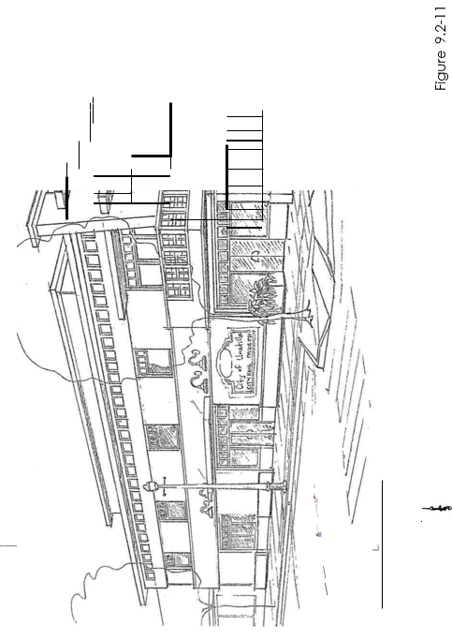

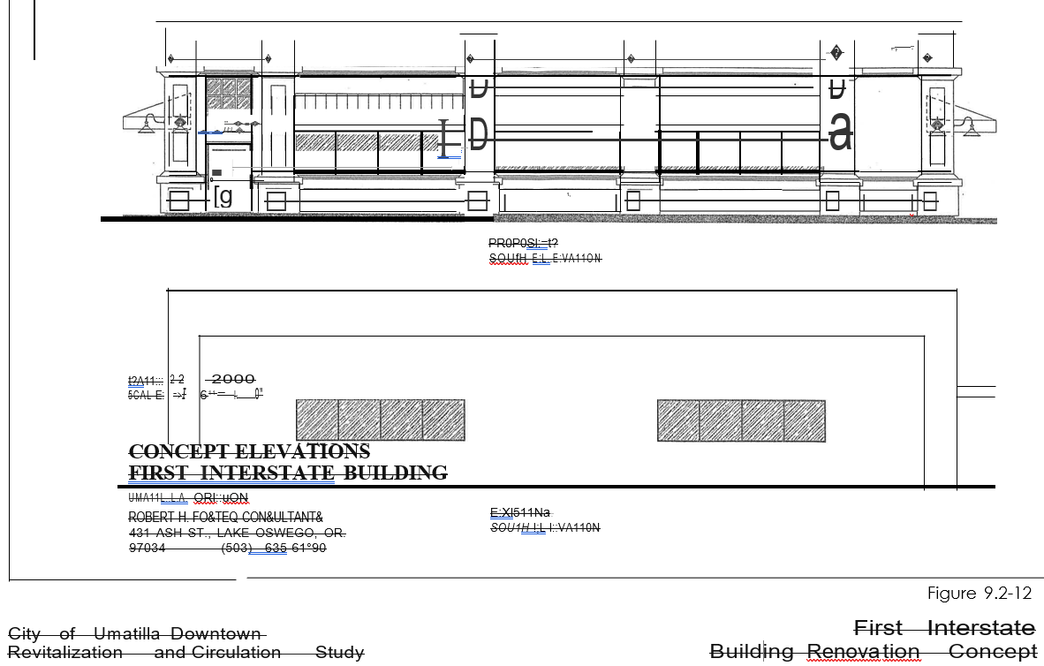

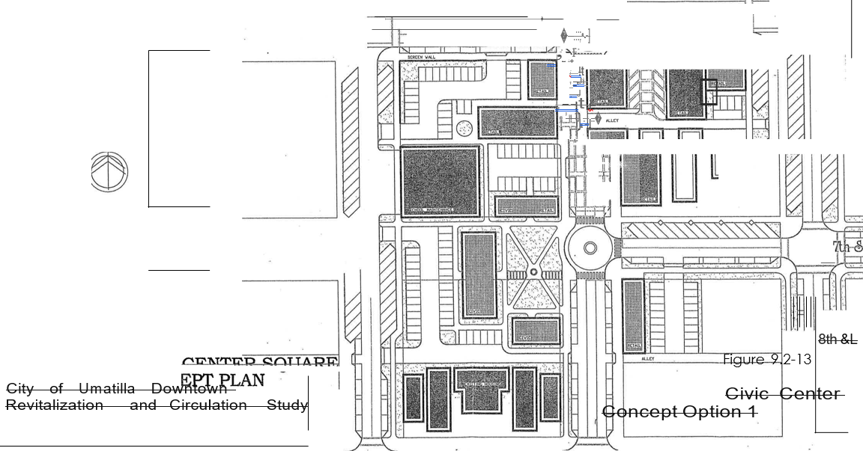

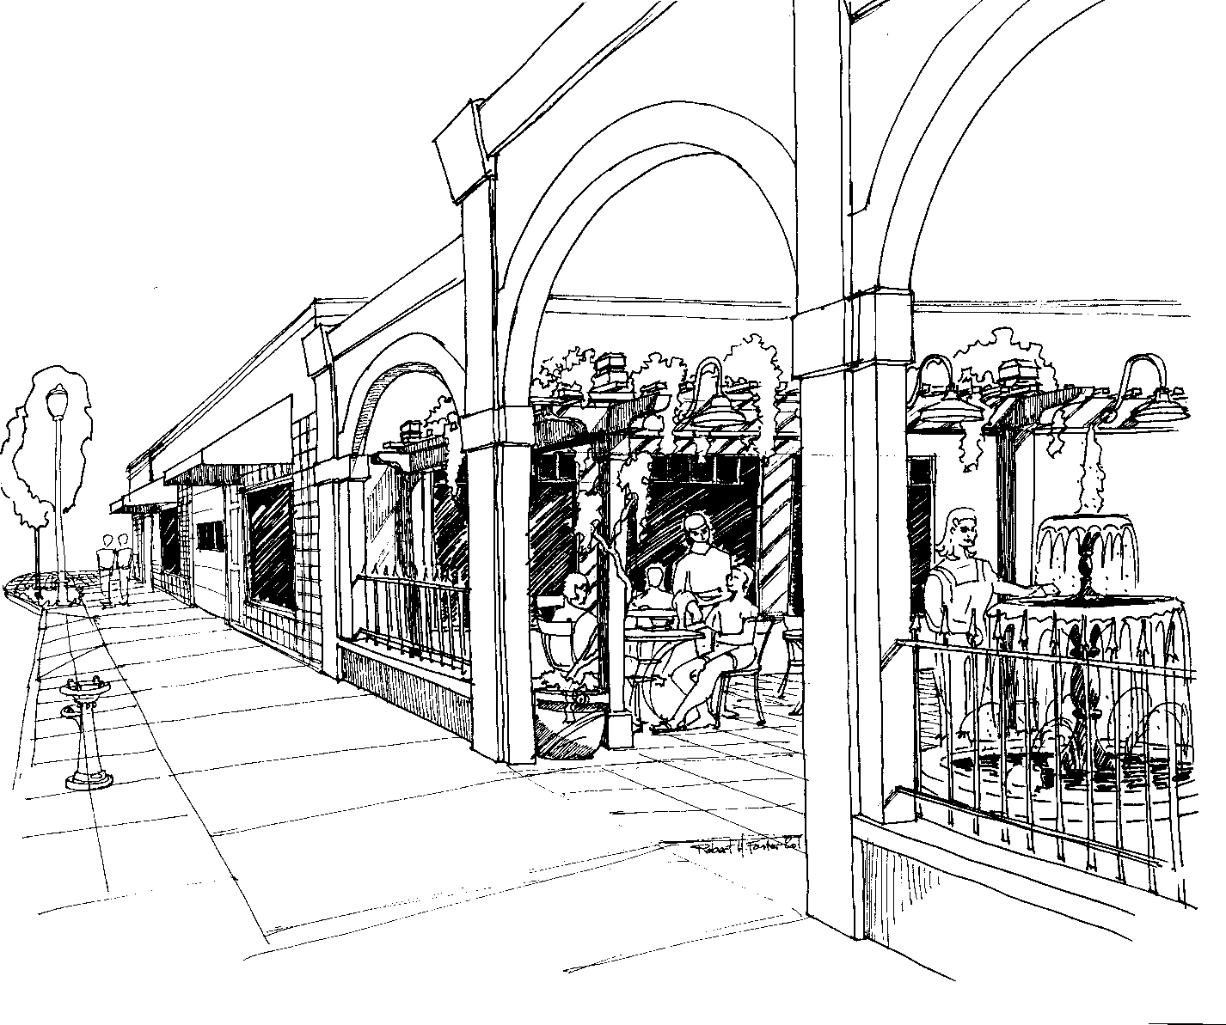
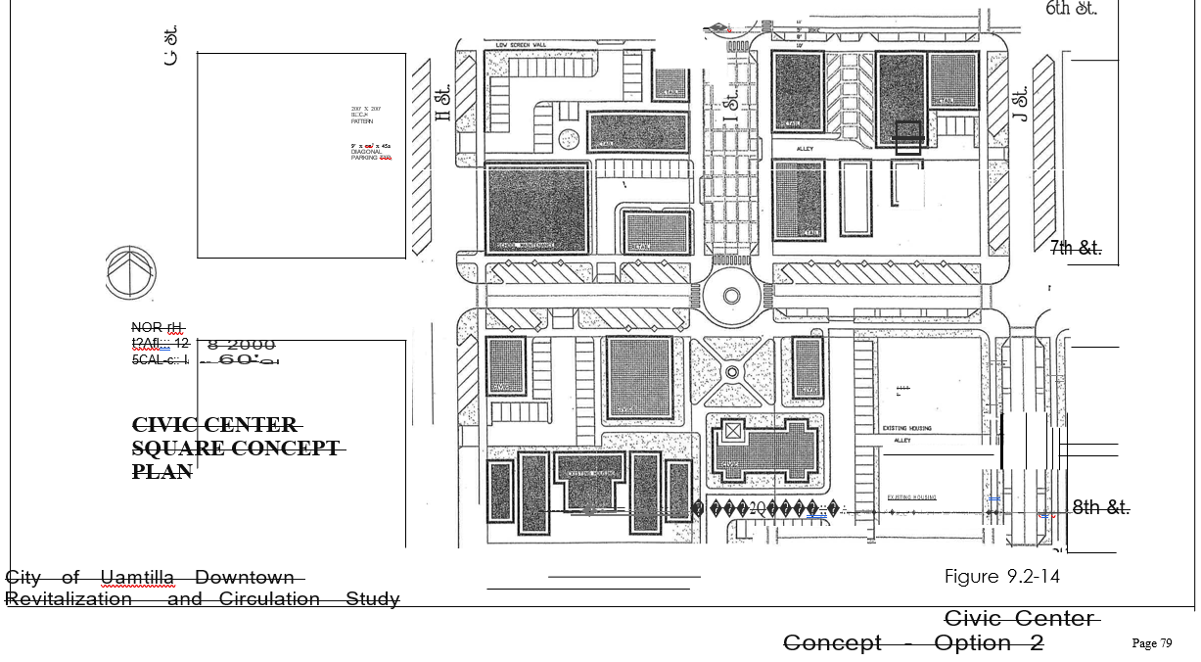

Figure 9.2-15. Library Plaza Concept with Archway Façade

9.2.410(8) Downtown Residential
Creating residential housing opportunities downtown will help the City establish a stronger downtown neighborhood. New residents will build a market for new downtown businesses. Downtown housing development should be oriented toward the street with parking in the center of the block. Access to center block parking lots would be by alleys running east to west between the numbered streets. New housing development would be encouraged to follow this typical pattern of development.

9.2.410(9) Downtown Mixed-Use
The Downtown Revitalization Plan proposes a new development pattern for downtown Umatilla that combines office and residential uses. This new pattern would allow office and commercial uses at street level with housing on the second floor or behind the storefront. Parking would be available on the street with off-street parking located in the middle of the block. Access to mid- block parking would be by alleys running east to west between the numbered streets and driveways located at the center of the block.

This mixed-use development concept is illustrated with typical plan and section drawings in Figure 9.2-16. The plan and section drawings illustrate how retail or office space might be located on the first floor with housing on the second floor. The drawings also illustrate how off- street parking can be included in this type of development.

9.2.410(10) Auto-Oriented Commercial
A portion of the east side of downtown Umatilla is suitable for car- and truck-oriented uses. The plan proposes that truck- and car-oriented uses be located along 6th Street from a point west of the intersection of Yerxa Avenue running east to the Union Pacific Railroad bridge. Given that this location is near the Port of Entry and the Interstate 82 interchange, it provides an opportunity for commercial development in this area.

9.2.420 Streetscape and Pedestrian Improvements
This section describes streetscape and pedestrian improvements that are a part of the Downtown Revitalization Plan. Sketches were developed to depict streetscape design elements, based on “typical” conditions. Recommended improvements have been broken down into illustrative projects, which include estimated project costs the City can use for the purposes of planning.

9.2.421 Design Elements
To develop a schematic streetscape plan, it was assumed that a typical block measured 200 feet by 200 feet and that the typical street right of way measured 80 feet in width, with streets measuring 60 feet from curb to curb. The existing 6th Street cross section is illustrated in Figure 9.2-17. The section view shows an 8-foot-wide parking lane on both sides of the street, one 15-foot-wide travel lane in each direction and a 14-foot-wide center turning lane.

The proposed 6th Street cross section design reduces the width of the travel lanes and adds center medians to slow traffic. Bike lanes have also been designated. The proposed 6th Street section, see Figure 9.2-18, shows a 7–foot-wide parking lane on both sides of the street, one 6-foot-wide
bike lane in each direction, one 11-foot-wide travel lane in each direction, and a 12-foot-wide center turning lane or median.

A concept plan was developed for the 6th and I Streets intersection. I Street should become the City’s “Pedestrian Street.” Sixth Street is already considered to be the City’s “Main Street.” The concept plan shows curb extensions and crosswalks, 10-foot-wide sidewalks along 6th Street, and 14-foot-wide sidewalks along I Street. Each curb extension depicts ramps to meet requirements of the American’s with Disabilities Act (ADA) and planting areas for landscape plants or trees. The concept plan also depicts concrete scoring patterns used on the paving surface. The 6th Street and I Street intersection concept plan is shown in Figure 9.2-19.

A “typical” sidewalk pavement sketch in Figure 9.2-20 illustrates the sidewalk design proposed for new improvement projects. The sketch depicts a sidewalk that varies from 8- to 10-feet wide, curb and gutter, street trees, and parking. A second sketch shown in Figure 9.2-21 illustrates the need for added width to include streetscape furnishings and other amenities. This sketch defines a 4-foot wide furniture zone adjacent to the curb where street trees, lights, signage, benches, trashcans, and drinking fountains should be located. The sketch also shows how storefront awnings (from 4- to 6-feet-wide) can make the street more attractive to pedestrians.

A new proposed local side street cross section in the downtown core area is shown in Figure 5-
13. This cross section shows angle parking on both sides of the roadway and two travel lanes within a pavement width of 64 feet and 80-foot right of way. The angle parking lanes each take 20 feet and the two travel lanes are 12 feet each. The remaining right of way is comprised of 6 foot sidewalks. An additional two feet of right-of-way is available for utilities behind the sidewalks on each side of the street.

9.2.422 Illustrative Improvement Projects
Using the design concepts described above, a list of illustrative improvement projects was developed to help the City budget and plan for implementation of the pedestrian and streetscape improvements (see the Pedestrian and Streetscape Improvement Plan, Figure 9.2-7). Recognizing that financial resources to implement the improvements might be limited, a large number of small projects were created. The series of cost estimates for typical improvements were used to develop the costs for illustrative improvement projects. The cost estimates are intended to be used by the City for planning and budgeting purposes and are not intended to reflect the actual cost of the improvements. A sequence of small projects allows the City greater flexibility in implementing the improvements. If financial resources are limited, fewer projects can be implemented. If funding is readily available, then the improvement schedule can be accelerated.

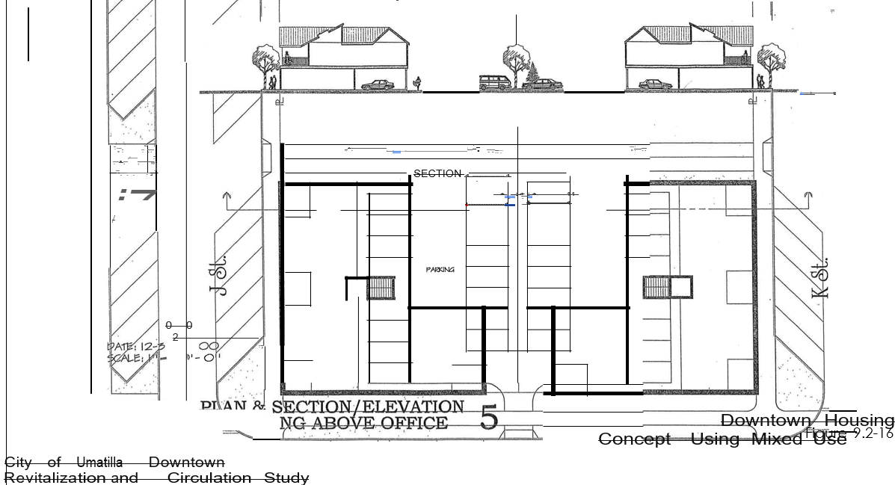
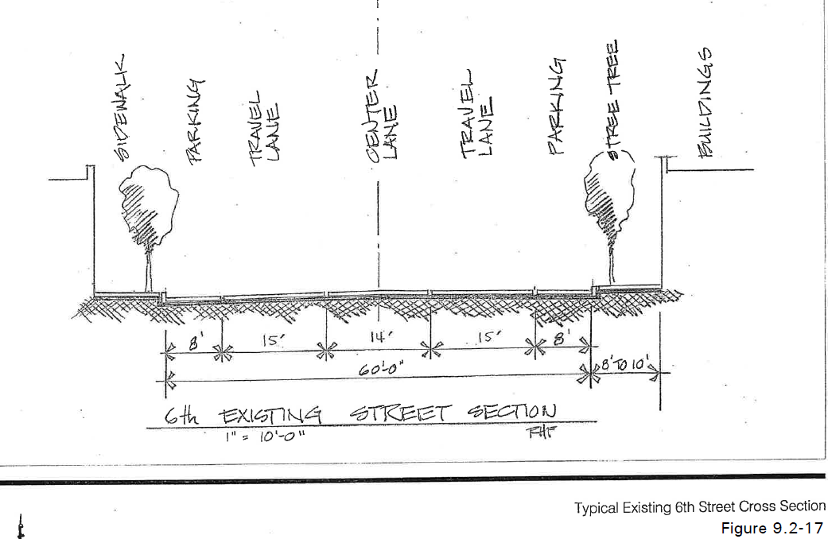
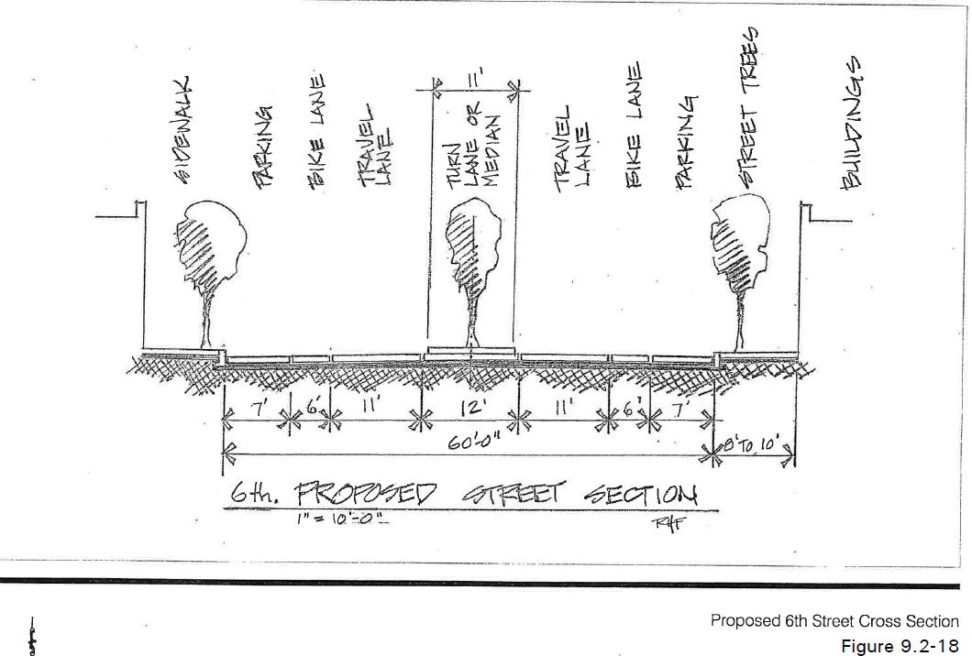
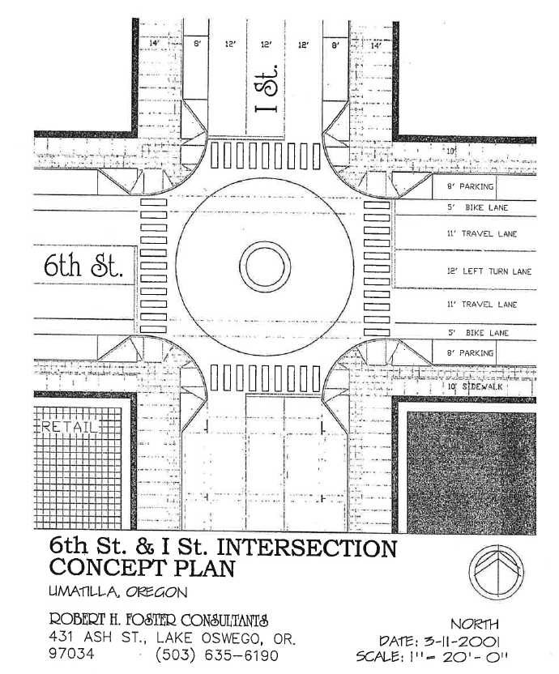
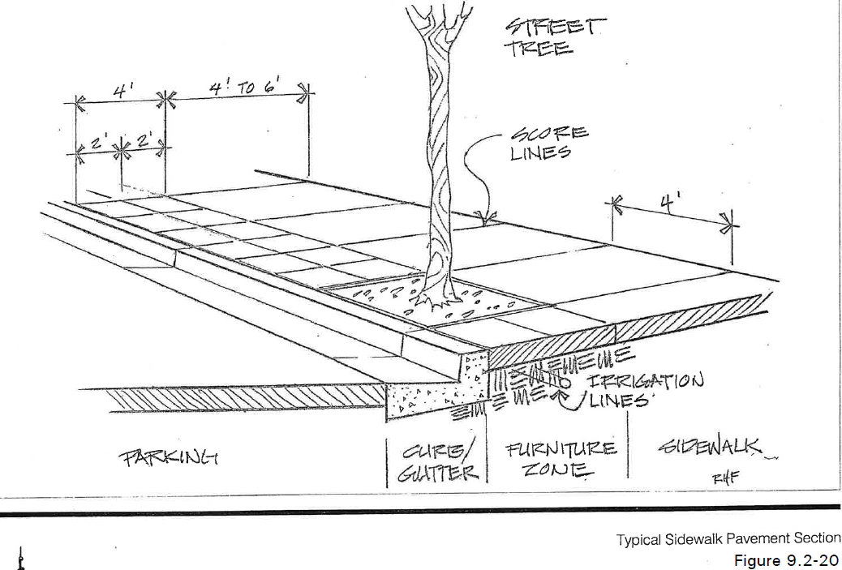

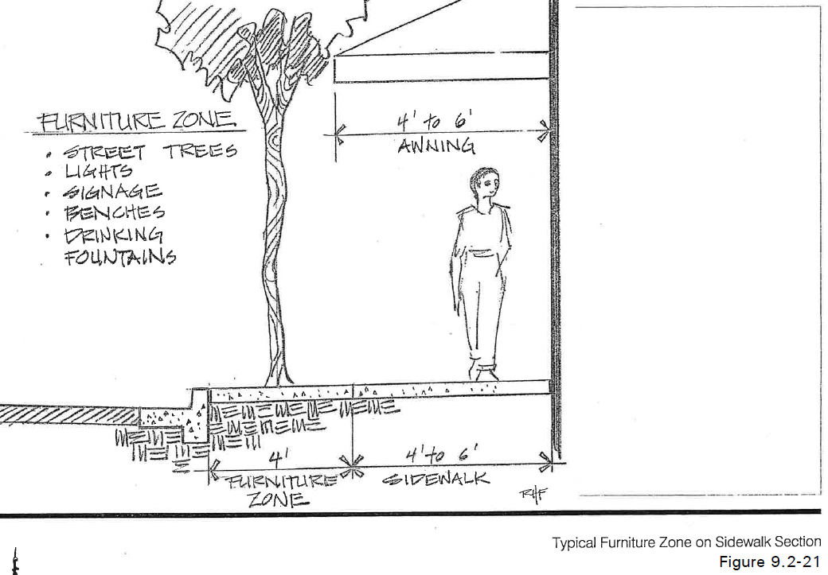

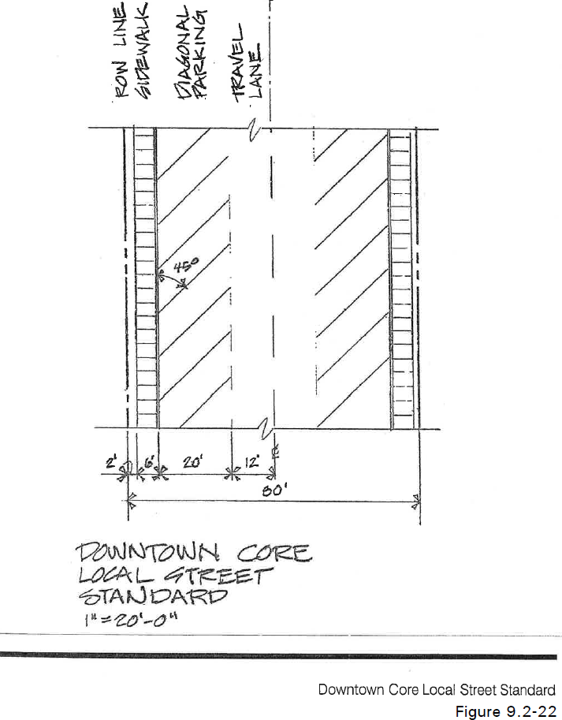

Unit costs used to prepare the estimates are summarized in Table 9.2-9. Many of the items listed area available in a range of different prices. For example, the sample prices for tree grates ranged from $100 to $275 per grate. Sample street lights prices ranged between $1,700 to
$3,000 per light. Median prices are shown in the table below and are adjusted to include installation.

Table 9.2-9. Unit Costs of Improvement Project Items

ITEM | UNIT | COST/UNIT
Demolition | SF | $1.00
Curbs | LF | $15.00
Street Patching | SF | $6.00
Trenching | LF | $15.00
Sidewalk | SF | $7.00
Trees | EA | $500.00
Tree Grates | EA | $190.00
Irrigation (drip system) | LF | TBD
Landscaping | SF | $5.00
Planters (trough) | EA | $600.00
Street Lights | EA | $2,250.00
Trash Cans | EA | $750.00
Bench | EA | $1,000.00
Drinking Fountain | EA | $3,000.00
Bike Rack | EA | $500.00
Painted Crosswalk | SF | $1.00
Concrete Crosswalk | SF | $8.00

Table 9.2-10 summarizes the improvement projects by phase and estimated total cost. The Streetscape and Pedestrian Improvements Phasing Plan in Figure 9.2-23 illustrates how the projects might be implemented through a sequence of many projects.

Table 9.2-10. Streetscape Improvement Projects by Phase

Project Name/Phase | Estimated Total Cost
Phase 1 Projects
Intersection at 6th and I Streets with Curb Extensions | $65,000
Intersection at 6th and H Streets with Curb Extensions | $61,000
Intersection at 6th and G Streets with Curb Extensions | $61,000
Subtotal | $187,000
Phase 2 Projects
6th Street Sidewalks between H and I Streets | $106,000
6th Street Sidewalks between G and H Streets | $106,000
6th Street Median between G and H Streets | $30,000
Subtotal | $242,000
Phase 3 Projects
6th Street Median between I and J Streets | $30,000
Intersection at 6th and J Streets with Curb Extensions | $57,000
6th Street Sidewalks between I and J Streets | $106,000
Subtotal | $193,000
Phase 4 Projects
I Street Sidewalks between 6th and 7th Streets | $133,000
I Street Sidewalks between 5th and 6th Streets | $133,000
South of Intersection at Corner of 5th and I Street | $66,500
Subtotal | $332,500
Phase 5 Projects
6th Street Median between F and G Streets | $30,000
Intersection at 6th and F Streets with Curb Extensions | $61,000
6th Street Sidewalks between F and G Streets | $106,000
6th Street Sidewalks between E and F Streets | $106,000
Subtotal | $303,000

Table 9.2-10. Streetscape Improvement Projects by Phase (Continued)

Phase 6 Projects
Gateway Feature (West End) | $42,000
Intersection at 6th and E Streets with Curb Extensions | $61,000
Intersection at 6th and D Streets with Curb Extensions | $57,000
Subtotal | $160,000
Phase 7 Projects
6th Street Sidewalks between D and E Streets | $106,000
6th Street Median between D and E Streets | $30,000
Intersection at 7th and I Street (Special Condition) | $57,000
Sidewalks south of 7th and I Street Intersection | $66,500
Subtotal | $153,500
Phase 8 Projects
Intersection of 6th and Switzler Avenue | $61,000
Intersection of 6th and Yerxa Avenue | $61,000
Intersection of 7th and Switzler Avenue | $34,000
6th Street Sidewalks east of Yerxa Avenue | $106,000
Subtotal | $262,000
Phase 9 Projects
Sidewalks north of 6th Street and Switzler Avenue | $53,000
Sidewalks east of Intersection of 6th Street and Yerxa Avenue | $106,000
Subtotal | $159,000
Phase 10 Projects
6th Street Sidewalks between Switzler and Yerxa Avenues | $176,000
6th Street Median between Switzler and Yerxa Avenues | $30,000
Subtotal | $206,000
Phase 11 Projects
Switzler Avenue Sidewalks between 6th and 7th Streets | $102,000
Gateway Feature (East End) | $42,000
Subtotal | $144,000
Total Estimated Cost for all Phases | $2,395,000

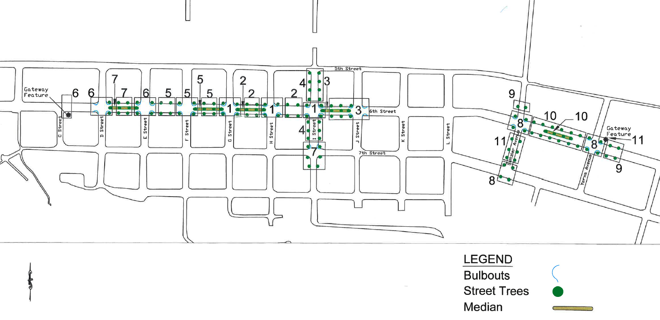
9.2.423 Improvement Descriptions 9.2.423(1) Switzler and Yerxa Avenues
Two intersections on the east side of downtown Umatilla should be improved: the intersection of 6th Street and Switzler Avenue, and the intersection of 6th Street and Yerxa Avenue. The intersection of 6th Street and Switzler Avenue is important because Switzler Avenue provides a link to the neighborhoods to the north. It is also a link to bicycle trail on 3rd Avenue. Figure 9.2-24 illustrates a park concept that could be constructed on the northwest corner of the 6th Street/Switzler Avenue intersection. The intersection of 6th Street and Yerxa Avenue is important because Yerxa Avenue offers a connection between the High School and commercial establishments on 6th Street. Improvements should include, sidewalk bulb outs, street trees, and striped pedestrian crossings.

9.2.423(2) West City Entrance
The City can define the entrance to the City by creating a monument, sculpture, or other type of landmark feature. The feature can be further enhanced using accent lighting, paving and landscape elements. The location of the entrance feature should be along 6th Street near the intersection of C Street. Figure 9.2-25 illustrates a gateway concept that could be implemented or the west city entrance.

9.2.423(3) East City Entrance
The bridge over the Union Pacific Railroad creates an entrance on the east side of the City. Adding a landmark or symbol can enhance this entrance. The landmark or symbol might take the form of a sculpture, monument, or sign. The entrance can be accented with historic lights. Figure 9.2-26 illustrates a gateway feature for the east city entrance.

9.2.423(4) Intersection of 6th and I Street
The plan envisions the corner of 6th and I Streets as the commercial center for the downtown area because 6th Street is the primary vehicular route through town, and I Street is considered to have the greatest potential as a pedestrian-oriented cross street. Improvements to this intersection would include accent pavement, benches, and possibly a raised intersection.

9.2.423(5) Close A Street Intersection
To increase safety at the Umatilla River Bridge it is recommended that the intersection of A Street and 6th Street be closed by creating a cul-de-sac or dead end at the south end of A Street.

9.2.423(6) Heritage Trail/Senior Center Parking
A new parking area is proposed to serve both users of the Lewis and Clark Heritage Trail and the Senior Center. The joint parking lot is to be located at the intersection of B and 7th Streets.

Figure 9.2-24 Park Concept at the Northwest Corner of 6th Street/Switzler Avenue
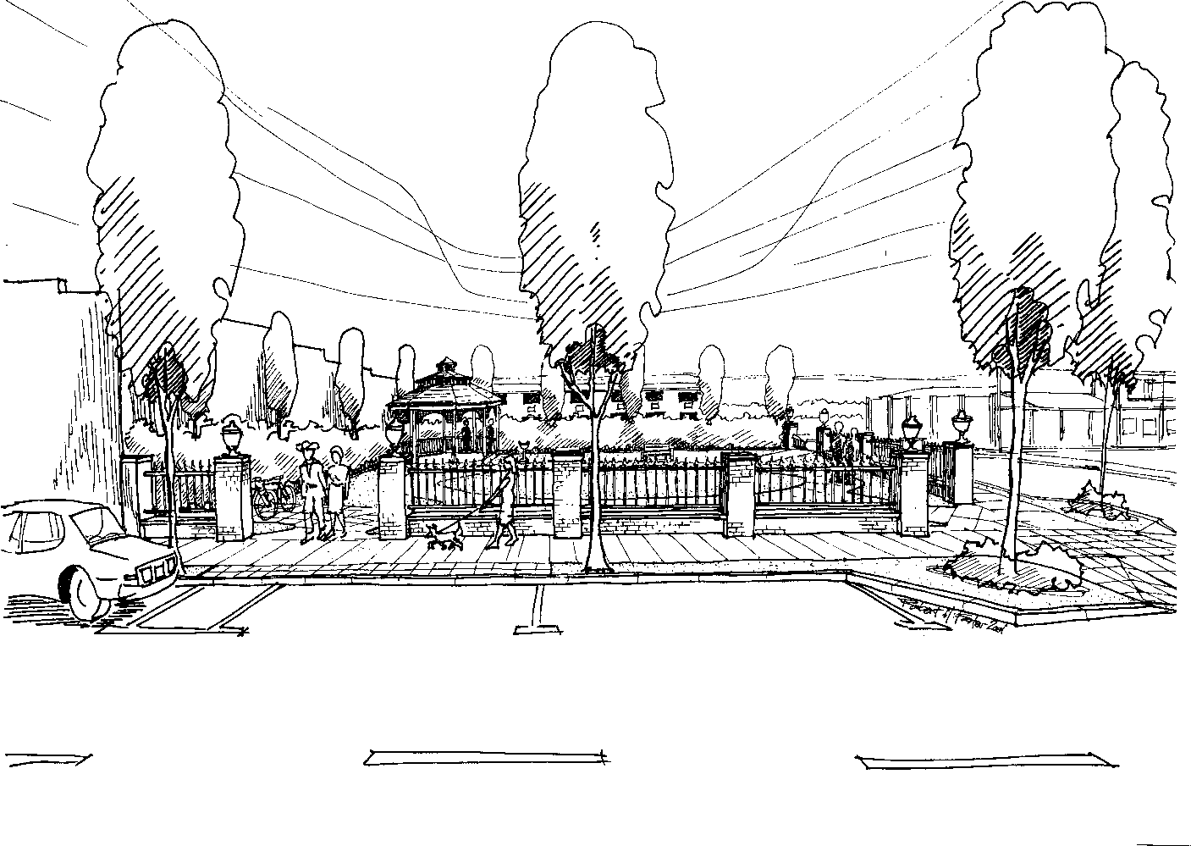

Figure 9.2-25 West City Entrance Gateway Feature
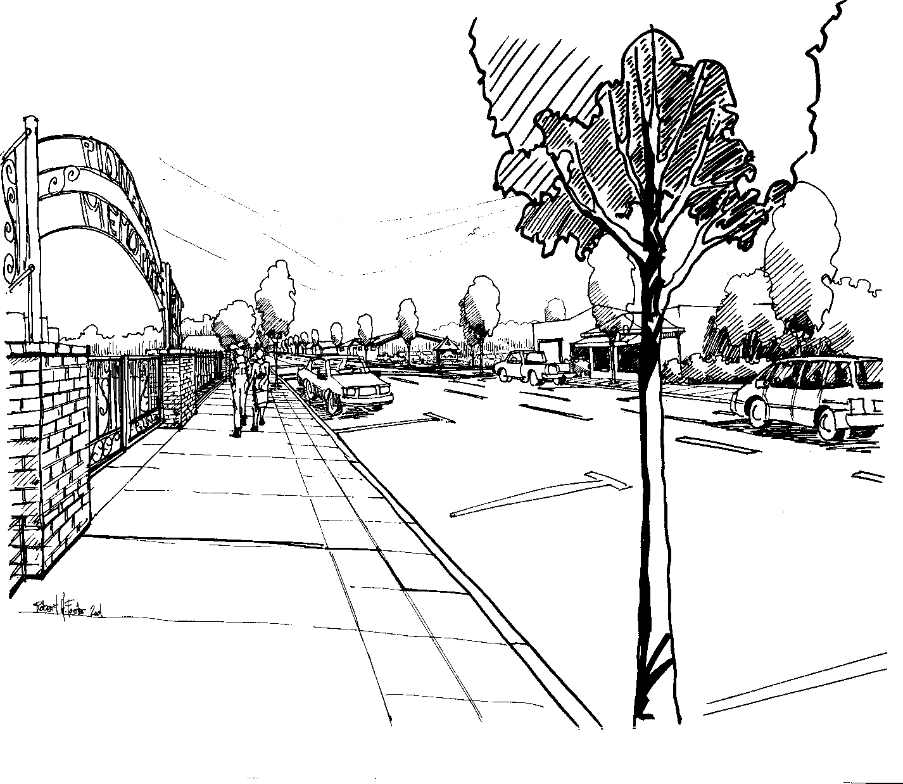

Figure 9.2-26 East City Entrance Gateway Feature
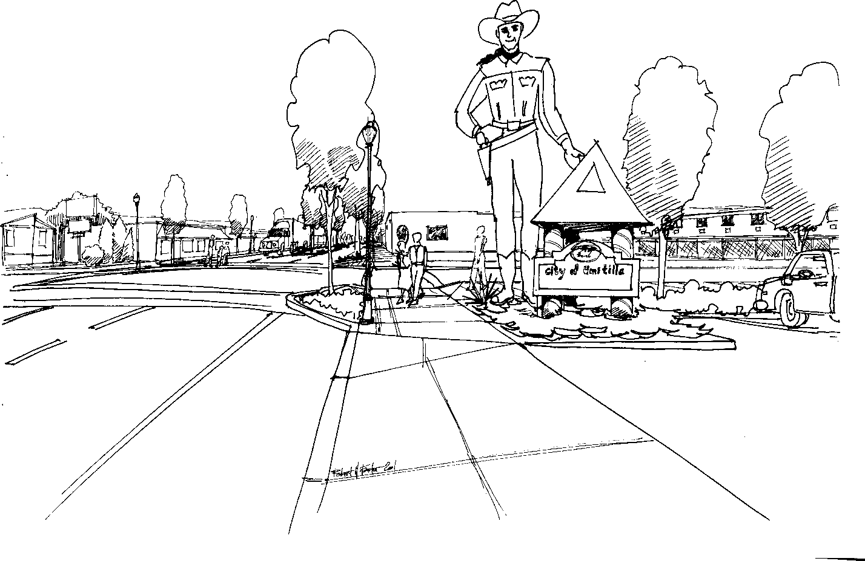

9.2.500 CIRCULATION PLAN
The circulation plan for the downtown study area is comprised of the following sections: functional classification, parking, street improvements, and access management. The supporting information used to create this information can be found in the Appendix. The majority of the supporting information can be found in the Opportunities and Constraints Report.

9.2.510 Functional Classification
The functional classification for the study area was taken from the 1999 City of Umatilla Transportation System Plan (TSP). In the study area, 6th Street (Highway 730) is the only major arterial. Five collectors exist in the study area. They are 7th Street from “B” Street to Umatilla River Road, “B” Street from 6th Street to 7th Street, “F” Street from 3rd Street to 7th Street, Switzler Avenue from 3rd Street to 7th Street, and 3rd Street. The remaining study area streets are local streets.

No streets are being proposed to be reclassified by this study. However, consideration should be given to create a pedestrian-oriented environment around “I” Street and portions of 6th Street within the downtown core area. This can be done by considering this area as a Special Transportation Area (STA).

9.2.511 Parking
The parking survey summarized in the Opportunities and Constraints report has documented that sufficient on-street parking exists on 6th Street to support the existing commercial uses.

Of the 160 on-street parking spaces along 6th Street between A Street and Jane Avenue, the peak usage occurred at 3:00 PM with only 23 spaces used. This is a maximum overall utilization of 14 percent. At the maximum overall parking utilization, 137 on-street parking spaces were available.

Based on the parking survey conducted, there seems to be more than sufficient parking supply for the immediate future. Should the City of Umatilla encounter parking problems in the distant future, a two tiered strategy could be implemented to meet any future demand. First, on-street parking spaces are not marked on the side streets. Additional spaces could be sought by striping parking spaces on the side streets. Conservatively, at least 100 spaces could be added from side street parking. Considerably more side street parking spaces could be developed if the local street cross-section depicted in Figure 9.2-22 was implemented. Should the City of Umatilla add additional side street parking spaces, then it should consider installing curb, gutter, and storm drains at that time. The second strategy to add parking in the downtown area is to close one or two side streets between 6th and 7th Streets and develop surface street public parking lots. The closure of one or two side streets should not have a significant impact to traffic since the downtown area has a well developed grid system. There is a side street approximately every 200 hundred feet. The only consideration are to avoid closure of the collector side streets which include “B” Street, “F” Street, and Switzler Avenue and “I” Street which is the center of the downtown revitalization concept. Each side street block has a right-of-way dimension of 80 feet by 200 feet and could accommodate at least 30 new parking stalls.

9.2.512 TSP Street Improvements
There are no roadway improvement projects planned in Umatilla’s Transportation System Plan (TSP) for the study area. However, based on discussions with ODOT, the Umatilla River Bridge may be rebuilt in the next five or six years. Should this occur, the City of Umatilla would like to consider a new alignment for the bridge. The new alignment would cross the Umatilla River at 5th Street. Highway 730 would be re-aligned with 6th Street between “C” Street and “E” Street to the east. To the west, Highway 730 would be re-aligned to the current highway alignment west of Powerline Road. Powerline Road could then be re-aligned to the new highway alignment further west of the new bridge.

There are three traffic signal projects planned for the study area at the eastern and western boundaries of the study area. The three intersections identified in the TSP as needing signalization by 2017 are the Powerline Road/Highway 730, Umatilla River Road/Highway 730 (6th Street), and “J” Street/Highway 730 (fire signal) intersections.

Other than the streetscape plan and pedestrian improvements, no new street improvement project is proposed.

    - Median Improvements Created by the Downtown Revitalization Plan
In order to enhance the pedestrian friendliness, attractiveness and traffic calming along 6th Street, medians and bulb-outs are proposed. Medians narrow the area of pavement and may provide a refuge area for pedestrians. Bulb-outs create a perception of narrowing the street to the motorist. They are also used to make pedestrian crossings shorter, and therefore easier and safer. Both medians and bulb-outs narrow the area of pavement and travel lane widths providing a visual cue to the driver to slow down. When used in conjunction they can have a significant impact on travel speeds along the roadway. Figure 9.2-7 shows the proposed Pedestrian and Streetscape Improvements, which illustrate the proposed locations of medians and bulb-outs.

The proposed medians will eliminate left turn pockets along 6th Street the following locations:
- Westbound left at D Street
- Eastbound left at E Street
- Westbound left at F Street
- Eastbound left at G Street
- Westbound left at G Street
- Eastbound left at H Street
- Westbound left at I Street
- Eastbound left at J Street

Although the proposed medians may replace the left turn pocket in several locations along 6th Street, left turn movements would still be allowed. No turn restrictions are being proposed.
Even though a median is proposed between Switzler Avenue and Yerxa Avenue, left turn pockets along 6th Street have been retained to provide access to the local businesses including the
Red Apple grocery store. Bulb-outs along 6th Street are proposed at all intersections where medians are proposed.

Replacing the left turn pockets with the proposed medians is not expected to have a significant impact on left turns from 6th Street to side streets for several reasons. There are side streets approximately every 200 feet. This provides numerous opportunities to make left turns, thereby spreading the left turn volumes on several intersections. Also, left turn volumes do not constitute a large percentage of traffic along 6th Street between D Street and J Street (there are less than 5 percent of the traffic at 6th Street/Switzler Avenue).

The redevelopment along 7th Street between H Street and I Street is expected to close 7th Street in this section permanently. Since 7th Street will no longer provide a continuous alternative to 6th Street through Umatilla, little or no diversion is expected in through traffic from 6th Street to local streets.

It is estimated that the reductions in travel speeds on 6th Street will also increase delay on the side streets by approximately five (5) to ten (10) percent. In addition, round-the-block circulation should not be impeded by the proposed medians and bulb-outs.

    - Bulb-Out Design Detail
The intent of the proposed bulb-out detail is to provide a compact layout for pedestrian access beyond the existing curbs in the downtown area. Seventy-five percent of the corners have no catch basins, and runoff is primarily directed to the north and west following the slope of the existing ground and adjacent highway grade. A small tapered landscaped area would be provided on either side of handicap ramps, with these ramps faced in two directions, set out from the present curb line. The bulb-out design detail described above is shown in Figure 9.2-27.

Drainage would pass underneath this bulb-out following the current flow line of the existing curb, utilizing a combination of an open top metal grated trough behind the landscaped area to provide for ease of cleanout, connections between this trough and around the corner with a grated hatch into a 4-inch pipe, with the additional construction of a 12-inch wide concrete apron around the bulb-out to carry overflows in the event of plugging of the drainage trough or 4-inch diameter pipe.

Downtown Revitalization and Circulation Plan
Umatilla, Oregon

....................
u,, ..................... .
GRATED CLEAN-OUT

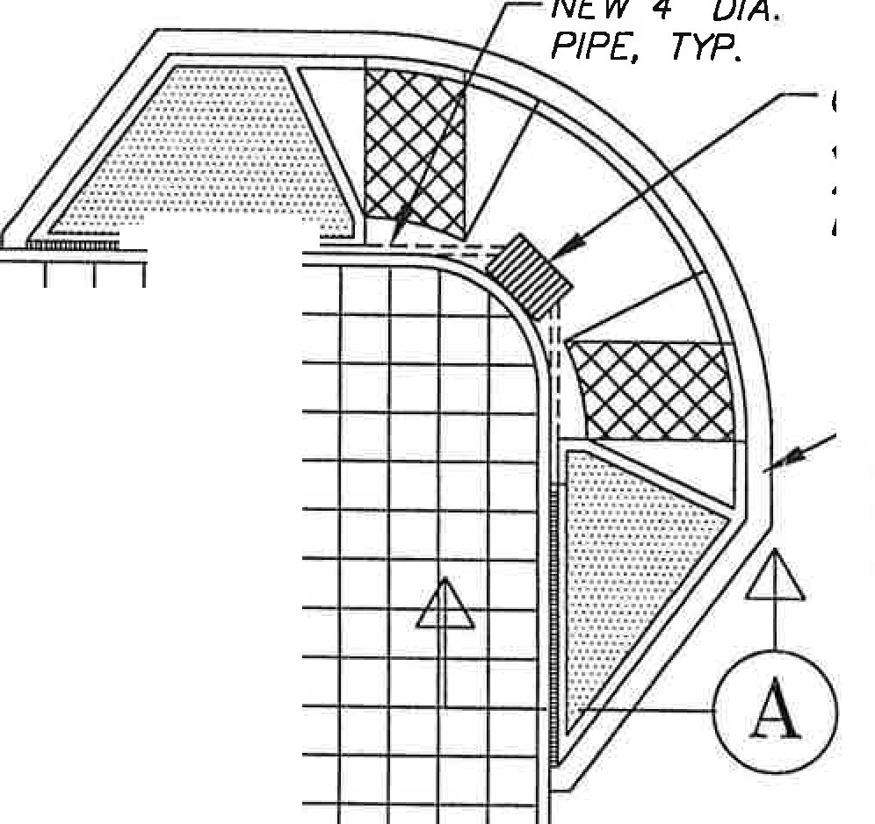

� T ALL CORNERS AND ABOVE CATCH BASINS, TYP.

CARRY 12" WIDE OVERFLOW CHANNEL AROUND BULB OUT

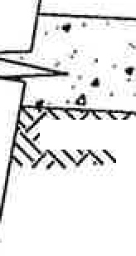
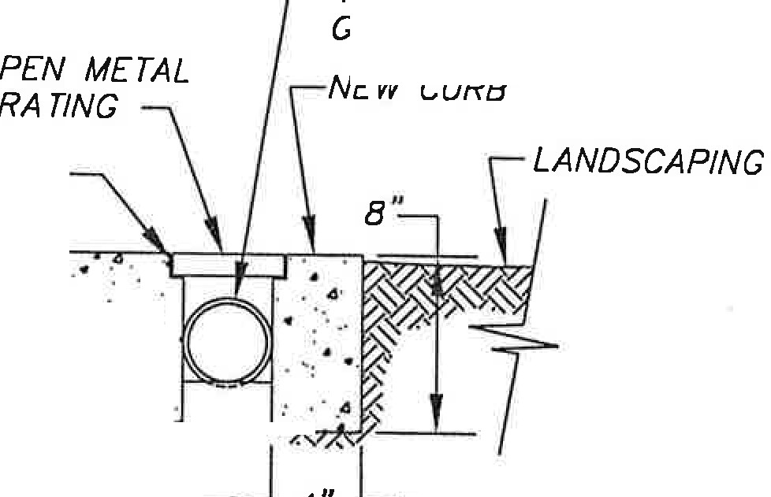

-- 4 --
4" PIPE BEYOND GRATING
SAW cur NOTCH
..
.
. .. .: -,·: . .
.. . . .
.
��=��...;..:J- •• .-
. ,
,,�
:. . .
.·..·.....
·:- •...
�I•
. ..
.
.
EXISTING
CURB
,,
4" -
� .

Bulb Out Design Standard Detail
Figure 9.2-27

400006.0
Page 101

    - Access Management
Appendix 9A-4 has a detailed discussion of Umatilla’s access management practice. The City’s TSP documents the access management standards. The only proposed change to those standards by this plan is to update the ODOT facility standards to meet the standards set in the recently adopted 1999 Oregon Highway Plan (OHP). Also, the Downtown Core and Downtown Transitional areas should be considered as a Special Transportation Area (STA).

    - Special Transportation Area Designation in Downtown Umatilla
Access management is important to promoting safe and efficient travel for both local and long distance users along State Highway 730 in the City of Umatilla. The 1999 Oregon Highway Plan specifies an access management spacing standards and policies for state facilities. Although the City of Umatilla may designate state highways as arterial roadways within their transportation system, access management for these facilities follows the Access Management Spacing Standards of the 1999 Oregon Highway Plan. These spacing standards are based on highway classification, type of area and speed, which are shown in the appendix to this document. This section describes the state highway access management objectives and specific highway segment where special access spacing standards apply.

Highway 730 through the City of Umatilla is categorized in the 1999 Oregon Highway Plan as a Regional Highway. The primary function of these highways is to provide connections and links to regional centers, Statewide or Interstate Highways, or economic or activity centers of regional significance. The management objective of Regional Highways is to provide safe and efficient, high speed, continuous-flow operation in rural areas and moderate to high-speed operations in urban and urbanizing areas. A secondary function is to serve land uses in the vicinity of these highways. Inside STAs (Special Transportation Areas), local access is also a priority. Inside Urban Business Areas, mobility is balanced with local access.

To assist in implementing state access management standards and policies, the 1999 Oregon Highway Plan also recognizes that state highways serve as main streets of many communities, such as downtown Umatilla. Shorter block lengths and a well-developed grid system are important to a downtown area, along with convenient and safe pedestrian facilities. In general, downtown commercial arterial streets typically have blocks 200 to 400 feet long, driveway access sometimes as close as 100-foot intervals and occasionally, crosswalks, along with on street parking. The need to maintain these typical downtown characteristics must be carefully considered along with the need to maintain the safe and efficient movement of through traffic. The Oregon Highway Plan recognizes the main street function through the designation of Special Transportation Areas (STAs).

9.2.521 Special Transportation Area
A Special Transportation Area (STA) is a designation that may be applied to a state highway, when a downtown, business district or community center straddles the state highway within a community’s urban growth boundary. STAs can include central business districts but they do not apply to whole cities or strip development areas along individual highway corridors.
The primary objective of a STA is to provide access to community activities, businesses and residences, and to accommodate pedestrian, and bicycle movements along and across the

highway in a compact central business district. An STA designation will allow reduced mobility standards, accommodate existing public street spacing and compact development patterns, and enhance opportunities to provide improvements for pedestrians and bicyclists in the downtown area. Inclusion in an STA allows for redevelopment with exception to the proposed access management standards.

Access management in STAs corresponds to the existing city block for public road connections and discourages private driveways. However, where driveways are allowed and land use patterns permit, the minimum spacing for driveways is 175 feet or mid-block if the current city block spacing is less than 350 feet. In addition, the need for local street connections may outweigh the consideration of maintaining highway mobility within an STA.

In Umatilla, the area along Highway 730 between “A” Street (milepost (M.P.) 182.66) and River Road (M.P. 183.52) exemplifies the design features that would be consistent of an urban downtown area designated as an STA. Within this mile segment, buildings are spaced close together, parking is on street, and the posted speed limit is 25 m.p.h. The compact development pattern qualifies this area for an STA highway segment designation.

After adoption of the TSP by the Umatilla City Council and a finding of compliance with the Oregon Highway Plan, the City of Umatilla and ODOT Region 5 may jointly designate this segment of Highway 730 as an STA through a Memorandum of Understanding (MOU). The MOU should incorporate by reference the TSP and the following STA Management Plan provisions.

9.2.522 Special Transportation Area Management Plan
The Umatilla STA is located on the portion of Highway 730 (6th Street) between the intersections of “A” Street (M.P. 182.66) and River Road (M.P. 183.52), which is located completely within the urban growth boundary and city limits of the City of Umatilla.

The primary objective of the Umatilla STA is to provide access to community activities, businesses and residences, and to accommodate pedestrian, and bicycle movements along and across the highway in the city’s central business district.

The designation of an STA in Umatilla is intended to accommodate the existing public street spacing and compact development pattern. Specific access management conditions for the Umatilla STA on Highway 730 include:

- Minimum spacing for public road connections at the current city block spacing of 200 feet.
- Public road connections are preferred over private driveways. Private driveways are discouraged in an STA.
- Where land use patterns permit, ODOT will work with the City and property owners to identify appropriate access to adjacent property owners within the STA.

- Where a right to access exists, access will be allowed to property at less than the designated spacing standard only if the property does not have reasonable alternative. If possible, other options should be considered, such as joint access.
- Where a right to access exists, the number of driveways to a single property shall be limited to one. ODOT will work with the City and property owners if additional driveways are necessary to accommodate and service the traffic to the property, and will not interfere with driver expectancy and the safety of through traffic on the highway.
- Driveways shall be located where they do not create undue interference or hazard to the free movement of normal highway or pedestrian traffic. Locations in areas of restricted sight distance or at points that interfere with the placement and proper functioning of traffic control signs, lighting or other devices that affect traffic operation will not be permitted.
- If a property is landlocked (no reasonable alternative exists) because a driveway cannot be safely constructed and operated and all other alternatives have been explored and rejected, ODOT might be required to purchase the property. However, if a hardship is self-inflicted, such as by partitioning or subdividing a property, ODOT has no responsibility for purchasing the property.

Traffic on the state highway operates at LOS C or better, which correlates to maximum volume to capacity ratio of 0.69. Increase in traffic volumes over the 20-year projection period is expected to increase significantly based on Umatilla’s Transportation System Plan in Chapter 12. The level of service and correlating volume to capacity ratio is projected at LOS E and F which correlates to a volume to capacity ratio greater than 0.80 which is the maximum standard for Highway 730 within the city’s urban growth boundary. This projection from the TSP is based on an aggressive growth assumption, which may not occur. The volume to capacity ratio of Highway 730 through the STA area of Umatilla should be monitored periodically to assure that the state highway is operating at or better than the established standard.

To maintain highway mobility through an STA in Umatilla, land use development decisions (within the urban growth boundary) shall not cause traffic flow to exceed a volume to capacity ratio of 0.80. The posted speed limit in the STA is currently and will remain at 25 miles per hour as allowed by state statute in a business district. Curb (parallel or perpendicular) parking is permitted in the STA, provided minimum sight distance requirements are met for all public road connections and private driveways. Parking in this area is adequate at this time. No signals or traffic control devices currently exist in this area.

To enhance Highway 730 for pedestrians and bicycles, there is a proposal to change the use of the existing street cross-section. Highway 730 is currently a three-lane roadway with parallel parking on both sides of the street. Sidewalks generally exist along the highway but no bike lanes exist. The proposal is to restripe Highway 730 to include one travel lane in each direction, maintain the on-street parking, and stripe bicycle lanes on both sides of the highway. In addition, medians are planned in place of the center turn lane in certain sections. The proposed cross-section was shown previously in Figure 9.2-18.

The designation of an STA in Umatilla further identifies the need to accommodate pedestrian, and bicycle movements along and across the highway in the central business district. The recommended urban arterial standard within the STA consists of an 80-foot right-of-way with a paved width of 60 feet that includes two 11-foot travel lanes, 6-foot bike lanes, 7-foot parking strip on each side of the road, and a center median of 12 feet. The standard includes 8 to 10 foot sidewalks on each side of the road that includes a four-foot furniture zone that can accommodate street lighting and street trees. To accommodate bicycle movements along the highway, bike lanes should be installed along the entire length of the STA boundary. Bulb-outs have also been proposed throughout most of the STA area. Figure 9.2-23, shows the locations where bulb-outs are being proposed. There are no other bicycle and pedestrian improvements identified in this area.

Another essential component to accommodate pedestrians in an STA is street crossings. There is one crosswalk enhancement proposed. Figure 9.2-19 shows the proposed crosswalk improvements to the intersection of Highway 730 (6th Street) and “I” Street. There are no other specific crosswalk enhancements or safety improvements recommended within the STA at this time other than the bulb-outs previously mentioned. Future improvements and modifications to the highway within the STA and within the curb line, or if no regular established curb, to the right-of-way utilized for highway purposes will be made in accordance with the Oregon Highway Design Manual and with ODOT approval.

Existing maintenance and operational strategies along Highway 730 will be employed within the STA, consistent with Oregon Revised Statute 373.020, as follows:

- ODOT shall be responsible for the ongoing maintenance of: a) the roadway surface between curbs, or if no regular established curb, to that portion of right-of-way utilized for highway purposes b) painting centerline stripe, c) designated school crosswalk delineation, directional and regulatory signs except those signs described as the City’s responsibility and d) plowing snow one blade-width of centerline stripe provided there are no conflicts with utilities.
- City shall be responsible for the on-going maintenance of: a) storm sewer system,
b) sidewalks, c) landscaping, d) luminaries, e) U-turn signs, parking signs, and street name signs, f) painting parking-stripes and other pavement delineation not described as ODOT’s responsibility, and g) snow removal from parking strip.

Future improvements and modifications to the highway within the STA will include maintenance and operational strategies with ODOT and City approval.

9.2.600 IMPLEMENTATION
Implementation concepts can be broadly categorized as either downtown redevelopment strategies or changes to policies and plans. Redevelopment strategies will enable the City to create an economic development program to make it more attractive to commercial and industrial businesses. The strategies also identify funding sources to assist with implementation of public improvement projects defined in the Plan. Ideally, changes in regulatory policies should remove any regulatory obstacles to development within downtown Umatilla and guide prospective development to achieve the community’s goals. This chapter begins with a discussion of downtown redevelopment strategies and then identifies recommended changes in regulatory policies such as the Comprehensive Plan and Zoning Ordinance.

9.2.610 Downtown Redevelopment Strategies
The civic center concept and other conceptual design work done to date for this project will be helpful in the creation of a more compact downtown and a sense of place. However, it appears the City of Umatilla also needs to address commercial development and business recruitment and retention at a more basic level. This section primarily speaks to those issues, but also identifies potential funding sources for both proposed improvements to the downtown and commercial development.

While undergoing efforts to improve the physical appearance of the City and encourage commercial development it will be important to keep in mind that getting the first few new businesses in will be the most difficult. Also, it will most likely be easier to get new businesses in than to get existing businesses to relocate.

Development of tools for marketing and business recruitment will be a necessary first step.

9.2.611 Getting Ready for Economic Development/Marketing
Most economic development and marketing activities begin with compilation and interpretation of background data. Getting the work done can be challenging because of the time commitment required and what often seems a lack of immediate results. However, long-term success at improving the economic vitality of Umatilla may hinge on getting this up-front homework done. Key development/marketing tools could be expected to include:
- Business and property inventories. Such an inventory would include information on land and building sizes, current use, and property ownership. A database can be used to store this information. Periodic updating of the business and property database is recommended as information about individual properties change, or at least once a year.

- Contact and survey Umatilla business and property owners. Surveying these groups both provides key information and a critical opportunity to get their buy-in on the City’s efforts. Completed questionnaires should be entered into a computer database. A brief report summarizing results should be prepared and made available to City staff as well as participants. Care should be taken to assure 1) that questions are limited in number and will provide usable results, and 2) results are aggregated in the report in such a way that confidential information is not attributed to any particular business or property owner.

- Coordinate customer survey(s). Two optional approaches may be taken to surveying current and/or prospective customer bases. The first technique involves use of intercept surveys — targeted to those who already come to area businesses. Examples of ways to conduct intercept surveys include: 1) distribution of survey cards by business owners to customers passing through the premises (with drop boxes available for completed survey cards); or
2) posting volunteers who ask survey questions at cooperating businesses and/or strategic places such as key street corners.

A second optional approach involves gathering a random sample of the population of Umatilla trade area and (potentially) beyond. The most common way to conduct this type of survey is through a telephone survey, with as many completed responses as possible obtained for statistical validity.

- Organizing economic and demographic data in a form useful for marketing Umatilla. The final piece of the data collection effort involves organizing key information into a marketing piece useful to the City’s marketing efforts. The purpose is to provide statistical indicators of business potential to market to possible investors. Demographic and economic indicators typically covered include:

  - Population — and change over time.
  - Age of population — compared with county or city-wide averages.
  - Number of households — and household size.
  - Household incomes — and change over time.
  - Business cluster analysis — to define the mix that is uniquely Umatilla.
  - Umatilla employment — and change over time.
  - Sales leakage estimates — both for retail and services.

Focus should be placed on the positive trends; for instance increasing incomes, households with family needs, product orientation to take advantage of growing Hispanic population. In addition, updates to this information should be made as needed; especially when there are significant new data sources available (such as the year 2000 Census).

9.2.612 Marketing Approach & Products
What should be done with all this market information? Several specific products and activities are recommended. For each step recommended here, it will be necessary to identify responsible parties.

- Assemble a business development/marketing package. Whether the target is the owner of an existing business or a prospective investor or developer, the best results are obtained by customizing information to the needs and interests of the recipient. Economic development organizations often find that a well-designed folder with pockets for a variety of materials provides the greatest flexibility together with ease of presentation.
Examples of materials that could be readily compiled follow. These could be available on computer and provided as needed. Each particular insert might be anywhere from 1-4 pages long:

  - Summary results of customer, business and property owner surveys -- with particular focus on identified business gaps/opportunities.
  - Business inventory/directory and map.
  - Target business list — with reasons why Umatilla represents a good location choice for each business type targeted.
  - Success stories — highlighting examples of businesses that have done well in Umatilla and why (ideally with photos and quotes from the owners).
  - Listing of available properties together with rental rates and/or sales prices -- prepared in collaboration with property owners, management companies or realtors as appropriate.
  - Historical information and general description of the City of Umatilla -- including incentive programs and other financial assistance available.
  - Summary of community demographic and economic trends.

- Prepare a business directory. The directory should include a map of the district showing business locations, cross-referenced by type. If possible, the directory should be updated annually. A completed business directory can serve multiple audiences — including visitors, regular customers and employees, though its intended use may be primarily for insertion in business development/recruitment folders.

- Organize a business recruitment program. Once the data tools and marketing package are in place, it is time to put all of this information to good use. The most effective recruitment program begins locally and expands outward. First, identify current district business and property owners who may have the resources or know-how to open targeted business. After local contacts have been made, identify and contact successful businesses operating elsewhere in the county that might represent a good fit for a Umatilla location. Final areas of contact may include selected comparable businesses elsewhere in the Northeast Oregon/ Southwest Washington region.

For maximum effectiveness, a tag team approach is suggested for contacting desired businesses. This approach involves a recruitment coordinator and an individual who has an existing or potential peer relationship with the type of business being solicited (such as members of a local chamber of commerce or merchants association or even an ad hoc committee). A database of business contacts should be maintained with a tickler file for follow-up as warranted.

- Define and activate business finance and incentive programs. Business finance programs may include anything from a façade improvement program to the possibility of setting up a shared risk pool focused on business lines of credit for existing or start-up businesses.

For instance the City of Pendleton created an incentive and marketing program for a four- block area in the downtown. The City, Pacific Power, RCDC, but primarily a grant from Oregon Economic and Community Development Department funded this program. It is a one-time program that continues until the $45,000 is spent. The incentive program is structured so that if a business moves into the four-block area it receives $1.00 for every

square foot (SF) leased, $0.25 per SF for advertising, and $200 for educational purposes. The goal is to cut vacancies in the four-block area in half. Funds are also going toward the downtown’s share of freeway billboard cost and promotions of main street area. Reportedly the incentive program is probably not bringing in businesses to downtown Pendleton but businesses coming in are getting off to a stronger start.

- Plan and execute Umatilla promotions and events. Specific business district-related events and promotions could play an important role, especially as the commercial district becomes more active. Potential events may be focused toward the general public or customers, or aimed at business recruitment targets. Results of the surveys and demographic and economic analysis may suggest opportunities for events that address Umatilla’s best market prospects (for instance a Cinco de Mayo event).

- Jointly promote and advertise. Promotional efforts need not be limited to events. Better information on business/property owner and customer interests should make it possible to fashion cooperative business promotion and advertising campaigns. Whatever the opportunity, the decision of where to spend marketing resources will be more informed and have a greater chance for success if based on solid marketing data. Celebrate the City’s racial and ethnic diversity, the history of Umatilla, and the City’s roles as the location where the Columbia River reaches Oregon and as a gateway to the state.

- Cultivate strategic partners. Let potential financial partners know about efforts being made, including results of studies and surveys. One of the goals should be to increase awareness of the City of Umatilla and the potential role that the City can play in the overall economic development of county and region. Cultivating this interest is important, because it can evolve into financial partnerships required for complex public/private development.

In addition to the aforementioned marketing approaches, it is important to make the process for starting a business in Umatilla as easy and pleasant as possible. Providing clear zoning codes/ordinances without too much room for administrative discretion, including specific use lists with a limited number of uses relegated to conditional use. In order to stimulate activity, the City may want to be liberal in that most uses are allowed somewhere. For instance, auto related uses may not be allowed in the downtown core but should be allowed at interchange. The focus should be to make it simple and straightforward to locate in Umatilla.

9.2.620 Potential Funding Sources
The following two tables list potential funding sources for strategic investment in downtown Umatilla. The first table includes the most commonly used or high-priority funding resources and the next table includes other or secondary resources.

Table 9.2-11. Potential Funding Sources for City of Umatilla Strategic Investment

Commonly Used/High Priority Funding Sources
Funding Resource | Description
City of Umatilla | City funds for downtown projects can come from the general fund or a dedicated fund. Examples of dedicated funds include transient room tax, meal tax, etc. Detailed descriptions of some of dedicated funding resources follow.
Local Improvement District (LID) | LIDs are used to finance public improvements and facilities by distributing the cost of the improvements to surrounding property owners. Costs are typically distributed to property owners by street footage or land area, but can also be allocated based on size or assessed value of property or building. LIDs allow property owners to finance their assessment over time at the cost of public borrowing.
Economic Improvement District (EID) | EIDs are an alternative to type of assessment district exclusive to commercial and industrial areas. EIDs can be used to fund intangible improvements such as planning, management, promotion or maintenance in addition to development or improvement activities. Assessments cannot exceed 1% of real market value of property located within the district in any given year.
Revolving Loan Funds | The City can develop and provide revolving loan funds for infill projects. Specific eligibility requirements can be attached to these funds. This is especially useful where attention to detail is required.
Tax Increment Financing (TIF) | Tax increment financing provides dedicated public funds for planned physical improvements in a specific geographic area. This process requires designation of a “blighted”* Urban Renewal Area, creation of an Urban Renewal Agency and development of Urban Renewal Plan. Tax increment funds accumulate through increases in property values in the renewal district. Recent small town strategies have included structuring the URA to include both downtown commercial areas and those along highways. In this way development along the highway also functions as a source of tax increment funding that can be utilized for redevelopment of the downtown.
Business License Fee | Business license fees are placed on businesses within certain boundaries (for instance within an EID). The business license fee may be in the form of a surcharge on an existing license fee. The City is responsible for collection of fees and disbursement of funds.
Transient Room Tax | Additional funding could also potentially come from reallocating a percentage of the transient room tax (TRT) for debt service on revenue bonds or by increasing the tax rate.
Community Development Block Grants (CDBG) | Funds are available on a competitive basis for public improvements that benefit low/moderate income households. Some cities have received funding for public improvement projects or loans for private businesses for economic development purposes.
Oregon Housing and Community Services (OHCS) Community Incentive Fund | This fund is one part of the “Oregon Livability Initiative” and provides financing for development projects which help communities meet one or more of the following objectives: 1) Create more jobs in distressed³⁹ communities that want economic growth; 2) increase the supply of affordable housing near jobs and transportation; 3) Reduce sprawling development patterns; 4) Revitalize urban centers, downtowns, and main streets. Awards have been determined for the current biennium. The earliest new applications would be accepted is fall of this year subject to legislative refunding of the program. A well-defined project scope and budget and committed financial resources on the part of submitters is necessary to compete effectively for these funds.

³⁹ The economic distress index as employed by Oregon Economic and Community Development is used.

Table 9.2-11. Potential Funding Sources for City of Umatilla Strategic Investment - (continued)

Commonly Used/High Priority Funding Sources
Funding Resource | Description
Oregon Department of Transportation (ODOT), Transportation Enhancement Program | Oregon Department of Transportation (ODOT) has financial assistance programs, such as the Transportation Enhancement Program, to help implement projects such as the pedestrian and streetscape improvements. This program allocates federal TEA-21 funding for projects to enhance the cultural, esthetic, and environmental value of the state’s transportation system. Federal funding is available to a maximum of 89.73%. Matching funds are a minimum of 10.27% of the project cost.

Table 9.2-12 Potential Secondary Funding Sources

Other Possible Sources
Funding Resource | Description
Business Gross Receipts Tax | This is an excise tax on gross or net income earned by business activity. The fee amount can be based on the net income or gross receipts minus cost of goods sold. Gross receipts subject to such a tax must usually be based on local transactions. For example, Portland’s tax is based on net income and is currently at a rate of 2.2%
County/Municipal Bonds | These are bonds issued by a county or municipality. The tax-exempt bonds are used to finance public capital improvements. The bonds may either be voted or non- voted. Bonds must fall within the city’s allowable debt capacities.
Current Employee Tax | This can be a payroll tax or a tax on businesses in which the fee scale is based in part on the number of employees or employee income.
Fuels Tax | This is a tax on gasoline and diesel fuel. In Oregon, two counties and three cities have their own local fuels tax. Rates range from 1-3 cents per gallon. These funds are typically dedicated to transportation improvements. In Umatilla’s case could be allocated to improvements on 6th Street/ Hwy 730.
Restaurant Meals Tax | A selective sales tax on the purchase price of meals served in public establishments, this tax is added onto the patron’s bill. Revenues are based on rates typically ranging from 1% to 5%. It appears the State has preempted the possibility of including alcoholic beverages in the tax. Ashland is currently the only city in the state with a meal tax. Corvallis and Seaside failed when they tried to enact this tax.
Special Assessments for Street Lighting, Maintenance and Cleaning | Subject to voter approval a city may collect assessments on property within its boundaries for street lighting, maintenance or cleaning which benefit the property. The associated measure needs to focus on the provision of one service. Assessments for street lighting can include an amount sufficient to pay for construction, reconstruction, modification, installation, operating and maintenance costs
Private Donations | Occasionally funds are made available from private sources. An endowment fund, one time or ongoing contributions can fund a position, program or street furnishing. These private contributors may include major employers or citizens. This kind of funding strategy is usually most successful for: (a) A non-profit facility like museum or interpretive center; (b) arts and cultural organizations / events, (c) for a critical economic development initiative with major private sector leadership; or (d) beautification items such as benches or fountains which can bear a plaque with the name of the contributor.
*Note: “Blighted” indicates that because of unsafe structures, deterioration, faulty planning, harmful land use or inadequate facilities the area is detrimental to the welfare of the community.

9.2.630 Policies and Plans
Generally, the Downtown Revitalization Plan is consistent with the goals, findings and policies adopted in the City’s Comprehensive Plan; however, the City’s Plan, published in December of 1977, is outdated. To implement the Downtown Revitalization Plan, revisions to the Umatilla Comprehensive Plan and Zoning Ordinance are included under Sections 9.2.631 and 9.2.632.

9.2.631 Umatilla Comprehensive Plan 9.2.631(1) Land Use:
The Downtown Revitalization Plan is consistent with the Land Use section (Chapter 2) of the Comprehensive Plan for the reasons listed below.

The Downtown Revitalization Plan was based on the 1990 Census figures, preliminary figures released from the 2000 Census, and locally developed data from stakeholder interviews. Combined, the census figures provided sufficient information on projected population growth and economic development to use in the Downtown Revitalization Plan. As additional 2000 Census data becomes available, it may provide additional insight needed for implementation.
The location and capacity of city services is not anticipated to be an issue with the implementation of the improvements proposed in the Downtown Revitalization Plan due to the nature of the improvements. The improvements are confined to streetscape projects that should not significantly affect the physical location of utilities or their capacity. Utility location and capacity issues should be investigated at the time of new building construction or building renovation.

Information on the existing land use patterns in downtown Umatilla and surrounding areas was incorporated during the planning and analysis process. Plan recommendation carefully considered the existing land use pattern and developed recommendations based on city goals and findings.

Projected land use needs for Umatilla are documented in Chapter 14, Sections 14.2 and 14.3. This information is deemed reliable. The Downtown Revitalization Plan is consistent with the Buildable Lands Analysis. The Plan assumes growth that is well within the range outlined in the Buildable Lands Analysis. Based on this Comprehensive Plan policy, the City should consider whether the policy is met, particularly with respect to findings on natural resources and public services capacity. The City should also consider a complete revision of the Comprehensive Plan, given it was completed twenty-four years ago and the planning time horizon used was 2000.

The Downtown Revitalization Plan was developed in a manner consistent with the Comprehensive Plan goal for citizen involvement. Several means of soliciting citizen involvement were used including a questionnaire, community visioning, and numerous public workshops. More information about the citizen involvement process is included in Section 9.2.300.

Because the Downtown Revitalization Plan encourages compact growth in the downtown area, it supports the City’s land use Finding 2.5.101 of minimizing development costs. The Plan is also

consistent with the City’s policy of encouraging new development within the area served by public utilities.

Revisions to downtown zoning designations recommended by the Downtown Revitalization Plan are intended to improve neighborhood quality and identity, as stated in Comprehensive Plan land use Finding 2.5.103. Creation of a new Downtown Residential zone in downtown Umatilla is intended to promote new types of housing compatible with Downtown Commercial activities. The zoning supports the housing policy stated in the Comprehensive Plan to provide a diversity of housing types.

The Downtown Revitalization Plan functions as an Area Plan for the downtown. The study area for the Downtown Revitalization Plan shall be used to establish the Area Plan boundary for the purposes of the Comprehensive Plan amendment and changes to the Comprehensive Plan map. The Plan boundary is described below.

The study area, or Area Plan boundary, consists of a portion of the City of Umatilla, bounded on the north by the Union Pacific Railroad and on the west and south by the Umatilla River. The area extends eastward ending at the Highway 730 overpass over the railroad tracks. The southeast portion of the area includes public school properties and playing fields and also includes two city blocks west of Sloan Avenue. The southeast portion of the area does not include land located beyond the railroad spur, which loops to the southeast to a point south of Sloan Avenue.

9.2.631(2) Transportation
The Downtown Revitalization Plan supports the transportation policies stated in the Comprehensive Plan by:

- Encouraging pedestrians circulation;
- Providing transportation alternatives to personal vehicles by creating a pedestrian and transit- friendly downtown;
- Limiting points of access along U.S. 730;
- Reviewing pedestrian circulation problems downtown; and
- Promoting adequate linkages between uses.
9.2.631(3) Urbanization
The purpose of the Downtown Revitalization Plan is directed at achieving urbanization objectives and policies stated in the Comprehensive Plan; specifically Policy 14.9.102, to promote “functional efficiency and visual attractiveness of public and private properties.”
9.2.632 Umatilla Zoning Ordinance
A careful review of the Umatilla Zoning Ordinance indicates that a few important changes to the Ordinance are required to implement the development concepts envisioned by the Downtown

Revitalization Plan. No revisions to regulatory processes are required or desirable. The development approval process should remain relatively simple to encourage development.

Generally, the ordinance revisions are intended to achieve three objectives:
- Focus Downtown Commercial development where it is likely to be most successful,
- Create opportunities for a vital mixture of commercial and residential activities, and
- Define a transition of land uses from the interchange to the downtown core that will provide a wide variety of opportunities for commercial development.

The following changes implement the Plan. First, the Downtown Commercial zone has been reduced in size to concentrate development in an area that is more pedestrian in scale. Second, a new Downtown Residential zone has been designated to allow a mixture of professional office and residential uses that are compatible with the downtown core. Another new zone, Downtown Transitional (DT), has been developed that can accommodate either an extension of Downtown Commercial uses, or as a conditional use small-scale auto-oriented commercial activities. Finally, minor revisions to the Downtown Commercial zone were made to increase density and create an environment more suitable for pedestrians.

Section 9.3 (Reserved for expansion)

Section 9.4 (Reserved for expansion)

Section 9.5 (Reserved for expansion)

Section 9.6 (Reserved for expansion)

Section 9.7 (Reserved for expansion)

Section 9.8 Economic Development Findings
    - A balance should be achieved between commercial and industrial opportunities in the City.

    - Businesses and industries with a sustained growth potential should be encouraged.

    - The range of commercial enterprise in the community should be expanded.

Section 9.9 Economic Development Policies
    - The City, through cooperation and a close working relationship with the public and private sectors, will encourage new and continuous employment opportunities.

    - The City will continually research and study the need for industrial/commercial sites and maintain an inventory of such lands.

    - The City will coordinate with the Port of Umatilla and the Oregon Department of Economic Development on local and regional economic development projects.

    - The City wishes to maintain its role as a regional employer by maintaining at least a 20-year supply of industrial and commercial land. (Ord. 688)

    - Within the downtown area, the City of Umatilla shall encourage development of a pedestrian-oriented town center that combines both commercial and public activities and is intended to become a community gathering place.

    - The Downtown Commercial (DC) District is intended to provide a concentrated central business district centered on 6th Street, Highway 730. The district allows a mix of civic, retail, service, and office uses, designed to be pedestrian-friendly and oriented towards fronting streets and sidewalks.

    - In portions of the downtown area, the City of Umatilla shall allow for a variety of commercial opportunities accessible by pedestrians and vehicles alike that are compatible with the pedestrian scale of downtown. The Downtown Transitional (DT) District provides for a transition of uses between General Commercial uses found near the interchange and Downtown Commercial uses, which are more pedestrian in scale. The District is primarily intended to accommodate Downtown Commercial uses, which are pedestrian-friendly and oriented toward the street; however, the District is designed for greater flexibility by allowing certain General Commercial uses that require sites located closer to the downtown.

    - Within the downtown area, the City of Umatilla shall establish a Downtown Residential (DR) District to encourage improved land use compatibility between Downtown Commercial and residential uses. The intent of the DR District is to accommodate residential or professional office projects near the downtown core.

What is the City of Umatilla Downtown Revitalization & Circulation Plan?

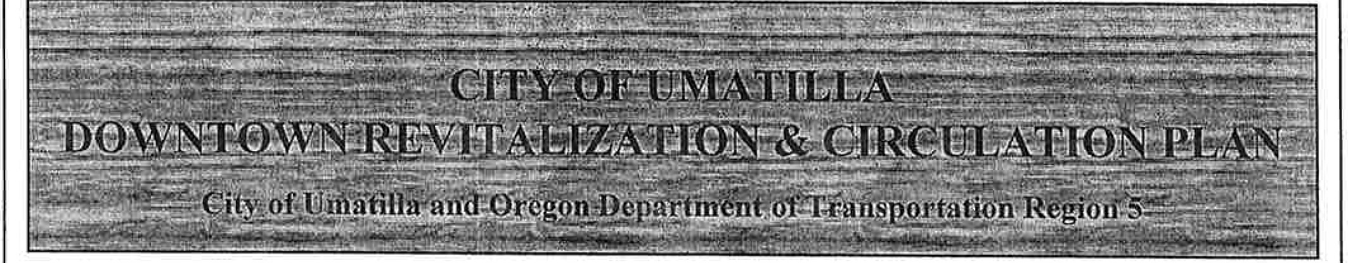
The City of Umatilla and the ODOT have recently begun a project to develop a downtown revitalization plan. A consultant team, led by H. Lee & Associates, has been hired to conduct the study. The plan will develop and implement concepts along 6th Street which will promote downtown Umatilla as an activity center for commerce, mixed land use such as retail and residential uses, community activities, and pedestrian friendly accessibility while balancing the need for traffic circulation of the state highway.

Why Conduct a Study?
The study is an extension of the "visioning and place-making" workshops recently conducted by the City. The workshops through an ad-hoc committee identified short-term projects that could be accomplished. This study will take the initial effort and refine it to develop the framework for Umatilla's future development in its downtown area. This plan is critical to the future development of downtown Umatilla.

number of meetings and will be kept informed through a series

AAppendix 9.2-A-1
1
of newsletters. To be placed on the newsletter mailing list, contact Jennee at H. Lee & Associates at 800-354-2687.
Below is an invitation to attend the first two meetings open to the public. Also, on the back of this newsletter is a questionnaire soliciting your input to be returned to City Hall by October 31, 2000.
The second meeting is a "Design Charette." The charette is a process to gather input and explore possibilities for creating a vital community core. Sketches of ideas will be • developed during the design charette. Your attendanc� is critical to develop ideas for the City ofUmatilla's future downtown area.
Design Charette Meeting Wednesday, November 8, 2000
7:00 to 9:00 P.M.
Umatilla High School 1400 - 7th Street
The first meeting is a Walking Tour. Attend to learn more about the project and to help us identify your area's downtown needs. Get involved at this early stage in the process and then continue to work with us throughout the project. Lunch will be served so please RSVP b,y calling Jennee at 800-354-2687 by Oct. 30.
Walking Tour and Lunch Meeting Thursday, November 2, 2000
12:00 to 1:30 P.M.
Umatilla City Hall 300 - 6th Street

CITY OF UMATILLA
DOWNTOWN REVITALIZATION & CIRCULATION PLAN PUBLIC QUESTIONNAIRE COMMENTS

- What land marks or buildings best identify downtown Umatilla?
  - Fishing- Umatilla Marina RV Park
  - Tourism - A Touch of Heaven, Museum (if open), Oregon Visitor Center, McNary Dam, Columbia Crest Winery, Corps Nature Trails, Golf Courses, and Library
  - Shops (town is known for ugly junk stores)
  - Stripjoint (not proud of in our town)
  - Red Apple Cowboy (needs a facelift; needs to be removed; a definite stay)
  - Ag Building
  - City Hall
  - Fire Station (best kept-up)
  - Abandon, rundown, vacant buildings
  - Closed and abandoned businesses (gas stations, retail sores)
  - Run down, low rent housing (farm workers)
  - Truck Stop - crossroads
  - Bridge over Umatilla River
  - Port of Entry
  - Umatilla Chamber of Commerce (which has a cigarette store on one side, liquor store on the other side and a Naked Girly Bar across the street) - Should be moved to a more POSITIVE location!!!!
  - Sage brush and old dirty store fronts throughout the town.
  - Graveyard is the only landmark left
  - The Old MOR Theater (it's an eyesore)
  - Old Post Office Complex
  - None Known
  - Bank (empty building surrounding it)
  - The chain link fence around it prohibiting entry
  - Carlson's Drug Store building (positive)

- What are positive characteristics of Umatilla that should be maintained in the future planning of downtown Umatilla? What are the negative characteristics that should be improved upon? •
  - Positive - there is an attitude of improvement around town. More people are getting involved in planning. Were getting away from second hand stores.
  - The parks are okay; we need more garbage patrol (broken glass and beer cans).
  - New High School
  - Need community activities (adult softball, craft fairs)
  - Community Theater
  - Proximity to the river and river background
  - Craft shops
  - Small community
  - There is nothing downtown except old, closed buildings and those dumpy second hand stores!
  - No good stores, recreational facilities, or nice places to eat.

- Classless town with no reason to stop in it.
- Overpriced
- Tear down dilapidated buildings or improve them because they look terrible.
- None! Massive demolish and raze program should be implemented.
- Murals are great - keep them painted and in good shape.
- Clean up the streets, paint the planters and water the plants.
- Put together a good city flyer and make sure it put in many locations.
- Positive - bridge over Umatilla, flower containers, cemetery
- Negative- too many vacant buildings and small motels converted to single family dwellings
- Need more TREES!!!!!
- The strip bar needs to go!!!!!!!!
- Building face-lifts (painted in softer colors that all match- NOT bright blue)
- McNaryDam
- Parks and nature trails
- Umatilla RV park in a great location on the Columbia River
- Umatilla State Welcome Center
- Park by the marina is the only positive thing
- No nice Umatilla sign downtown welcoming people.
- Negative- buffalo's painted on the building as you come into town, Red Apple Cowboy
- Clean-up Main Street; empty buildings and lots
- Keeping streets clean and having more flowers and trees.
- Junky made sheds need to be torn down and not built right up to the property line.
- Enforce NO farm animals in town.
- Ugly building signs
- Maintain and improve areas Umatilla Museum and City Library
- Sidewalks and crosswalks
- Green areas would be nice; lawns kept up
- Maybe a town square? •
- The cemetery upgrade is nice - maybe more there.
- Retail only along Main Street - keep commercial buildings elsewhere, unless it can beautify
- There are NO positive characteristics in Umatilla
- Negative - the old gas stations cluttering up the streets. (ugly and too many of them)
- Need sidewalks all the way down 6th Street.
- Keep MOR Theater
- Abolish all dumpy looking lots and garbage on 6th Street (there's way too much)
- Professional signs on businesses should be used.
- Apparent lack of interest in introducing new businesses, lack of any kind of promotion except Walleye Derby.
- No shopping beyond auto parts and second hand stuff
- Murals should be kept and maintained
- A nice WIDE 6th Street
- Inadequate storm drains and failure of police/judiciary to apprehend and punish "speeders" and those vehicles with inadequate fenders (tires that stick out beyond them, etc... )

- What type of commercial developments would you like to see in downtown Umatilla?
- South Hill- Mini-Mart, Laundromat, small businesses
3
- McNary - Is well rounded out.
- Downtown-Bakery (open early), small hardware store
- Target something to bring the real shoppers here and for us not to have to go to Tri-Cities and Hermiston
- Wal-Mart
- Bi-Mart
- Restaurants that cater to families without a bar!!
- Nice places/restaurants to eat with good food (comparable to Raphael's or Moore Mansion)
- A fast food shop or two (Subway, McDonald's, etc... )
- Something/places for kids to go and do things (recreational programs, pool, etc... )
- Places to shop
- Just a bright street and something to look at as a person goes through
- Small businesses and services that would serve the needs of the community. Promote local purchasing.
- Develop our use of the ground along the river. What a nice attraction-park, swings, etc.. - to bring travelers into town.
- Another mom/pop type restaurant NOT a chain
- Recreation area (outdoor/indoor)
- Small professional plaza (dentists, lawyers, CPA, etc )
- Big grocery store, hardware store, novelty stores, antique, western - something that people would be interested in that are driving through
- Real estate office
- Fred Meyer store (competition to Wal-Mart in Hermiston)
- Clean antique shops, sports and tackle shop, guide services on the river, yogurt shop, art galleries, Domino's pizza delivery, place to get car serviced.
- Mini mall, some tourist attractions, murals, etc (stick with an Indian theme)
- Arby's, Burger King, anything at all!!!!!! Please !!
- Drive-thru restaurants and other specialty shops
- Lumber yard
- A deli-like place
- Art and music store(s) - activities that draw families together and give them direction
- Rite-Aid
- Something for children!!
- A fitness club, bowling, skating, and a nice park for the kids!
- Kodack drive-up photo developing center (maybe in an hour?)
- A book exchange store
- Homeless shelter would be good in old theater
- Hardware/Plumbing/Electric combo
- NO more second hand stores
- Clothing and shoe stores
- Dry goods/notions/ whatever retail store
- New stores don't have to be big.

- Are there any traffic issues along 6th street such as pedestrian safety, speeding, parking, and congestion?
  - Pedestrian/Bicycle safety
    - Congestion
    - Speeding

- Parking
- River Rd. coming onto the highway
- Powerline onto the highway
- Frustrated with being passed by cars using the turning lanes
- Frustrated with truckers pushing me out of the city oblivious to the speed limit
- The bridge is very dangerous if you're turning West due to poor visibility and cars pulling up to turn East
- Traffic issues are minor compared to questions 1 and 2 above!
- Have you ever tried to walk across 6th Street?
- The railroad overpass blocks view of town.
- People go by - get more signs etc. to get people onto town
- Turning left to Powerline after Umatilla Bridge going West- People go around in the gravel and speed up there.
- Turning right from Post Office Street to go West-Too congested.
- The light at Scale needs to be changed. You sit WAY too long; lots of people and trucks run the red light so they don't have to wait for the green light
- Without question, the intersection coming off the freeway must be changed. (Safety being the number one priority)
- With the volume of truck traffic going into the Port of Entry, it is mandatory, in my opinion, that another off ramp accessing the Port of Entry, State Welcome Center, Umatilla RV Park, McNary Dam parks and trails, residential area, (3rd Avenue) is necessary ASAP.
- Umatilla is losing a lot of tourists because of the present intersection. They see a back up trucks and keep going, and when they do get here they complain about the mess at the intersection.
- No traffic issues, ½ the time it seems like a ghost town. There is no place in Umatilla to go.
- Large trucks going through town instead of on 82 - unsafe and a deterrent to tourism.
- The main problem is speeders and people who don't stop at crosswalks. Need to enforce existing laws.
- Pedstrians crossing at busy traffic times, especially as the students cross the highway to go to Red Apple
- Parking is a problem.
- Need more stop signs and some signal lights
- Pedestrians and cars have a hard time getting out onto 6th Street.
- Intersection of Hwy 730 and Powerline nee.ds a traffic light. The bridge makes it hard to see making left turn.
- Need a signal at 6th and Switzler, 6th and Powerline
- Speed limit in and through town should be increased to 35 MPH, as in common in all surrounding communities. It would facilitate traffic movement especially with the numerous trucks on 6th Street.
- Pedestrian crossings should be SAFE crossings and enforced by the UPD.
- Stop signs or other traffic control device to break up traffic.
- River Rd. and Powerline are both quickly becoming more than just a concern.
- There is ample parking along the corridor for current business and any expansion
- There are lots of vehicles making left hand turns on to Highway 730 difficult.
- There is a certain arrogance in school children to step off of the curb (in the crosswalk) in the midst of traffic, one after the other rather than forming a group and minimizing
disruption, when escaping from school during lunch by going to the store, that requires curtailment.

GENERAL COMMENTS:

- A question to consider in planning Should the little things like parks, museums and town
activities be in place before attracting businesses or business drawn in before little things in place.
- We need to get all owners involved. A system needs to be in place recruiting businesses and the entrance areas of town should be considered as part of downtown (landscaping, cleanliness).
- To get people into the downtown area we need businesses that cater to a bedroom community and tourist stop. About 20,000 to 25,000 people stop at the visitor center yearly; 13,000 average travel the cruise vessels a year; 25,000 are visitors at Umatilla Marina RV Park yearly. There are other numbers going through town also, a very small percentage have a place to stop downtown, lets give them something to do.

- Our claim to fame is the Exotic Dancers - Pandora's Box - what a disgrace - that and junk stores.

- If not for new homes being built who'd want to live here? And these people probably don't shop much here in town!

- At least the old grocery store has been revamped and at one point the old bank had life again. How long will it sit in shambles again. Is it all about some one or general being money hungry and wanting extreme $ rent.
- There is an office complex just sitting & looking like slumsville.

- We lack programs supportive of our youth; stop and drop some$ through shopping, aesthetics and classy shopping, lets get rid of those dumpy apartments on 6th and restrict the yard sale/second hand shops. How about trying to have all of the buildings filled instead of vacant. How about an ordinance to prohibit that tacky pick-up of the "Mayor of2000" from being parked in Umatilla County!!!! We lack community activities -no swim team, exercise/gym, or trail. Programs that do exist aren't well publicized so new comers turn to Hermiston/Tri-Cities to meet their need thus losing$, volunteers and sense of community.

- Prior to investments in the community, is H. Lee & Associates task with reporting the diversity of the City of Umatilla? Such as,
  - Permanent residents?
  - Transient or migrant type workers?
  - Average income of residents?

- Where is the "PRIDE" in the community with the current property owners that allow rundown unkept buildings exist? Where are the ordinances that would require owners of abandon buildings to maintain for sightlessness? It appears the city may be weak in this are.
9.

- Strength from within must come first.
- Joint effort should be made with the school. The new location (old Interstate Bank bldg.) of the administration offices is a place for reader board.
- Put in a computerized reader board like Boardman. Update school and city events regularly from the district office. Current city board (reader) and school reader boards don't reach the community.
- Be sure info on Newsletter is current- meet the candidates was on Oct 16 - newsletter came after that.
- What's wrong with the original entry gate for the old cemetery?
- Get rid of Riverside!!!
- Get rid of billboards on 6th Street.

- I just moved here a year ago. I'm hoping for more growth in Umatilla. I would love to see downtown cleaned up. It would be nice if the Middle School could have a new front, It's an eyesore next to the new school.
- . I lived in a small town about the size of Umatilla. The year before I moved they renovated their Main St. They buried all overhead powerlines, painted store fronts, put antique looking lamp posts in and trees. It made a HUGE difference.

- This is the first town tourists see when coming into Oregon traveling the Northern route. I've talked to an average of 20,000 people between April 1 and October 31. We receive many negative comments daily regarding the intersection and access to Umatilla. Once the travelers make it down to our Welcome Center, they think the river is beautiful and we get lovely comments about our view.
- I think with this opportunity Umatilla should look at making a total image change.

- Umatilla does not submit any information to the Welcome Centers; there should be some sort of newsletter/flyer of yearly activities and/or events.

- Travelers should be encouraged to use Hwy. 730 instead of Hwy. 82; to help and promote local economy.

- Another off ramp accessing 3 and Brownell is the most obvious and logical answer to many ofUmatilla's problems and should work jointly with the highway department to see that this happens.
rd

- The beauty of the Columbia River and great fishing should be promoted as a tourist attraction.

- Umatilla should look at other small towns in Oregon that have HAD a turnaround. (Sisters, Troutdale, Bend, Redmund, Aumsville, Lafayette, Bandon, and many others)
9
7

- Umatilla is an untapped gold mine. With the great weather, beauty and fishing this could be a wonderful retirement area and great area for families to raise their children.
- BOTTOM LINE: A sense of community equals economical survival.

- We need a department store also one that sells CDs and tapes for kids.
- There should be a light east, between Post Office and Arco Service Station. Very dangerous; taking a chance every time you pull out..
- There should be a light west of Umatilla across the bridge on Powerline Road and Hwy. 730.

- My comment is I'm ashamed to say I live here. Too many empty buildings and piles of junk around town. Store fronts need to be repainted especially that depressing color of the Theater which could be turned into a place where we could have local talent contests or some kind of entertainment

- I am concerned with the fact that people from McNary love to say they don't live in Umatilla, they live in McNary. The downtown area needs to be improved upon greatly. It has a very "scummy" feeling about it. Dismal, nothing cheery. It is depressing.
- We do no shopping here because there is nothing here!!! We go to Hermiston for everything. Let some businesses com to town please! This is a major access right off the freeway, you would think there would be some restaurants and stores here!

- Maybe an extra lane for truckers only? That area around the Texaco/traffic light is a disaster.

- A great deal of traffic flows through Umatilla without stopping. If we could make Umatilla a charming tourist town with a main theme (examples: like the town of Sisters, Florence, Newport or even Toppenish, WA), we could have a charming and prosperous town. The building fronts would have a common theme. Perhaps a deal with local builders/contractors to do the building fronts within a set time frame and for a discounted amount. Perhaps new businesses could be encouraged to come into town with guaranteed city tax cuts for a specified length of time. Perhaps there are government grants to apply for the development.

- Re-do sidewalks in brick or fake brick with landscaping. Attractive hanging planters and flower boxes with light posts and benches. New, good quality shops, specialty shops and drive-through fast food restaurants on both sides of Hwy. 730.
- The "Old Town" themes have always appealed to me. A long log house, visitors center, Native American food service, parks and picnic area, etc...

- Umatilla downtown has Nugget park (Wonderful) but South Hills & McNary could sure use some green space - soccer fields, softball complex, walking/bike paths, and a facelift and upheep on the tennis courts at McNary would also be nice.

- There is more to Umatilla than just "Downtown"!
9.2-A-1
8

Umatilla Downtown

Summary of Walking Tour Activities, Notes, and Comments November 2, 2000

Agenda
- Introductions
- Purpose/Schedule
- Pre-tour work session
- Images
- Activities
- Elements
- Define downtown
- Walking tow-
- Post-tour work session
- Observations
- Opportunities/challenges
- Next steps - Chanette Nov. 8th and Nov. 9th

I. PRE-TOUR WORK SESSION

Images
- Commercial traffic
- Abandon buildings
- Trash
- 15 gas stations
- No discemable downtown
- No benches

Downtown Activities
What are the activities that happen in a successful downtown?
- Shopping
- Foot traffic
- Sight seeing
- Mix of businesses
- Cultural/historical sites
- Tourist information
- Gathering place/place to meet
- Events/parades
- Village green/square
- Marina signage
- Spillway

Design Elements
9.2-A-2
What are the design elements that you find in a successful downtown?
- Parking close by

Il. WALKING TOUR
What to look for:
- Pedestrian District
- Auto orientated district
- Development opportunities
- Constraints
- Pedestrian features
  - Plaza
  - Crosswalk locations
  - Connections
  - Handicap needs

Ill. POST-TOUR WORK SESSION

Observations/Comments
- Too open and spread out
- Highway with sidewalks
- Separate downtown from highway
- Slow traffic
- Curb extensions
- Street trees
- Selective medians
- New traffic light
- Pedestrian crossing
- No reason to stop
- Need museum to have a presence on 6th
- DEQ problem with gas stations
- Theatre - opportunity site
- Youth orientated activities
  - Skate rink/park
- Skate park
- Need parks with operable restrooms
- Decorative phone booths
- Murals
- Farmer's market
- Marina- swirnming/signage
- Recruit post office back to downtown
- Improve low income housing

- sentee owners
- Vandalism
- Service needs
- Parking in back
- Parking available on street
- Side streets are an option for diagonal parking
- Building scale- relationship to street
- Gaps - spread between buildings (fill gaps)
- How to attract business
- E Street option for Main Street - ends at city park
- Make I Street main street and link to the alley
- Put public services on one street
- E Street is opportunity area for links to the park
- Loop to 7th
- How to minimize street noise

Opportunities and Challenges
What to focus on:
- Pedestrian infrastructure/traffic control
- How to implement - what are real improvements (be real)
- Phased improvements
  - Identify parties
  - Lots of small improvements
  - Fire stations
  - Trees at cemetery
  - Incremental changes/small projects
- Options for funding
  - Gas tax option
  - LID
- Tour boat - many people get off the boat and are bussed out of town
- 10,000 visitors per year

Umatilla Downtown

Summary of Community Vision Comment Sheets November 2, 2000

Ten Community Vision comment sheets were completed. Participants identified themselves by one or more of the following categories:
- 2 local employees
- 4 local business owners
- 4 local property owners
- 3 local residents
- 2 local or state government officials
A summary of participants' responses, grouped by topic, follows.

In your opinion, what are the five greatest opportunities that should be addressed by the plan?
- Develop a specific center of town for pedestrian shopping and walking. Make this area on 71n Street instead of 6th (Hwy 730).
- Development, shops, etc. on side streets south of town - leave 6th Street as a highway
- Downtown side streets
- 1/4 mile zone very doable

- Develop pedestrian-friendly atmosphere
- Make the town pedestrian-friendly
- "Sidewalk" comers to jut into streets for safety
- Parks/benches
- Develop a visual package - landscaping, murals
- Sidewalks. street lamps, murals, trees
- Downtown landscaping
- Clean up Umatilla's appearance

- Address Umatilla's heritage

- Revitalize the business sector
- Help develop more retail services - offer diversity
- Town wide open for a variety of businesses
- Some businesses are trying to help

- Old building and parking- now is the time for the City
- Off-street parking is available
- Either use or tear down vacant buildings

- Boys and Girls Club would be great

- Develop activities for children and teenagers
9.
- Youth programs - any entertainment facilities

- Traffic control
- Slowing down traffic
- Eliminating some or all truck traffic
- Addressing the truck traffic issue -this is a major noise and hazard that would not be all that difficult to cure
Additional Comments
- Switzler to Mor Theater
- Farmer's Market, revitalize Landing Days, cultural events
- Would be nice to have a theme to follow
- Umatilla Landing Days - make this a citywide participation to draw all visitors in addition to the Governor's fishing tournament. We have a lot of artists, crafters, and talented citizens in addition to the yard sales that everyone enjoys. A variety of towns in a various states do this. We already have the holiday weekend in September designated. We also have many antique dealers that would participate.
- Need several, through the year, activities that would draw people
- Town needs more landscaping and trees

In your opinion, what are the five most significant challenges for this project?
- Businesses are spread out
- Over one mile of "Main Street"
- Mall-type development
- Improve appearance of 6th Street

- Irregular sidewalks
- Pedestrian lights (street crossing)
- Pedestrian traffic

- Private property owners/gas stations
- Vacant buildings
- Abandoned gas stations
- Buildings are old structures
- Getting rid of old buildings and derelict facilities

- Money to involve property owners
- Cooperation of property owners
- Present building owners
- Cooperation of any and all property owners - development and upgrade

- Cooperation of government agencies - ODOT, DEQ
- DEQ regulations - the old service stations

- State cooperation

- Working with Port District, Confederated Tribes

- Community cooperation
- Motivation
- Volunteer participation
- Commitment and follow through of the plan itself

- Noisy highway
- Traffic noise
- Truck traffic

- Encourage cleanup
- Vandalism is problem
- Reactivate garden club

- Cash
- Funding
- Additional funding - grants or private
- Recruitment of business to invest

- High density housing is a problem- move it off of the Main Street

Additional Comments
- Ask for assistance from F.F.C.L. (Future Family and Community Leaders) at Umatilla High School. Nancy Iverson is the instructor. They might make it their project to take to state and national competition. [Not clear whether this comment is referring to Umatilla Landing Days or cleanup or the garden club.]

URBAN DESIGN, BUILDING IMPROVEMENTS & LAND USE

- Awnings
- Building signage
  - Blade signs
  - Transom signs
  - Flat signs
  - Sandwich boards
- Building Facades
- Murals
- Greenwalls
- Take advantage of Columbia and Umatilla Rivers natural beauty
  - Trees
  - Benches
  - Parks to encourage people to go there
- Important center downtown, middle town
- Need sidewalks and trees or bushes or flowers or something nice
- Skate park
- We need signal lights so people won't go over the speed limit and so they can stop in town
- Fix-up old movie theater
- Multi-use zoning, Old MOR Theater, commercial/retail below.
- Move post office downtown
- MOR Theater into community center with movies, lectures, play areas. Building can anchor that end of town
- Floral garden
- More bike paths
- Pool
- Need a town garden
- Amphitheater would be awesome
- Pedestrian overpass (6th Street)
- Larger library building on Main St. rather than behind a parking lot
- We some trees by the sidewalk and maybe a clock close by
- Rose/floral garden
- Plaza for gathering, music, and farmer's market
- Coffee shop
1
- Love the red paint! Need a dalmatian statue - or other art work recognizing firemen and women!
- Maintain and up-keep murals that are in town
- A soccer field
- Paint a "school mural" on new district office
- Need signage ordinance!!!!
- Much more buildings
- Trees and light posts
- Marina kept up for family use
- Building fronts need more of a vanity
- Accent the "cowboy" light him up at night
- Public pool
- Some more banks
- We need a fancy funland park that is safe and fun
- Building fronts are "monotonous" same shape, no variety of color - drab, uninviting
- Expand or build new elementary school ASAP!!
- New elementary building or at least increase the size of current building

PEDESTRIAN IMPROVEMENTS
2

- Bulb
- Outs/Crosswalks
- Traffic Calming
- Accent Pavement/Raised Pavements
- Medians/Islands
- Handicap Ramps
- Islands in the tum lanes would interfere with the emergency equipment on Highway 730
- Sidewalks in serious need of repair
- Three lane bridge with tum lane
- Handicap ramps
- Build new library I conjunction with park for after school and summer activities
- Move post office downtown closer to (between) City Hall and Museum
- Handicap ramps
- Restrooms
- Put a median landscape in the middle of the street on Main Street
- Drinking fountains
- Fix height differences in sidewalk - need additional handicap ramps
- Add bulb outs, herringbone crosswalks to break up street
- Stop light at Switzler Street
- Three (3) bulb outs at MOR Theater, I Street intersection, and Switzler
- Involve kids in school
- Public restrooms for visitors
- Highway 730 (6th) - should always remain Highway Frontage and be designed to be used that way. Look at 395 through Hermiston as apposed to Main St. in Hermiston and the uses.
- I would agree with bulb outs in areas where there is high usage for crossing's (school children, etc.) but not on every corner.
- Transit service - regular schedule & route

CIRCULATION & PARKING
3

- One-Way Couplet
- Left Turn Lane
- Traffic Lights/Stop Signs
- Parallel/Diagonal Parking
- Surface Parking Lots
- Screen Parking
- Public Parking Lots
- Parking Signage
- Trees needed on Southeast side of Main St. at 6th St.
- Shrubbery
- Focus on additional parking on side streets
- More trees
- We have enough parking
- Original offstreet parking available on many side streets
- Tran.sit service
- Focus on slowing traffic down - eliminate tum lanes in some blocks and implement parallel parking
- Diagonal off street parking available on many side streets
- Centralize our group activities and/or businesses!
- Don't mention stop signs! It sends ODOT typically into cardiac arrest!
- False front s on vacant lots
- More green grass instead of weeds
- Bus system or some sort of transportation around town
- Trees
- Town transportation- maybe able to connect with other communities
- Read the T.S.P.

STREETSCAPEIMPROVEMENTS

- Planter Boxes
- Street Trees
- Benches
- Drinking Fountains
- Historic Pedestrian Lights
- Downtown Housing
- Signage
- Accent Pavement
- Gateways
- Plazas
- Public Art
- Archway entrance into town
- Bus transportation to get to town and activities
- Taxi service
- Plant trees in sidewalks and maintain.
- Install water and power for Christmas lights
- Bulb outs at crosswalks
- Umatilla History "THEME"
- Don't confuse Highway Frontage/6th Street with down town usage. Put downtown on 7th Street and avoid the highway
- Fix up all abandoned gas stations
- Historical marker; identify museum, fire hall, podium
- Public art
- Skate parks - like in McNary area
- Focus on our history! Silver Dollar Saloon
- Planter boxes with self watering (power to trees for lights)
- Look at Kennewick Ave. (downtown)
In Kennewick they are trying to redo it & I don't think it will be very productive
- City center gathering spot -benches, H20 fountains, trees
- We need a garden shop or a flower or something gardenish
- Skate O Rama
- Historic pedestrian lights
- Plazas
- Central Park
4

- Improved recreation facilities
  - Softball
  - Equestrian trails
  - Horseshoes
  - Skate park
  - Bike soccer
- Drinking fountains
- Central park
- Historic pedestrian lights!!
- Archway entrance into downtown
- Benches, benches, benches - Let's not make Hermiston' s mistake
- Narrow streets with trees and lights
- Two (2) circles in intersections ; misdirect traffic to slow it down
- Change name to Umatilla Landing - Go for River Boat theme!
- Benches, lights, trash cans
- Need more benches
- Gas lamps, type of street lamps
- Scatter benches along streets
- Need more vibrant colors that paint, flowers, statues, tree/shubbery can provide. All this brown is too depressing & boring
- Theme - western. We already have the cowboy

CHAPTER!
Appendix 9.2-A-4
9.2-A-4
INTRODUCTION
As part of the process of determining a strategy for downtown Umatilla revitalization, it is important to identify both the opportunities for development and the constraints that limit development. Opportunities and constraints for the downtown revitalization study were determined through site analysis, research, and public involvement techniques. Other contributing information included photographic analysis, historic site research, and data from the State Department of Environmental Quality (DEQ) identifying sites with hazardous materials.
The report is organized by the following sections:

- Transportation Issues
Pedestrian Facilities and Generators Streetscape
On-Street and Off-Street Parking Facilities Street Layout and Traffic Control Facilities
Existing Driveway Locations and Access Management Plrumed Public Facility Improvement Projects

- Land Use Issues
Curbside Building Frontage Location of Public Buildings
Vacant Land and Buildings with Space Available Neighborhood Boundaries

- Environmental Issues DEQ Cleanup Sites Historic Site Research Waterways

- Public Utilities

CHAPTER2 TRANSPORTATION ISSUES
9.2-A-4

Pedestrian Facilities and Generators

Pedestrian facilities alon� 6th Street were inventoried. As shown in Figure 1, most of the roadway sections along 6t Street have sidewalks with the exception of the following locations:

- West of "A" Street to the Umatilla River Bridge - both sides of the street
- Between "A" Street and "B" Street- south side of the street
- East of "B" Street to "C" Street - north side of the street
- The frontage of the first parcel west of "C" Street on the south side of the street
- Between "K" Street and "L" Street on the north side of the street
- Between "L" Street and the Bonoco Gas Station on the north side of the street
- East of the old 76 Gas Station site to Yerxa Avenue on the north side of the street
- A small section between Switzler Avenue and Yerxa Avenue on the south side of the street fronting the apartments

In general, contiguous sidewalks exist along 6th Street from "C" Street to "L" Street on both sides of the roadway. Missing sections exist west of "C" Street and east of "K" Street. Most of the missing sections of sidewalk east of "K" Street exist along the north side of 6th Street. Only a small section of sidewalk east of "K" Street exists along the south side of 6th Street.
Wheelchair ramp locations were also inventoried as part of the 6th Street pedestrian facility inventory. As shown in Figure 1, many wheel chair ramps are missing at intersections along 6th Street. A person in a wheelchair does not have adequate facilities to negotiate along the sidewalks on 6th Street due to the missing wheelchair ramps. No intersection has wheelchair ramps on all four comers of the intersection and ramps do not exist at two adjacent intersections on either the north or the south side of 6th Street.

Figure 2 shows the pedestrian generators in the study area. The pedestrian generators in the study area were identified with the help of city staff. The only three pedestrian generators identified were the Red Apple grocery store, Clara Brownell Middle School, and Umatilla High School. The majority of pedestrian activity occurs during the lunch hours of the schools. Students can walk to the Red Apple for lunch. The significant pedestrian travel path for this activity occurs on ?1h Street from "L" Street to Yerxa Avenue; 'L Street Switzler Avenue, or Yerxa Avenue from ?1h Street to 6th Street; and 6th Street from 'L' Street to Yerxa Avenue. Since there are missing sidewalks along the north side of 6th Street from "L" Street to Yerxa Avenue, it is likely that students would utilize ?1h Street to Yerxa Avenue and Yerxa Avenue from ?1h Street to the Red Apple as their primary route.

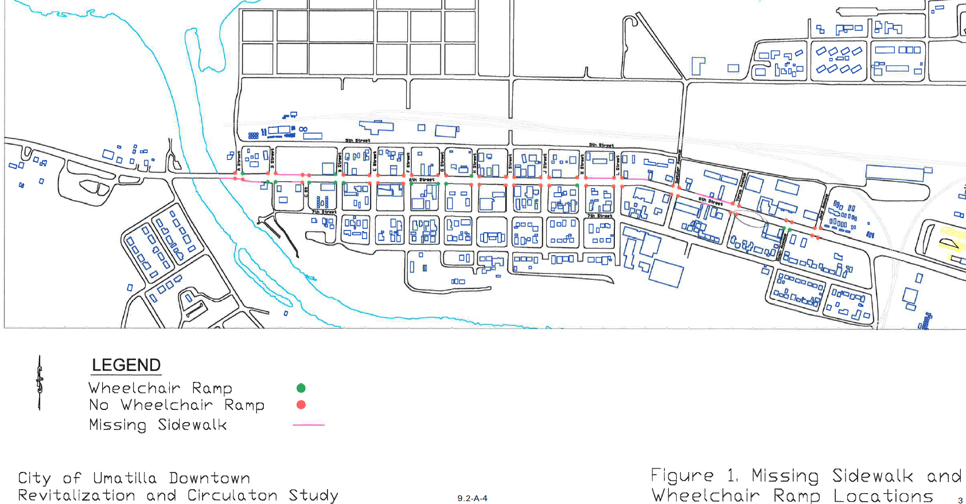

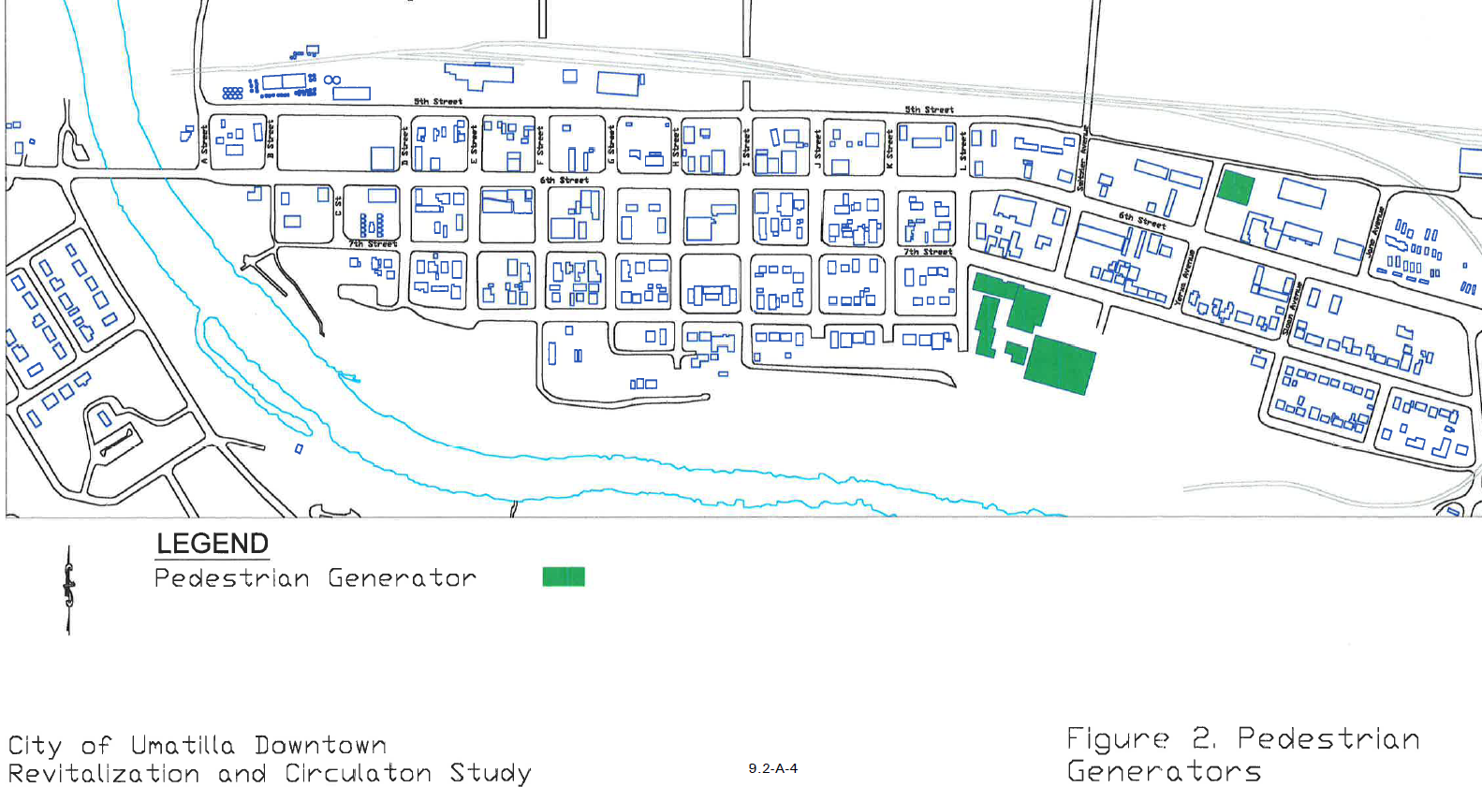

Streetscape

There are limited streetscape features in the study area. The City has some small planter boxes along 6th Street. However these planter boxes are not always planted and maintained. There are sporadic street trees along 6¹h Street.

On-Street and Off-Street Parking Facilities

H. Lee & Associates has conducted a parking utilization survey for the City of Umatilla, Oregon along 6th Street. As part of this survey, H. Lee & Associates conducted a field survey of parking supply and demand by hour for 6th Street. The parking demand survey was conducted on December 20, 2000. The survey was conducted from 8:00 AM to 5:00 PM.

As shown in Table 1 there are 160 parking spaces along 6th Street between A Street and Jane Avenue. On-street parking demand varies from a low of 8 spaces at 8:00 AM to a high of 23 spaces at 3:00 PM. As shown in Table 2 the maximum overall utilization is 14 percent. The block along 6th Street with the highest utilization is the north side of 6th Street between E Street and F Street with 57 percent utilization at 3:00 PM. Throughout the day, there appears to be more than sufficient parking to support the existing commercial activities.
There are currently no public off-street parking lots in the City of Umatilla. Based on a maximum overall utilization of 14 percent of the on-street parking supply, it does not appear that a public off-street parking lot is warranted.

Street Layout and Traffic Control Facilities

The roadway system in the study area is a grid pattern. The main east-west through street that provides regioual access is 6th Street. It is also known as Highway 730. Other east-west streets in the study area include 5°1 Street, i¹¹Street, and 8th Street. 5th Street and ?'h Street traverse the entire study area while 8th Street is constructed only between "D" Street and "L" Street and Sloan Avenue and Umatilla River Road. The north-south side streets generally exist every 200
feet. Two hundred feet by 200 feet is generally the block configuration of Umatilla streets.
Within the downtown study area, there are no signalized intersections. All intersections are stop sign controlled. 6th Street is the primary road through Umatilla has the right-of-way from the side streets.

Existing Driveway Locations and Access Management

To evaluate existing driveway spacing compared to current access management standards, the existing driveway locations along Highway 730 (6th Street) was inventoried from the Interstate 82 interchange to Umatilla River Bridge. The intent of this exercise is twofold. First, the
Table 1. On-Street Parking Demand Survey Results

Table 1.
2000 PARKING INVENTORY
City of Umatilla Trans_eortation System Plan

 | Parking |  |  |  |  |  | Parking Demand by Hour
Street Segment Supply |  |  | 8:00 AM | 9:00 AM | 10:00 AM 11:00 AM 12:00 PM |  |  | 1:00 PM | 2:00 PM |  | 3:00 PM | 4:00 PM |  | 5:00 PM
6th Street
A St. to B. St. - Northside | 4 |  | 0 | 0 | 0 | 0 | 0 | 0 | 0  9.2-A-4 |  | 0 |  | 0 | 0
A St. to B. St. - Southside | 6 |  | 0 | 2 | 1 | I | 1 | 0 | 2 |  | 3 |  | 3 | 0
B St. to C St. - Northside | 7 |  | 0 | 0 | 0 | 0 | 1 | 0 | 0 |  | 0 |  | 0 | 0
B St. to C St. - Southside | 4 |  | 0 | 0 | 0 | 0 | 0 | 0 | 0 |  | 0 |  | 0 | 0
C St. to D St.- Northside | 5 |  | 0 | 0 | I | 0 | 0 | 0 | 0 |  | 1 |  | 0 | 0
C St. to D St.- Southside | 5 |  | 0 | 0 | 0 | 2 | 0 | 2 | I |  | 0 |  | 0 | I
D St. to E St. - Northside | 5 |  | 0 | 0 | 0 | 0 | 0 | 0 | 0 |  | 0 |  | 0 | 0
D St. to E St. - Southside | 6 |  | 0 | 0 | 0 | 0 | 0 | 0 | 0 |  | 0 |  | 0 | 0
E St. to F St. - Northside | 7 |  | 0 | 0 | I | I | 0 | 0 | 0 |  | 3 |  | 2 | 0
E St. to F St. - Southside | 7 |  | 0 | 0 | 0 | 2 | 2 | 2 | 2 |  | 4 |  | 2 | 4
F St. to G St. - Northside | 5 |  | 0 | 0 | 1 | 0 | 1 | 0 | 2 |  | 2 |  | 3 | I
F St. to G St. - Southside | 5 |  | 0 | 0 | -0 | 0 | 4 | 0 | 0 |  | 2 |  | 2 | 1
G St. to H St. - Northside | 0 |  | 0 | 0 | 0 | 0 | 0 | 0 | 0 |  | 0 |  | 0 | 0
G St. to H St. - Southside | 2 |  | 0 | 0 | 0 | 0 | 0 | 0 | 0 |  | 0 |  | 0 | 0
H St. to I St. - Northside | 7 |  | I | I | 3 | 0 | 1 | 0 | I |  | 1 |  | 1 | 1
H St. to I St. - Southside | 3 |  | 0 | 0 | 0 | 0 | 0 | 0 | 0 |  | 0 |  | 0 | 0
I St. to J St. - Northside | 9 |  | 2 | 2 | 2 | 2 | 2 | 3 | 3 |  | I |  | 2 | 2
I St. to J St. - Southside | 4 |  | 0 | 0 | 1 | 0 | 0 | 1 | 1 |  | 2 |  | 2 | 0
J St. to K St. - Northside | 1 |  | 0 | 0 | 0 | 0 | 0 | 0 | 0 |  | 0 |  | 0 | 0
J St. to K St. - Southside | 3 |  | 0 | 0 | 0 | 0 | 0 | 0 | 0 |  | 0 | - | 0 | 0
K St. to L St. - Northside | 8 |  | 0 | 0 | 0 | 0 | 0 | 0 | 0 |  | 0 |  | 0 | 0
K St. to L St. - Southside | 3 |  | 0 | 0 | 0 | 0 | 0 | 0 | 0 |  | 0 |  | 0 | 0
L St. to Switzler Ave. - Northside | 4 |  | 2 | 2 | 0 | I | 1 | 1 | I |  | 1 |  | 2 | 2

Table 1.
2000 PARKING INVENTORY
City_ofUmatilla Transportation System Plan

 | Parkjng |  |  |  |  |  |  |  | Parking Demand by Hour
Street Segment Supp.ly |  | 8:00 AM |  | 9:00 AM |  | I0:00 AM |  | 11:00 AM 12:00 PM |  |  |  | 1:00 PM |  | 2:00 PM |  |  | 3:00 PM |  | 4:00 PM |  | 5:00 PM
L St to Switzler Ave. - Southside | 12 | 3 |  | 1 |  | 4 |  | 4 |  | 0 |  | 4 |  | 5 |  |  | 1 |  | 1 |  | 4
Switzler Ave. to Yerxa Ave. - Northside | 7 | 0 |  | 0 |  | 0 |  | 0 |  | 0 |  | 0 |  | 0  9.2-A-4 |  |  | 0 |  | 0 |  | 0
Switzler Ave. to Yerxa Ave. - Southside | 8 | 0 |  | 0 |  | 0 |  | 1 |  | l |  | 1 |  | 3 |  |  | 2 |  | 3 |  | 1
YerxaAve. to Sloan Ave. -Northside | 7 | 0 |  | 0 |  | 0 |  | 0 |  | 0 |  | 0 |  | 0 |  |  | 0 |  | 0 |  | 0
YerxaAve. to Sloan Ave. - Southside | 8 | 0 |  | 0 |  | 0 |  | 0 |  | 0 |  | 0 |  | 0 |  |  | 0 |  | 0 |  | 0
Sloan Ave. to Jane Ave.- Northside | 6 | 0 |  | 0 |  | 0 |  | 0 |  | 0 |  | 0 |  | 0 |  |  | 0 |  | 0 |  | 0
Sloan Ave. to Jane Ave.- Soutbside | 2 | 0 |  | 0 |  | 0 |  | 0 |  | 0 |  | 1 |  | 1 |  |  | 0 |  | 0 |  | 0
Total for 6th Street | 160 |  | 8 |  | 8 |  | 14 |  | 14 |  | 14 |  | 15 |  |  | 22 |  | 23 |  | 23 |  | 17

Table 2
2000 PARKING UTILIZATION
City of Umatilla Trans_2ortation System Plan

 | Parking | tilization by Hour
Street Segment Supply |  | 8:00 AM | 9:00 AM | I 0:00 AM 11:00 AM 12:00 PM |  |  | 1:00 PM | 2:00 PM | 3:00 PM | 4:00 PM | 5:00 PM
6th Street
A St. to B. St. - Northside | 4 | 0% | 0% | 0% | 0% | 0% | 0% | 0%  9.2-A-4 | 0% | 0% | 0%
A St. to B. St. - Southside | 6 | 0% | 33% | 17% | 17% | 17% | 0% | 33% | 50% | 50% | 0%
B St. to C St. - Northside | 7 | 0% | 0% | 0% | 0% | 14% | 0% | 0% | 0% | 0% | 0%
B St. to C St. - Southside | 4 | 0% | 0% | 0% | 0% | 0% | 0% | 0% | 0% | 0% | 0%
C St. to D St.- Northside | 5 | 0% | 0% | 20% | 0% | 0% | 0% | 0% | 20% | 0% | 0%
C St. to D St.- Southside | 5 | 0% | 0% | 0% | 40% | 0% | 40% | 20% | 0% | 0% | 20%
D St. to E St. - Northside | 5 | 0% | 0% | 0% | 0% | 0% | 0% | 0% | 0% | 0% | 0%
D St. to E St. - Southside | 6 | 0% | 0% | 0% | 0% | 0% | 0% | 0% | 0% | 0% | 0%
E St. to F St. - Northside | 7 | 0% | 0% | 14% | 14% | 0% | 0% | 0% | 43% | 29% | 0%
E St. to F St. - Southside | 7 | 0% | 0% | 0% | 29% | 29% | 29% | 29% | 57% | 29% | 57%
F St. to G St. - Northside | .5 | 0% | 0% | 20% | 0% | 20% | 0% | 40% | 40% | 60% | 20%
F St. to G St. - Southside | 5 | 0% | 0% | 0% | 0% | 80% | 0% | 0% | 40% | 40% | 20%
G St. to H St. - Northside | 0 | 0% | 0% | 0% | 0% | 0% | 0% | 0% | 0% | 0% | 0%
G St. to H St. - Southside | 2 | 0% | 0% | 0% | 0% | 0% | 0% | 0% | 0% | 0% | 0%
H St. to I St. - Northside | 7 | 14% | 14% | 43% | 0% | 14% | 0% | 14% | 14% | 14% | 14%
H St. to I St. - Southside | 3 | 0% | 0% | 0% | 0% | 0% | 0% | 0% | 0% | 0% | 0%
I St. to J St. - Northside | 9 | 22% | 22% | 22% | 22% | 22% | 33% | 33% | 11% | 22% | 22%
I St. to J St. - Southside | 4 | 0% | 0% | 25% | 0% | 0% | 25% | 25% | 50% | 50% | 0%
J St. to K St. - Northside | 1 | 0% | 0% | 0% | 0% | 0% | 0% | 0% | 0% | 0% | 0%
J St. to K St. - Southside | 3 | 0% | 0% | 0% | 0% | 0% | 0% | 0% | 0% | 0% | 0%
K St. to L St. - Northside | 8 | 0% | 0% | 0% | 0% | 0% | 0% | 0% | 0% | 0% | 0%
K St. to L St. - Southside | 3 | 0% | 0% | 0% | 0% | 0% | 0% | 0% | 0% | 0% | 0%
L St. to Switzler Ave. - Northside | 4 | 50% | 50% | 0% | 25% | 25% | 25% | 25% | 25% | 50% | 50%

I

Table 2
2000 PARKING UTILIZATION
City of Umatilla Transportation System Plan
L St. to Switzler Ave. - Southside | 12 | 25% | 8% | 33% | 33% | 0% | 33% | 42% | 8% | 8% | 33%
Switzler Ave. to Yerxa Ave. - Northside | 7 | 0% | 0% | 0% | 0% | 0% | 0% | 0% | 0% | 0% | 0%
Switzler Ave. to Yerxa Ave. - Southside | 8 | 0% | 0% | 0% | 13% | 13% | 13% | 38% | 25% | 38% | 13%
Yerxa Ave. to Sloan Ave. - Northside | 7 | 0% | 0% | 0% | 0% | 0% | 0% | 0% | 0% | 0% | 0%
Yerxa Ave. to Sloan Ave. - Southside | 8 | 0% | 0% | 0% | 0% | 0% | 0% | 0% | 0% | 0% | 0%
Sloan Ave. to Jane Ave.- Northside | 6 | 0% | 0% | 0% | 0% | 0% | 0% | 0% | 0% | 0% | 0%
Sloan Ave. to Jane Ave.- Southside | 2 | 0% | 0% | 0% | 0% | 0% | 50% | 50%  9.2-A-4 | 0% | 0% | 0%
Total for 6th Street | 160 | 5% | 5% | 9% | 9% | 9% | 9% | 14% | 14% | 14% | 11%

driveway inventory compared to the current access spacing standard identifies access spacing deficiencies that can be better managed with new development. Second, in a downtown pedestrian oriented area, a special ODOT designation (special transportation area) could be justified with certain access spacing standards.
The existing driveway inventory is depicted in Figures 3a, b, and c. As shown in Figures 3a, b, and c, there are many blocks where the current access standard for Highway 730 is not met. In those situations, the application of the crossover easements and conditional access policy concepts depicted in the Umatilla Transportation System Plan, Figure 16, would work well to consolidate accesses over time as redevelopment occurred. Eventually, by practices those concepts, the existing access spacing standards for Highway 730 could be met. Also, over time in the proposed STA area, the overall goal is to have the local grid system provide access to businesses and not individual driveways.

The Umatilla Transportation System Plan (TSP) specifies the access spacing standards on Highway 730 (6th Street). They should be based on the 1991 Oregon Highway Plan (OHP). These standards are summarized in Table 3.

Table 3. 1991 OHP Highway 730 Minimum Intersection Spacing Standards
Roadway Segment | Public Street | Private Access Drive | Signal Spacing
Umatilla River Bridge to 1-82 northbound ramp | 500 feet | 150 feet | ¼mile
I-82 N01thbound Ramp to east city limits | ½mile | 500 feet | ½ mile

The Umatilla TSP has other access management standards. These standards are summarized in Tables 4, 5, and 6. Table 4 summarizes the recommended access management standards. Table 5 summarizes the minimum intersection spacing standards. Table 6 summarizes the private access driveway width standard.

Table 4. Recommended Access Management Standards from the TSP
Functional Classification | Intersections
Functional Classification | Public Road |  | Private Road ,•i
Functional Classification | Type1•i | Spacing | Type | Spacing
Arterial  Interstate 82: Interstate (Category I) Highway 730: Regional (Category 4)  Highway 395: District* | Interchange  at-grade/interchange at-grade | 2-3 miles  1/4mile  ¼mile | None L/R turns L/R turns | NA  500 ft  300 ft
Other Arterials within UGB | at-grade | 250 ft | L/R turns | 100 ft
Collector | at-grade | 250 ft | L/R turns | 100 ft
Residential Street | at-grade | 250 ft | L/R turns | access to ea. lot
Alley (Urban) | at-grade | 100 ft | L/R turns | access to ea. lot
(I) For most roadways, at-grade crossings are &ppropnate.
(2) Allowed moves and spacing requirements may be more restrictive than those shown to optimize capacity and safety. any access to a state highway requires a permit from the ODOT District Office. Access will generally not be granted where there is a reasonable alternative access.
*The Classification of Highway 395 is under review and a change is pending in the revised Oregon Highway Plan.
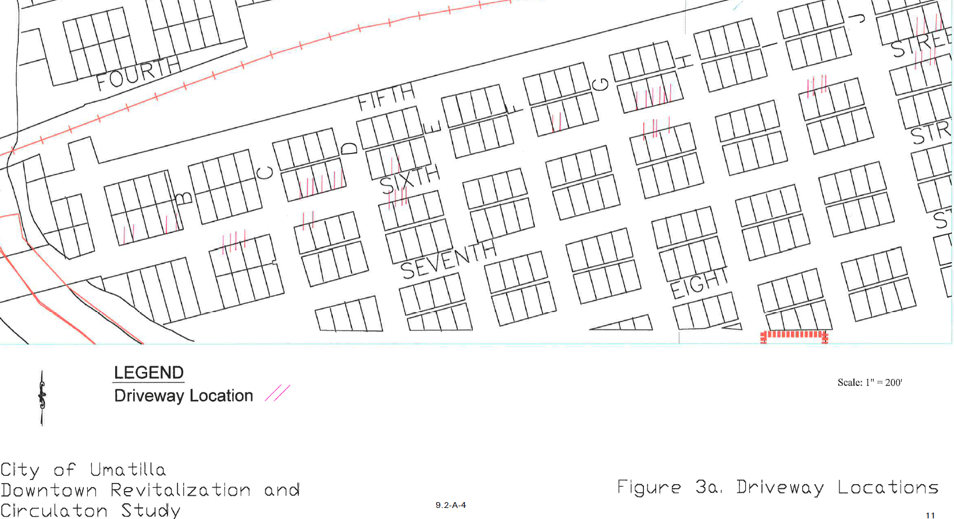
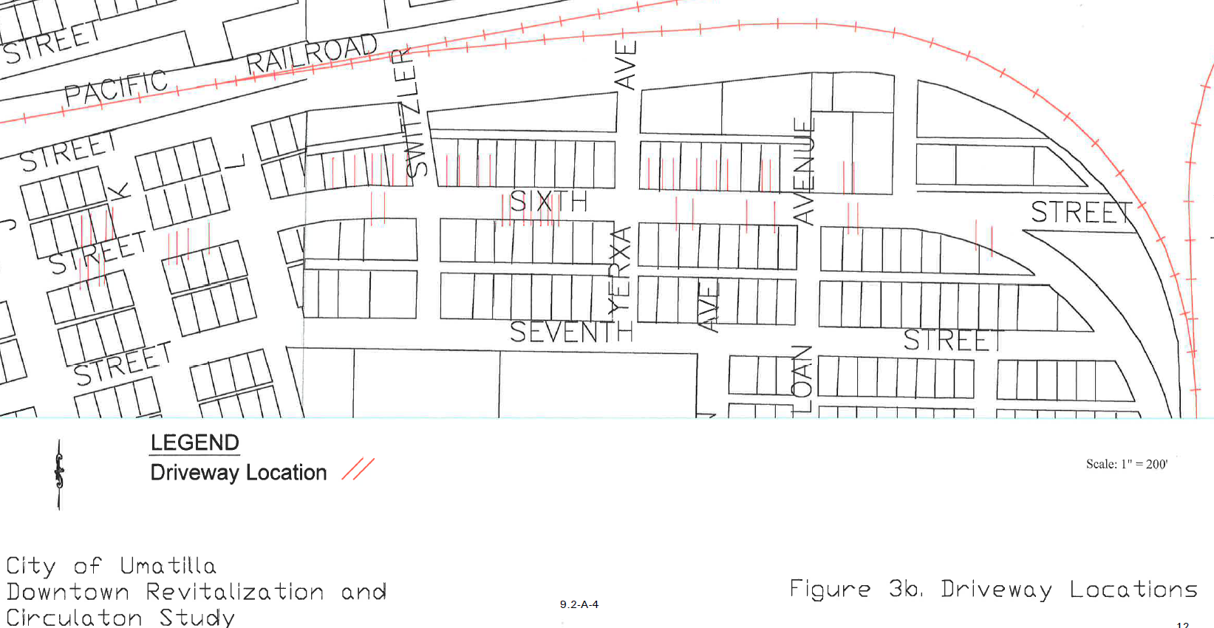
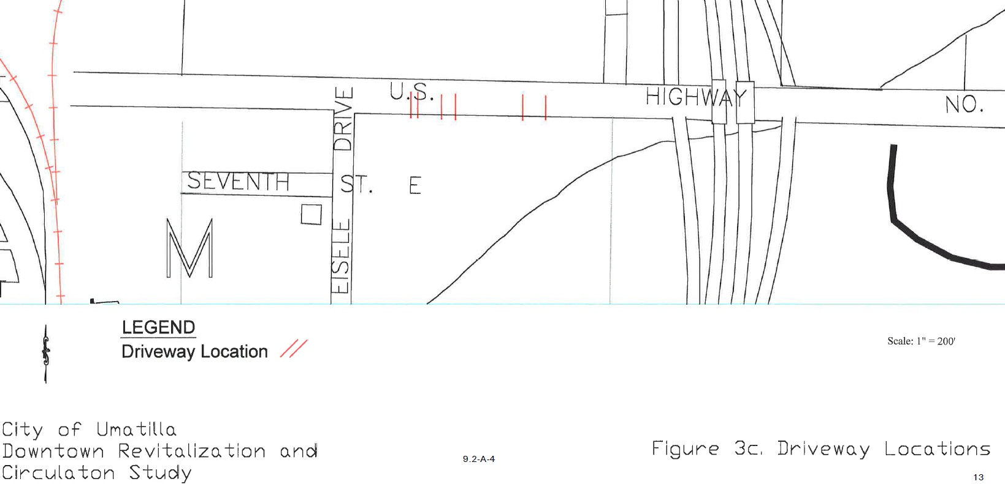

Table 5. Minimum Intersection Spacing Standards
9.2-A-4

Functional Classification | Public Street (feet) | Private Access Drive (feet)
Major Arterial | 1000 | 400
Minor Arterial | 800 | 300
Collector | 600 | 150
Neighborhood Collector | 400 | 100
Local | 200 | 50

Table 6. Private Access Driveway Width Standards

Land Use | Minimum (feet) | Maximum (feet)
Single Family Residential | 12 | 25
Multi-Family Residential | 20 | 35
Commercial | 20 | 35
Industrial | 20 | 40

Since the Umatilla TSP was completed, the 1991 Oregon Highway Plan has been updated. The 1999 Oregon Highway Plan standards have been revised. Table 7 summarizes the new access spacing standards for Highway 730 as specified by the 1999 Oregon Highway Plan.

Table 7. 1999 OHP Highway 730 Minimum Intersection Spacing Standards

Roadway Segment | Public Street' | Private Access Drive"
Milepost 167.58 to Milepost 184.08 | 600/450 feet | 200 feet
Milepost 184.08 to Milepost 184.11 | 600/450 feet | 200 feet
Milepost L84. I l to Milepost 184.87 | 770/550 feet | 200 feet
'Standard 1s given for speed Jmnt of 30 or 35 mpb first and then 25 mph second.
² See Note 4 associated with the table. Standard city block is 200 feet.

The following notes are associated with Table 7 in the 1999 OHP document:

"(1) Where a right of access exists, access will be allowed to a property at less than the designated spacing standard only if that property does not have reasonable access and the designated spacing cannot be accomplished. If possible, other options should be considered such as joint access.

Where the right of access exists, the number of approach roads (driveways) to a single property shall be limited to one, even when the property frontage exceeds the spacing standards. More than one approach road may be considered if, in the judgment of the Region Access Management Engineer, additional approach roads are necessa� to accommodate and service the traffic to a property, and additional
approach roads will not interfere with driver expectancy and the safety of the through traffic on the highway.
9.2-A-4

Approach roads shall be located where they do not create undue interference or hazard to the free movement of normal highway or pedestrian traffic. Locations on sharp curves, steep grades, areas of restricted sight distance or at points which interfere with the placement and ,proper functioning of traffic control signs, signals, lighting or other devices tnat affect traffic operation will not be permitted.

If a property becomes landlocked (no reasonable access exists) because an approach road cannot be safely constructed and operated, and all other alternatives have been explored and rejected, ODOT might be required to purchase the property. (Note: If a hardship is self-inflicted, such as by partitioning or subdividing a property, ODOT does not have responsibility for purchasing the property.)
Note (1) has precedence over notes (2), (3), and (4).

- These standards are for unsignalized access points only. Signal spacing standards supercede spacing standards for approaches.
- Posted (or Desirable) Speed: Posted speed can only be adjusted (up or down) after a speed study is conducted and that study determines the correct posted speed to be different than the current posted speed. In cases where actual speeds are suspected to be much higher than posted speeds, ODOT reserves the right adjust the access spacing accordingly. A determination can be made to go to longer spacing standards as appropriate for a higher speed. A speed study will need to be conducted to determine the correct speed.

- Minimum spacing for public road approaches is either the existing city block spacing or the city block spacing as identified in the local comprehensive plan. Public road connections are preferred over private driveways, and in STAs driveways are discouraged. However, where driveways are allowed and where land use patterns permit, the minimum spacing for driveways is 175 feet (55 meters) or mid-block if the current city block spacing is less than 350 feet (110 meters)."

In comparing the existing driveway locations on 6th Street with the current access spacing standard, future access for development will be much more restrictive to meet the standards in the TSP.

The only recommendation for change from the existing TSP access management standards is to update the access standards on the state facilities to match the 1999 OHP
Planned Public Facility Improvement Projects
9.2-A-4

There are not roadway improvement projects planned in Umatilla's Transportation System Plan (TSP) for the study area. However, based on discussions with ODOT, the Umatilla River Bridge may be rebuilt in the next five or six years. Should this occur, the City of Umatilla would like to consider a new alignment for the bridge. The new alignment would cross the Umatilla River at 5th Street. Highway 730 would be realigned with 6th Street between "C" Street and "E" Street to the east. To the west, Highway 730 would be realigned to the current highway alignment west of Powerline Road. Powerline Road could then be realigned to the new highway alignment further west of the new bridge.

There are three traffic signal projects planned for the study area at the eastern and western boundaries of the study area. The three intersections identified by the TSP as needing signalization by 2017 are the Powerline Road/Highway 730, Umatilla River Road/Highway 730 (6th Street), and "J" Street/Highway 730 (fire signal) intersections.
Pedestrian crossings across Highway 730 (6th Street) was mentioned in the TSP as needing consideration. This was mentioned in response to community concerns involving pedestrian safety. The TSP mentions the following recommendations for potential pedestrian enhancement projects:

- provision of additional street lighting to provide clear visibility of pedestrians at night,
- provision of curb extensions that provide for the existing on-street parallel parking while reducing the exposed crossing distance pedestrians must walk, and
- use of median treatments that provide pedestrians with a "safe haven" at a mid-crossing.
The following pedestrian projects are planned in the TSP within the study area:

- "D" Street from ?1h Street to 5th Street - add sidewalks
- "F" Street from Riverfront Pathway to 3rd Street- add sidewalks
- "I" Street from ih Street to 5th Street - add sidewalks
- "L" Street from Riverfront Pathway to 5th Street - add sidewalks
The following multi-use pathways are planned in the TSP within the study area:

- Powerline Road to "F" Street Pathway
- Riverfront/Park Pathway

CHAPTER3 LAND USE ISSUES
9.2-A-4

Curbside Building Frontage

Buildings fronting the street with no setback from the sidewalks are an important concept in downtown development. This pattern of development is conducive to pedestrian traffic that is a primary component necessary to develop a downtown area. Field observations were taken to identify buildings along 6th Street that have no setback from the sidewalk and street. The intent of this exercise was to identify concentration of buildings fronting 6th Street that could be used as a nucleus for identifying a downtown area for Umatilla. Figure 4 shows the buildings along 6th Street fronting the street.

As shown in Figure 4, two concentrations of buildings fronting the street exist along 6th Street. These concentrations of buildings are between "E" Street and "G" Street and "H" Street and east of "J" Street.

The first concentration of buildings fronting 6th Street between "E" Street and "G" Street include the old Mor Theatre building, vacant flea market building, Trading Post, Nick's Italian Restaurant, and the bank building on the south side of the street. Charlie's Tavern, USA Media, and A Touch of Heaven exist on the north side of the street. Based on information that will be present later, most of this block is either underutilized, vacant, or has buildings with space available.
The second concentration of buildings fronting 6th Street between "H" Street and "J" Street with direct street frontage include the Ward's Second Hand, auto repair and body shop, and offices on the south side of the street. Carlson's Umatilla Pharmacy, Napa Auto and Truck Parts, Umatilla Museum, Fire Station, and school district offices exist on the north side of the street.
There are several other buildings along 6th Street that front the street. However, these buildings are typically isolated from other similar buildings or are located within an auto oriented environment with buildings set back away from the street with parking in front of the buildings.

Location of Public Buildings

In surveying the City of Umatilla, eleven (11) public buildings/uses were identified. These buildings/uses are listed below:

- Senior Center
- City Hall
- Umatilla Museum
- Fire Station
- School District Offices
- Library

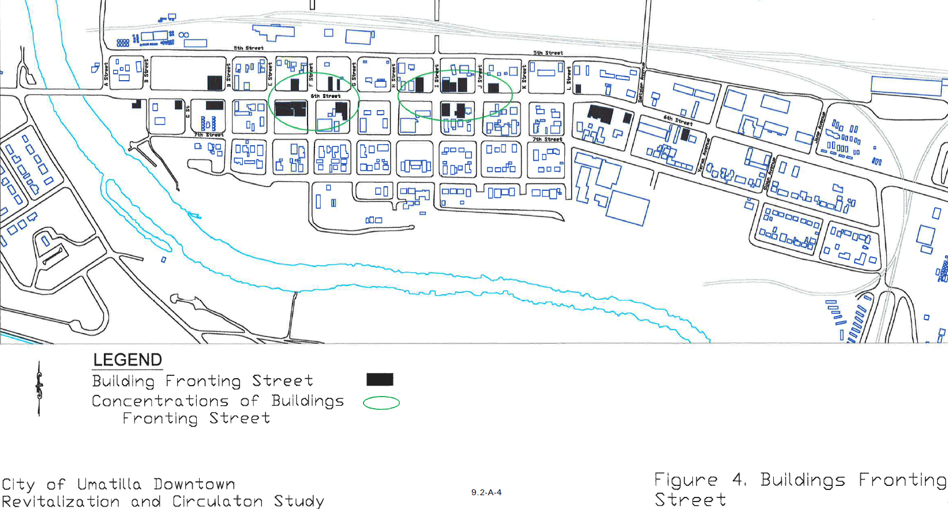

- Clara Brownell Middle School
- Umatilla High School Chamber of Commerce
- Post Office
- Oregon State Visitor Center
- PUC Weigh Station
Figure 5 shows the locations of each of the public uses listed above. As shown in Figure 4, most of the public uses within the City of Umatilla are scattered throughout the city.

The Senior Center is located on "B" Street south of 6th Street. It is located in an area that has no visibility from 6th Street. A city park is nearby within walking distance of the Senior Center. A city park is two to three blocks southeast of the Senior Center.
The Umatilla City Hall is located directly on the south side of 6th Avenue between "C" Street and "D" Street. The Pioneer Memorial Cemetery and Agri-Check is located directly north of City Hall. There are low income housing units to the south and east of City Hall. A house is located to the west of City Hall. Other than the Senior Center, no other public buildings and uses exist in close proximity to City Hall. A significant amount of existing uses adjacent to City Hall could be considered as transitionary uses ready for redevelopment at some future date.

The Umatilla Museum, fire station, school district offices, and library are all in close proximity to each other. They are located on 6th Street between "I" Street and "J" Street. The museum, fire station, and school district offices are located on the north side of 6th Street. The library is located on the south side of 6th Street. The library is currently looking for a site to expand. This cluster of public uses is the most concentrated area of public buildings in the City of Umatilla. Commercial uses SlUTound the public buildings on 6th Street between "I" Street and "J" Street.

The Clara Brownell Middle School and Umatilla High School are located adjacent to each other on 7th Street between "L" Street and Sloan Avenue. The schools are located within a residential area to the east and west. To the north of the schools, a commercial area exists.

The Chamber of Commerce is located on the south side of 6th Avenue to the west of Jane Avenue. Adjacent to the Chamber of Commerce to the west is the local liquor store. To the north of the Chamber of Commerce is Riverside, a bar with exotic dancers. To the northeast of the Chamber of Commerce there is a mobile home park. A residential area exists south of the Chamber of Commerce.

The Post Office is located on the southeast corner of the 6th Street/Draper Street intersection. It is located within an industrial area of the City of Umatilla. Immediately north of the Post Office is the PUC Weigh Station. There are truck stops to the east and west of the Post Office. South of the Post Office there are industrial uses.

The Oregon State Visitor Center is located on Cline Avenue north of 3rd Street. It is not visible from 6th Street and poorly signed. Also, access to the Oregon State Visitor Center is from Brownell Avenue, which is the egress for the PUC Weigh Station.

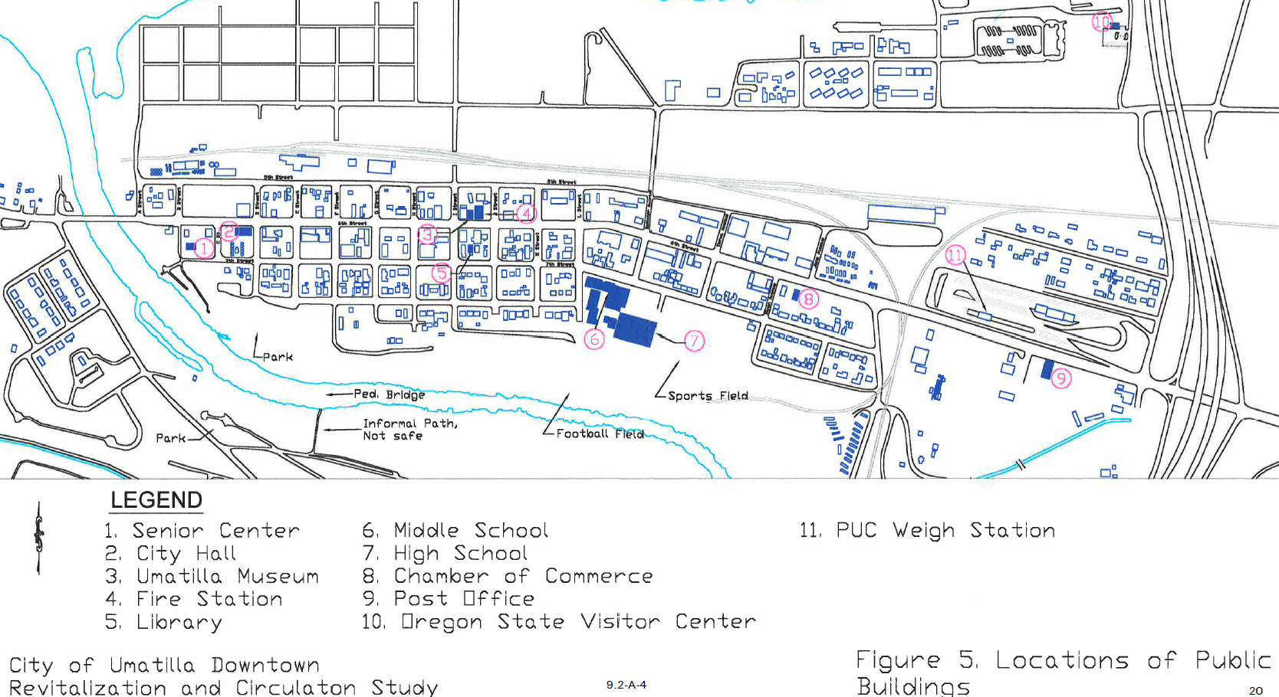

The PUC Weigh Station is located on the north side of 6th Street west of the I-82/HIGHWA Y 730 interchange. The weigh station is constrained by a residential area to the north, 6th Street to the south, I-82 to the east, and a railroad track spur to the west. Based on the land uses adjacent to the weigh station, it is unlikely that future expansion of the weigh station is possible.

Of the eleven (11) public buildings, six (6) are in a non-ideal area. The public buildings that could be better located are as follows:

  - Senior Center
  - City Hall
  - Library
  - Chamber of Commerce
  - Post Office
  - Oregon State Visitor Center

The Senior Center is currently located in an area that is not visible. Public uses should be more visible and in areas that encourage the community to interact with them. The Senior Center is currently in a location that is isolated from the community with no visibility.

The City Hall is located in an area that is surrounded by poorly maintained, low income housing from two sides. The poorly maintained, low income housing areas could be redeveloped into commercial uses or City Hall could be relocated in an area more representative of a downtown image.

The City of Umatilla is considering expanding the library. To accomplish this, the library must find either a larger building or construct a new facility on an available vacant lot. Its current location is ideal and near several public uses such as the museum, fire station, and school district offices.

The Chamber of Commerce is located near three uses that are not positive community images. These uses are the liquor store, Riverside Bar with exotic dancers, and the cigarette store. Consideration should be given to relocating the Chamber of Commerce to a more central commercial area.

The Post Office is located in an industrial area with significant amount of truck traffic. The Post Office is one of the communities more busy public uses and having it adjacent to uses that generate significant truck traffic creates potential conflicts between residents in automobiles and truck traffic. It would be more ideal to move the Post Office to an area where residents do not have to compete with trucks on the road and that is located within the core commercial area of Umatilla.

The Oregon State Visitor Center is very difficult for a person with no local experience to find. It is also located in an area that a motorist would have to compete with truck traffic. It would be more ideal for the Oregon State Visitor Center to move to an area with more visibility. It may be ideal for the Oregon State Visitor Center and the Umatilla Chamber of Commerce to be located adjacent to each other to promote both the city and state together.

Vacant Land and Buildings with Space Available

A field survey in combination with a workshop with City staff resulted in the development of a vacant land and building with space available inventory. This information was derived from field observations, local knowledge of City staff, and an interpretation of transitionary uses that would likely be ready for redevelopment. Figure 6 shows the results of the survey.

As shown in Figure 6, there are very few vacant commercial buildings in the study area. Only four buildings are completely vacant. These vacant buildings are identified below:

- Flea market building next to the Mor Theatre building - southwest comer of 6th Street and "F" Street
- House on the southwest corner of 6th Street and "J" Street
- Umatilla Marine building on the northwest corner of 6th Street and Switzler Avenue

When driving through the study area, it appears that there is a greater building vacancy rate than documented above. The explanation for this seems to be that there are many sites currently occupied that are underutilized. An example of this would be abandoned gas station sites with an existing use. A converted gas station building is very small in relation to the actual parcel size and the parcel seems to be underutilized.
Two commercial buildings in the study area have space available for lease. The first building with space available is an office building on the northwest corner of the th Street and "F" Street intersection. The second commercial building with space available is the building with the antique store on the southwest corner of the 6th Street and "I" Street intersection.

There are several vacant lots available in the study area for future development. These areas are depicted in a green hatching pattern in Figure 6. Some of the more significant vacant lots are described below:

- ½ block area bounded by the alley between 6th Street and 7th Street to the north, th Street to the south, "F" Street to east, and "E" Street to the west. This vacant lot is behind the Mor Theatre building.
- ½ block area bounded by th Street to the north, half way between th Street and 8th Street to the south, "I" Street to the east, and "H'' Street to the west.
- ½ block area bounded by half way between 5th Street and 6th Street to the north, 6th Street to the south, "L" Street to the east, and "K" Street to the east.
- A large vacant lot located on the southeast corner of the 6th Street and Yerxa Avenue intersection.
- A large vacant lot located south of 6th Street across from Jane Avenue

A typical City of Umatilla block is 200 feet by 200 feet. Therefore, the ½ block areas are roughly 200 feet by 100 feet.
There are eight other smaller vacant lots depicted in Figure 6. These smaller lots are approximately¼ block areas with dimensions of 100 feet by 100 feet.

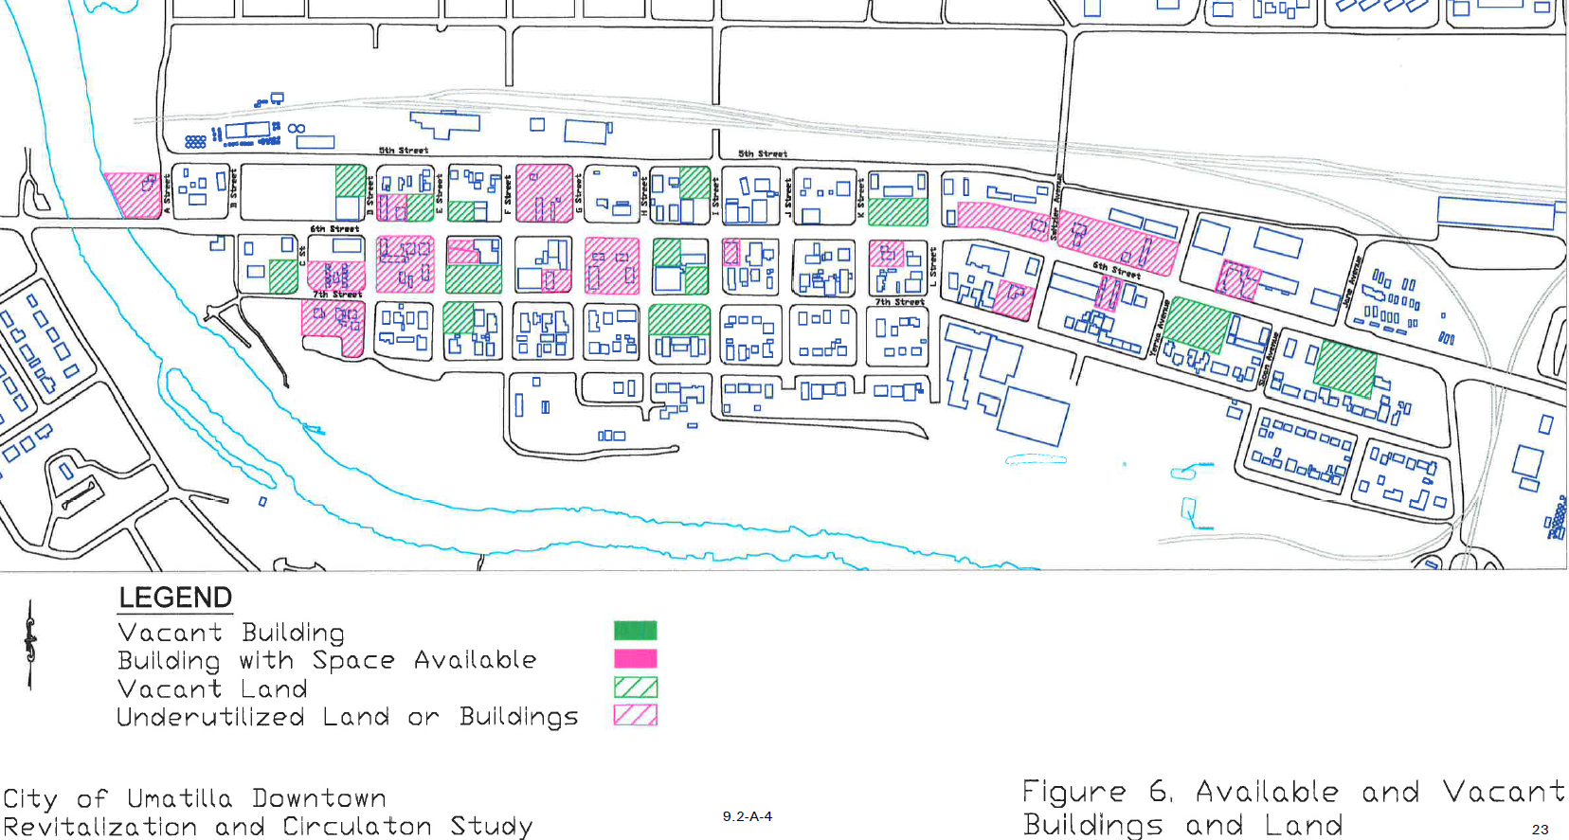

Underutilized land and buildings were identified with the help of City staff. Figure 6 depicts the underutilized land and buildings by a magenta hatch pattern. As you can see from Figure 6, there are significant areas of the study area that are currently underutilized with a good potential for commercial redevelopment. There are at least eight ½ to whole block areas that are underutilized. These areas are identified and described below:

- Whole block area bounded by 5th Street alignment to the north, 6th Street to the south, "A" Street to the east, and the Umatilla River to the west. This area is ideal for a public park and provides direct access to the Umatilla River. There is currently a single-family residence on this site.
- ½ block area bounded by the alley between 6th Street and ih Street to the north, ih Street to the south, "D" Street to the east, and "C" Street to the west. This area is directly behind City Hall and is currently occupied by several poorly maintained, low-income housing units.
- Whole block area bounded by ?111Street to the north, 8th Street to the south, "D" Street to
the east, and "C" Street alignment to the west. Several poorly maintained residential units currently occupy the site.
- Whole block area bounded by 6th Street to the north, ih Street to the south, "E" Street to the east, and "D" Street to the west. This block is currently occupied by multi-family residential uses and is adjacent to City Hall. City Hall is directly west of this potential redevelopment block.
- Whole block area bounded by 5th Street to the north, 6th Street to the south, "G" Street to east, and "F" Street to the west. Two commercial uses cuffently exist on this block. The current uses are USA Media and A Touch of Heaven.

- Whole block area bounded by 6th Street to the north, 7th Street to the south, "H" Street to the east, and "G" Street to the west. This area is occupied by two former gas station uses.
- ½ block area bounded by between 5th and 6th Streets to the north, 6th Street to the south, Switzler Avenue to the east, and Hair Etc. to the west. Two vacant buildings occupy this area. They are the old Bonoco gas station and the Umatilla Marine building.
- ½ block area bounded by between 5th Street and 6th Streets to the north, 6th Street to the south, Yerxa Avenue to the east, and Switzler Avenue to the west. This area has a vacated 76 gas station site, a vacant house that is boarded up, and the recycle center.
Figure 6 depicts numerous other underutilized sites that are¼ block or smaller.

Neighborhood Boundaries

As part of a field reconnaissance effort, the study area was categorized into land use districts. The study area was defined by six categories of land use districts. These districts included residential, office-residential, cemetery, commercial, downtown core, and downtown extended. The results are depicted in Figure 7.

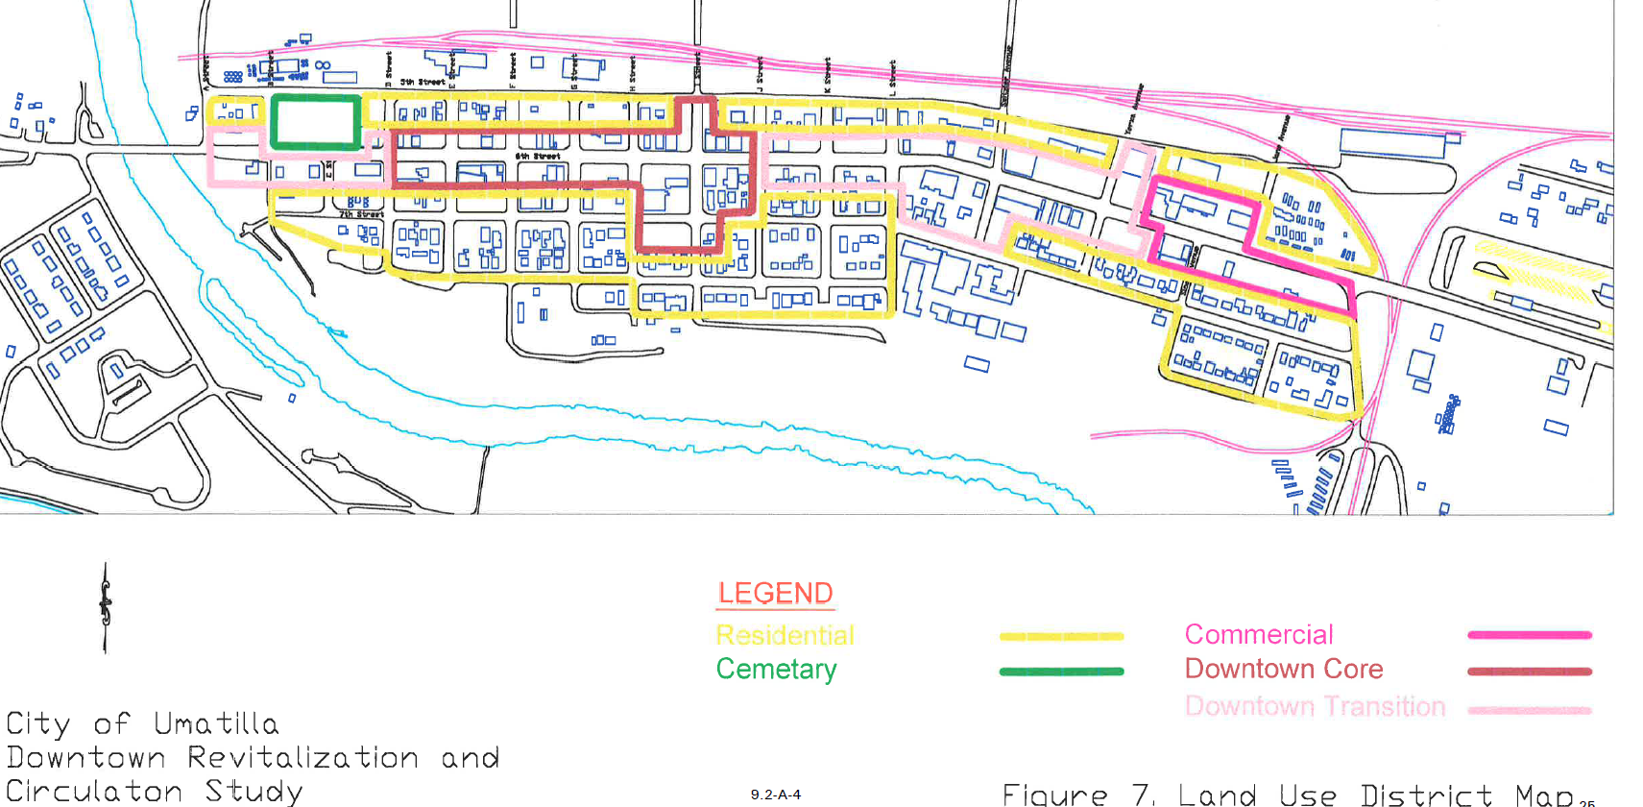

ENVIRONMENTAL ISSUES

DEQ Cleanup Sites

The Department of Environmental Quality (DEQ) was contacted for a list of sites within Umatilla that may contain hazardous materials. The list includes sites that are in the process of clean up as well as those that may have potential problems. Figure 8 summarizes the list obtained from DEQ. The figure shows the following: 1) active gas station or other sites with underground storage tanks, 2) underground storage tank sites that have been verified by DEQ as clean, 3) underground storage tank sites with potential problems, and 4) underground storage tank sites on DEQ's clean up list.

There are two active gas station sites within the downtown study area defined by the Umatilla River Bridge, Columbia River, Umatilla River, and Umatilla River Road. These active gas stations are Priceless and G&S which is also known as AMOCO. These active sites are not known to have any problems.

Three former gas station sites have been certified as clean by D�Q. These sites are the current Photography Plus building located on the southwest corner of the 6th Street/"B" Street intersection, the Sunshield located on the southeast comer of the 6th Street/"K" Street intersection, and the former Bonoco gas station site located on the north side of 6th Street between "L" Street and Switzler Avenue.

There are two sites that may have potential soil contamination problems by underground storage tanks. These sites are the Cenex site located north of 5th Street between "B" Street and "D" Street and the former 76 gas station site on the northeast comer of the 6th Street/Switzler Avenue intersection.
Three sites are on the DEQ clean up list. These sites are the OFI site north of 5th Street between "F" Street and "G" Street, the former Leather's gas station site on the southeast corner of the 6th Street/"G" Street intersection, and the former Shell gas station site on the southwest comer of the 6th Street/"H" Street intersection.

Historic Sites

Shapiro and Associates contacted the State Historic Preservation Office (SHPO) and the Umatilla County Historic Society to identify historic sites within the study area. Neither office noted any identified historic buildings or sites listed on the National Register of Historic Places. SHPO staff did note that a federally owned archeological site is located at the mouth of the Umatilla River. A few buildings in the area (the MOR Theater and the Wards store) are potentially eligible for the National Register, but without further research, it is not possible to determine whether they would actually meet eligibility criteria.

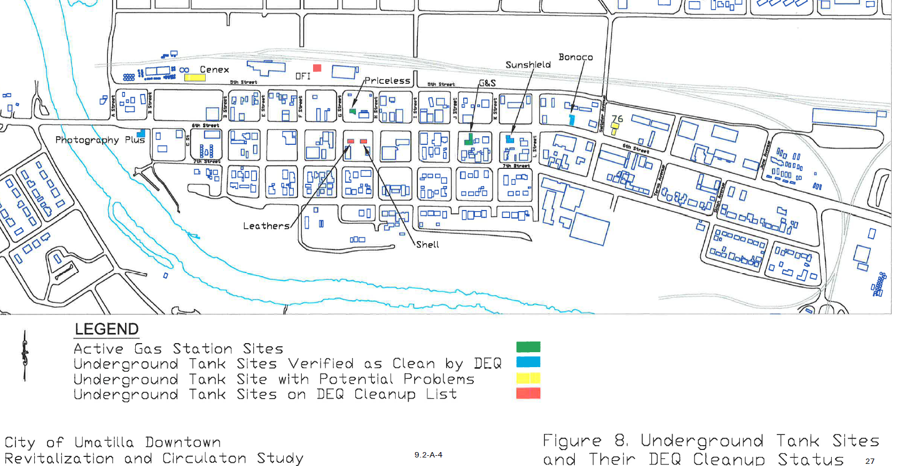

Waterways

The Columbia River and Umatilla River are two significant water :features in the study area. The Columbia River borders the City of Umatilla to the north and serves as a means of freight movement from commercial barge traffic. Commercial barge traffic bypasses McNary Dam from an existing lock at the dam. The Columbia River is also a major source of recreation to the area. The Umatilla River runs into the Columbia River as a tributary. It creates the western and southern boundaries of the study area. The Umatilla River provides a source of recreation as well as water for several irrigation districts.

PUBLIC UTILTIES
Based on field observations, most of the City of Umatilla's power and telecommunications utilities run along the alley between 6th Street and 7th Street. These utilities are above ground and mounted on poles.

It appears that 6th Street has a st01m water system with curb, gutter, and catch basins. However, the north-south side streets and other east-west streets do not appear to have any curb, gutter, and catch basins and may not be part of the storm water system.

Based on the City of Umatilla' s utility maps, the sewer lines are located in the alleys parallel to st\ 6t\ th, and 8th Streets. The sewer lines in the study area are generally 8-inch lines.

The water main generally runs along the south side of 6th Street and is an 18-inch line. There are feeder lines that exist along st\ i\ and 8thStreets as well as the north-south side streets. The
feeder lines are 2 to 8 inches in diameter depending on the location. There are no known utility service limitations in the study area.

2000 STREET INVENTORY
City of Umatilla Transportation System Plan
Appendix 9.2-A-5

Street Segment |  | Jurisdiction | Classification | Speed Limit  (mph) | ROW  Width (feet) | Street Width  (feet) | # of Travel  Lanes | Curbs |  |  | Sidewalk Width | Sidewalk Condition | Bikeway | Pavement Condition
 |  |  |  |  |  |  |  |  | On-Street
 |  |  |  |  |  |  |  |  | Parking | Sidewalk
6th S.
 | A St. to B. St. | ODOT | major arterial | 25 | 80 | 60 | 2 | both | both | Int. south | 10 | fair | no | fair/good
 | B St. to C St. | ODOT | major arterial | 25 | 80 | 60 | 2 | both | both | Int. south | 10 | good | no | fair/good
 | C St. to D St. | ODOT | major arterial | 25 | 80 | 60 | 2 | both | both | Int. north  south | 10 | good | no | fair/good
 | D St. to E St. | ODOT | major arterial | 25 | 80 | 60 | 2 | both | both | both | 8-9 | good | no | fa.ir/good
 | E St. to F St. | ODOT | major arterial | 25 | 80 | 60 | 2 | both | both | both | 8-10 | fair/good | no | fair/good
 | F St. to G St. | OOOT | major arterial | 25 | 80 | 60 | 2 | both | both | both | 8-13 | fair/good | no | fair/good
 | G St. to H St. | ODOT | major arterial | 25 | 80 | 60 | 2 | both | south | both | 10 | fair/good | no | fair/good
 | H St. to I St. | ODOT | major arterial | 25 | 80 | 60 | 2 | both | both | both | 10 | fair/good | no | fair/good
 | I St. to J St. | ODOT | major arterial | 25 | 80 | 60 | 2 | both | both | both | 9-10 | fair | no | fair/good
 | J St. to K St. | ODOT | major arterial | 25 | 80 | 60 | 2 | both | both | both | 10 | fair | no | fair/good
 | K St. to L St. | ODOT | major arterial | 25 | 80 | 60 | 2 | both | both | south | 10 | fair | no | fair/good
 | L St. to Switzler Ave. | ODOT | major arterial | 25 | 80 | 60 | 2 | both | both | Int. north  south | 5-10+  asphalt | fair | no | fair/good
 | Switzler Ave. to Yerxa Ave. | ODOT | major arterial | 25 | 80 | 60 | 2 | both | both | Int. north  south | 10-12 | fair | no | fair/good
 | Yerxa Ave. to Sloan Ave. | ODOT | major arterial | 25 | 80 | 60 | 2 | both | both | North Int. south | North 10+ asphalt, south 10 | good | no | fair/good
 | Sloan Ave. to Jane Ave. | ODOT | major arterial | 25 | 80 | 60 | 2 | both | both | North | North 4  south 5 | good | no | fair/good
A St.
 | 5th St. to 6th St. | City | local | 25 | 80 | 38-40 | 2 | no | no* | no | - | - | no | fair
BSt.
 | 5th St. to 6th St. | City | local | 25 | 65 | 38 | 2 | no | no* | no | - | - | no | fair
 | 6th St. to 7th St. | City | collector | 25 | 80 | 20-36 | 2 | no | no* | no | - | - | no | gravel
C St.
 | 6th St. to 7th St. | City | local | 25 | 80 | 39-48 | 2 | Int. east | Int. east | Int. east | 5 | good | no | good
D St.
 | 5th St. to 6th St. | City | local | 25 | 80 | 45 | 2 | no | no* | no | - | - | no | fair/good
 | 6th St. to 7th St. | City | local | 25 | 80 | 48 | 2 | Int. west | Int. west | Int. west | 5 | good | no | fair/good
ESt.

2000 STREET INVENTORY
City of Umatilla Transportation System Plan

Street Segment | Jurisdiction | Classification | Speed Limit  (mph) | ROW  Width (feet) | Street  Width (feet) | # of Travel  Lanes | Curbs |  |  | Sidewalk Width | Sidewalk Condition | Bikeway | Pavement Condition
 |  |  |  |  |  |  |  | On-Street
 |  |  |  |  |  |  |  | Parking | Sidewalk
I5th St. to 6th St. | City | local | 25 | 80 | 27 | 2 | no | no* | no | - | - | no | fair/good
16th St. to 7th St. | City | local | 25 | 80 | 51 | 2 | Int. east | no* | Int. east | 10 | fair | no | good
F St.
I5th St. to 6th St. | City | collector | 25 | 80 | 29 | 2 | no | no* | no | - | - | no | poor
16th St. to 7th St. | City | collector | 25 | 80 | 46 | 2 | Int. east | Int. east | Int. east | 3  9.2-A-5 | fair/good | no | fair/good
G St.
I5th St. to 6th St. | City | local | 25 | 80 | 41 | 2 | no | no* | no | - | - | no | fair
16th St. to 7th St. | City | local | 25 | 80 | 39-49 | 2 | west | no* | west | 6-10 | fair/good | no | fair/good
H St.
I5th St. to 6th St. | City | local | 25 | 80 | 30-43 | 2 | Int. west | no* | Int. west | 5 | good | no | fair
16th St. to 7th St. | City | local | 25 | 80 | 60 | 2 | Int. east | no* | Int. east | 10 | fair/good | no | fair/good
I St.
I5th St. to 6th St. | City | local | 25 | 80 | 40-64 | 2 | no | no* | no | - | - | no | fair
16th St. to 7th St. | City | local | 25 | 80 | 56 | 2 | no | no* | no | - | - | no | good
J St.
I5th St. to 6th St. | City | local | 25 | 80 | 41-54 | 2 | Int. east | Int. east | Int. east | 10 | good | no | fair/good
I6th St. to 7th St. | City | local | 25 | 80 | 47 | 2 | no | no* | no | - | - | no | good
K St.
I5th St. to 6th St. | City | local | 25 | 80 | 40 | 2 | no | no* | Int. east | 5 | good | no | poor/fair
16th St. to 7th St. | City | local | 25 | 80 | 37-40 | 2 | no | no* | no | - | - | no | fair
LSt.
I5th St. to 6th St. | City | local | 25 | 80 | 44 | 2 | Int. west | no* | Int. west | 5 | good | no | poor/fair
16th St. to 7th St. | City | local | 25 | 80 | 40 | 2 | no | no* | no | - | - | no | fair/good
Switzler Ave.
I5th St. to 6th St. | County | collector | 25 | 61 | 21-38 | 2 | Int. both | no* | Int. east | 12 | good | no | poor
I6th St. to 7th St. | City | collector | 25 | 60 | 39-47 | 2 | Int. both | no* | Int. both | 5 | good | no | good
Yerxa Ave.
I5th St. to 6th St. | City | local | 25 | 60 | 39 | 2 | no | no* | no | - | - | no | poor
16th St. to 7th St. | City | local | 25 | 60 | 36 | 2 | no | no* | no | - | - | no | fair/good
Sloan Ave.
16th St. to 7th St. | City | local | 25 | 60 | 25-35 | 2 | Int. both | no• | Int. east | 5 | good | no | good
Jane Ave.
I5th St. to 6th St. | City | local | 25 | 60 | 39 | 2 | no | west | no | - | - | no | fair

* Parking not marked on-street but it is possible to park on-street due to street width.

ADOPTED by the City Council this day of , 2025.

Council members voting yes:

Council members voting no:

Absent Council members:

Abstaining Council members:

And SIGNED by the Mayor this day of , 2025.

Caden Sipe, Mayor

ATTEST:

Nanci Sandoval, City Recorder

